Configuring Vulcan Networked Printers/Plotters on a Mac:

The print server vulcan.design.upenn.edu is a Windows print server, and will not load from a Mac the same way it does on a PC. Please use the following instructions to add a networked printer or plotter to your Mac.
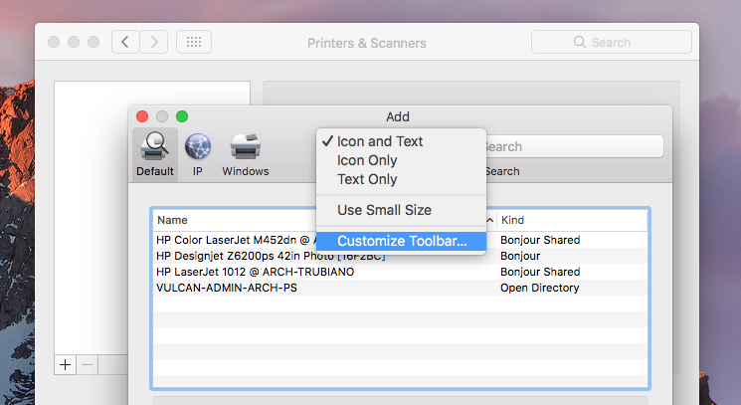
- Before starting: note the name and the model of the printer you want to use, e.g. MEY3-M750-PS, an HP M750

- Navigate to System Preferences → Printers & Scanners
- Click the + on the bottom left of the window to add a printer
- Right-click on the toolbar and select “Customize Toolbar”
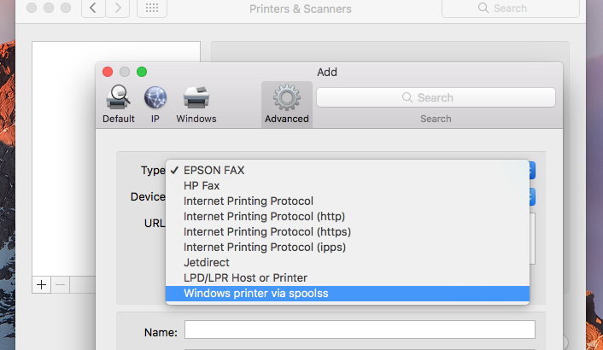
- Drag the “Advanced” icon into the toolbar

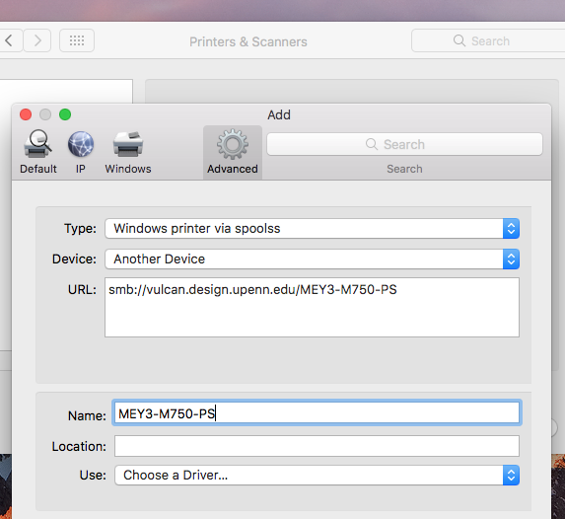
- Under “Advanced”, select type “Windows printer…”
- Add the printer by typing its full path and name as follows in the URL field:
smb://vulcan.design.upenn.edu/NAME (e.g. MEY3-M750-PS)
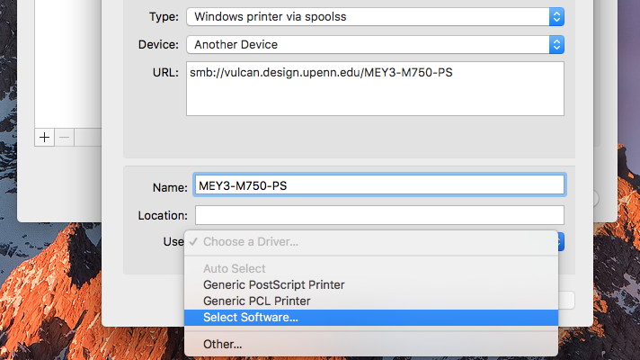
- Choose a driver via “Use” → “Select Software”
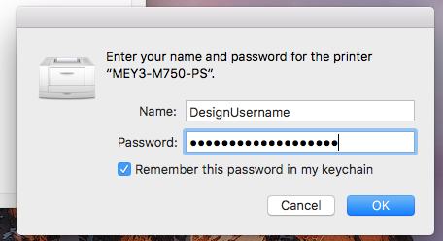
- Search for the printer model and add it – you may need to download drivers separately
- The first time you print to the printer, you will be asked for your username and password – use your Design username and password

Printer not connecting? Try this:

- Make sure you’re hard-wired into our network via Ethernet. Printers are not available over AirPennNet.
- Changed your Design password recently? An outdated saved password can block your print job. To fix this, open the application Keychain Access and delete any “vulcan” or printer saved password.
- Able to print, but not plot? Make sure 1) you’ve passed the plotting quiz, and 2) your studio isn’t on Tools Down.

