Weitzman ITS Remote-ify

Dates:
Weds, Thurs, Fri (3/11 - 3/13)
Times:
1000a – 200p
Location:
324 Lab – Meyerson Hall

Step 0: Prepare Hardware
- University systems support the following operating systems:
  - Windows 10 (1809, 1903, 1909)
  - MacOS 10.13.6 (High Sierra) or 10.14.6 (Mojave)
n.b. 10.15 (Catalina) cannot access SRS or BEN Financials, but may work with other systems
- Antivirus
  - Install and run Malwarebytes (Windows: https://www.malwarebytes.com/mwb-download/thankyou | MacOS: https://www.malwarebytes.com/mac-download) to check for existing infections
n.b. computers testing positive for malware must be completely cleaned before configuration for remote work
  - Install SEP (\\jove.design.upenn.edu\installs$\Utilities\Antivirus\Symantec\Current Installers\14.2 RU2); activate Windows Defender on Windows

Step 1: PennKey / 2FA
- Using a private browser sign into WorkDay (https://www.workday.upenn.edu) to test knowledge of PennKey password, 2FA setup
n.b. smartphones should use Duo Mobile for 2FA, rather than SMS
- Log into ISC 2FA Management (https://twostep.apps.upenn.edu) to print one-time codes:
  - Manage Settings > under Printed Codes, select Generate Codes
  - Print the page (do not photograph or save codes on computer or phone) and store securely at home
  - One-time codes are used when your primary method (e.g. Duo Mobile) is unavailable
  - To use, type a one-time code in the line when prompted for PennKey 2FA code; remember to cross-out this code, as it can only be used once

Step 2: VPN Setup
- Weitzman Design VPN (https://www.design.upenn.edu/remoteaccess)
  - Used for accessing Weitzman-specific resources; e.g. course folders, Jove shares
  - Installers and instructions available on the website linked above
- GlobalProtect (University) VPN Service (https://vpn.upenn.edu)
  - Used for accessing University resources; e.g. SRS, Atlas

How to install the GlobalProtect application

For Windows and MacOS, you can navigate to the following link in a browser to download the appropriate client:

vpn.upenn.edu

When you go to the link above in a browser window, you should see a screen that looks something like the one below.
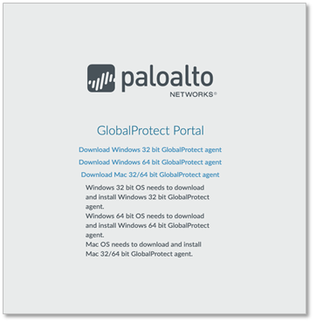
Figure 1: Screenshot of GlobalProtect Portal web page

Select the appropriate link for your operating system. Clicking on the link will download an installer for the appropriate client application. You will need to have administrator rights on your workstation to complete the installation.

Installing on MacOS

For example, on a MacOS machine, you will download a file called GlobalProtect.pkg – double-clicking on this file will cause it to bring up a dialog box that will ask you a series of questions and walk you through the installation process.
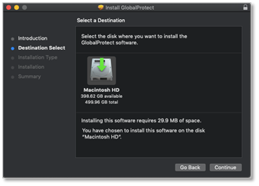
Figure 2: Screenshot of MacOS installer

On later versions of MacOS, beginning with High Sierra 10.13, you will need to approve kernel extensions in order for the GlobalProtect VPN client to function normally. You will be prompted with a dialog box like the one shown below. Click on the button labelled Open Security Preferences.

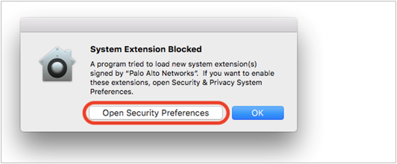
Figure 3: Screenshot of the MacOS System Extension Blocked dialog box

This will open your System Preferences dialog box. A warning will be displayed at the bottom of the dialog box next to the button labelled Allow. Click on the Allow button to continue.

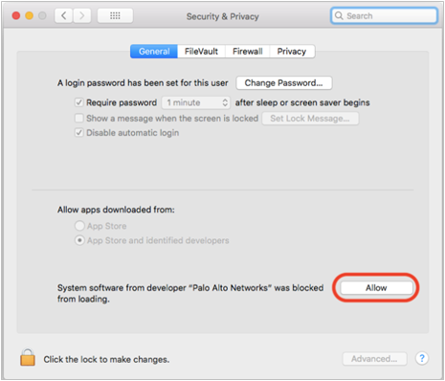
Figure 4: Screenshot of the Security Preferences dialog
Installing on Windows

On a Windows machine, you can download a file called GlobalProtect64.msi for a 64-bit operating system or GlobalProtect.msi for a 32-bit operating system. Double-clicking on this file will cause it to bring up a dialog box that will ask you a series of questions and walk you through the installation process.
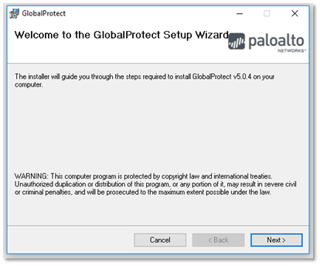
Figure 5: Screenshot of Windows installer
Windows will then prompt if you’d like to install in the default location.

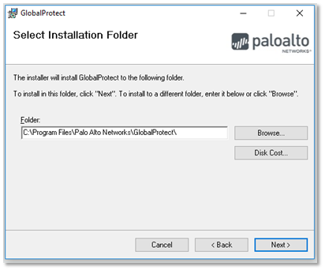
Figure 6: Screenshot of Windows installation folder prompt

Step 3: Office 365 Access
- Login to Office 365 (https://office365.com) with PennO365 credentials (username=PennKey@upenn.edu) to access Office programs online
- If needed, install Office365 for desktop and configure with the same account credentials
- If needed, you may reset your PennO365 password here (https://office365.password.isc.upenn.edu) — do not use the Microsoft “forgot my password” link, which does not work with PennO365

Step 4: Adobe Creative Cloud Setup
- Login to Adobe (https://auth.services.adobe.com/en_US/index.html) using Adobe CC credentials (username=PennKey@design.upenn.edu) and install the Adobe CC desktop app
- Once Adobe CC desktop has installed, you may install specific Adobe applications through it

Step 5: Access to SRS
- Install DataComet (\\jove.design.upenn.edu\installs$\Applications\DataComet-Secure SRS for Mac) or HostExplorer (\\jove.design.upenn.edu\installs$\Applications\Host Explorer)
- Certain University Services (SRS, Atlas, etc.) are restricted to on-campus access for security purposes; to connect from home, initiate VPN connection using the ISC
n.b. computers with MacOS 10.15 cannot access SRS – no acceptable application exists

Accessing Your Data
- PennBox (https://box.upenn.edu)
  - PennKey authentication

- Course Folders (Juno)
  - Connect to Weitzman VPN using FortiClient
  - Instructions for accessing Course Folders:
    - MacOS — Open Finder > press Command (⌘) and K together > copy-paste juno.design.upenn.edu/courses in the box provided, then press Connect > when prompted, enter Weitzman computer credentials as "registered guest”
    - Windows — Open any Windows Explorer folder > in the directory path bar, copy-paste \\juno.design.upenn.edu\courses and press Enter > when prompted, enter Weitzman computer credentials (username=DESIGN\PennKey)

- Department and Personal Network Folders (Jove)
  - Connect to Weitzman VPN using FortiClient
  - Instructions for accessing Department Folders:
    - MacOS — Open Finder > press Command (⌘) and K together > copy-paste jove.design.upenn.edu/dept-shares/DEPT_ABBREV in the box provided, then press Connect > when prompted, enter Weitzman computer credentials as "registered guest”
    - Windows — Open any Windows Explorer folder > in the directory path bar, copy-paste \\jove.design.upenn.edu\dept-shares\DEPT_ABBREV and press Enter > when prompted, enter Weitzman computer credentials (username=DESIGN\PennKey)
  - Instructions for accessing Personal Folders:
    - Following the instructions for Department Folders, substitute home for dept-shares and your PennKey name for the DEPT_ABBREV
    - Department Abbreviations:
      - AAUP = Architectural Archives
      - ADFA = Admissions & Financial Aid
      - ARCH = Architecture
      - BLDG = Facilities & Building Administration
      - CHAN = Environmental Building & Design (aka CEBD)
      - CPLN = City & Regional Planning
      - DEAN = Dean
      - DVPT = Development
      - FNAR = Fine Arts
      - FNCE = Finance
      - GRAD = Registrar
      - HSPV = Historic Preservation
      - LARP = Landscape & Regional Architecture
      - PRAX = Praxis
      - SHOP = Fabrication Lab
      - URBN = Institute for Urban Research (aka PennIUR)
Other considerations:
-PennNet Phone service (verify access)
https://pps.voice.isc.upenn.edu/
-Manage your forwarding, voice message, other settings

