SPONSORED PROJECTS HANDBOOK

Office of Research Services

rev 2015
Table of Contents
1 Introduction 2
1.1 Purpose of the Handbook 2
1.2 Principal Investigators 2
1.3 Sponsored Project Definition 2
1.4 Gifts 3
1.5 Who Can Submit a Proposal for External Support? 3
1.6 Sources of Project Support 4
1.6.1 University Sources of Project Support 4
1.6.2 Non-University Sources of Project Support 4
2 University Organization for Research Administration 7
2.1 General Administrative Structure 7
2.1.1 Vice Provost for Research 7
2.1.2 Provost's Council on Research 8
2.1.3 Office of Research Services 8
2.1.4 Human Research Protections 9
2.1.5 Office of Research Integrity and Compliance 10
2.1.6 Penn Center for Innovation 10
2.1.7 Business Services, Finance, Facilities Management and Human Resources 10
2.1.8 Dean and Department Chairs 10
3 Administrative Policy Considerations 12
3.1 Corporate Responsibility 12
3.2 Formal Documentation 12
3.3 Authorized Signatures 12
3.4 Classified Research 12
3.5 Endorsement of Research Results 12
3.6 Financial Conflict of Interest 13
3.7 Ownership of Intellectual Property 13
3.8 Students in Research 13
4 Roles and Responsibilities 14
4.1 The University and its Faculty 14
4.2 Academic Evaluation of Sponsored Programs 15
4.3 Administrative Requirements for Sponsored Programs 15
4.4 Administrative Review of Sponsored Programs 16
4.5 The Business Administrator 16
5 Preparation of Proposals 18
5.1 Introduction 18
5.2 Relevant Sponsored Projects Policies 18
5.3 Preliminaries to Proposal Preparation 18
5.3.1 Sponsored Research Agreements with Commercial Entities 19
5.4 Research and Project Proposal 20
5.4.1 General Requirements 20
5.4.2 Content of Proposal 20
5.5 Preparing Proposal Budgets 23
5.5.1 Direct Costs 23
5.5.2 Representations and Certifications 29
5.5.3 Facilities and Administrative Costs (formerly Indirect Costs or Overhead) 29
5.5.4 Cost Sharing 31
5.6 University Review of Proposals 31
5.6.1 Requests for Proposals and Requests for Applications 31
5.6.2 Proposal Signatures 31
5.6.3 Deadlines for Proposals 32
5.6.4 Electronic Submission of Proposals 32
All proposals submitted to external sponsors are prepared and routed for approval through the University’s PennERA (Electronic Research Administration) system. 32
5.6.5 Multiple Solicitations 33
5.7 Review and Approval Channels 33
5.8 Proposals Requiring Special Review 35
5.8.1 Human Subjects Review 35
5.8.2 Animal Care Review 35
5.8.3 Biohazards Safety Review 36
5.8.4 Investigational Drug and Device Testing 36
5.8.5 Radiation Safety 36
5.8.6 Radioactive Drug Research 36
5.8.7 Financial Conflict of Interest Disclosure 36
5.8.8 Clinical Trials 37
5.9 Project Site Visits 37
6 Types of Agreements and Instruments 39
6.1 Grants 39
6.2 Contracts 39
6.3 Cooperative Agreements 40
6.4 Other Agreements 40
6.5 Issues Requiring Special Consideration 40
6.5.1 HIPAA 40
6.5.2 Export Controls 41
7 Initiating the Project Award 43
7.1 Award Notification 43
7.2 What to Look for in a Notice of Award 43
7.3 Account Information Sheet 44
7.4 Establishing the Account 44
7.5 Budgeting 44
7.6 Payroll Management 44
7.7 Sponsor Payments 45
7.8 Anticipated Awards (Advance Account Requests) 45
7.9 Supplements to Awards 45
8 Award Administration 46
8.1 Sponsor-University Relationship 46
8.2 Relevant Sponsored Projects Policies 46
8.3 General Administration 47
8.3.1 Expenditure of Funds 47
8.3.2 Allowable Costs 47
8.3.3 Unallowable Costs 47
8.3.4 Specific Expenditure Categories 48
8.4 Subrecipients (Subawards) 52
8.4.1 Overview 52
8.4.2 The Subaward 52
8.4.3 Subaward Close-out 53
8.5 Consultants 53
8.5.1 Payment of Consulting Fees and Documentation 53
8.6 Program and Interest Income 55
8.6.1 Program Income 55
8.6.2 Interest Bearing Funds and Excess Cash 55
8.7 Rebudgeting of Funds 56
8.8 Project Extensions 56
8.8.1 Federal Sponsors 56
8.8.2 Non-Federal Sponsors 57
8.9 Cost Transfers 57
8.10 Billing and Financial Reporting 57
8.11 Over-expenditures and Collections 57
9 Project Changes 59
9.1 Overview 59
9.2 Documenting Project Changes 60
9.3 Expanded Authorities or Waiver of Authorities 60
9.4 Project Changes Allowability Checklist 61
9.5 Change of Principal Investigator or Reduction of Effort 61
9.6 Project Transfer to another Institution 61
9.7 Other Post Award Changes 62
9.8 Considerations of Project Changes by Categories 62
9.8.1 Change in Effort of Key Personnel 62
9.8.2 Change in Scope of Work 62
9.8.3 Significant Rebudgeting 62
9.8.4 Equipment Not Included in Proposal 63
9.8.5 Subrecipients Not Included in Proposal 63
9.8.6 Foreign Travel Not Included in Proposal 63
9.8.7 Consultants Not Included in Proposal 63
10 Effort Reports 64
10.1 Purpose and Scope 64
10.2 Effort Reporting and the Importance of Accurate Reporting 64
10.3 Responsibility for Accurate Reporting 66
10.4 Allocation of Effort among Activities 66
10.5 Reviewing and Changing Preprinted Effort Percentages 75
10.6 Effort Reporting of Individuals Subject to Salary Caps 76
10.7 Reporting Mandated and Voluntary Committed Cost Sharing 76
10.8 Effort Percentages Must Total 100% 76
10.9 Penn’s Effort Reporting System 77
10.9.1 ERS Reports 77
10.9.2 Roles and Responsibilities 77
11 Guidelines for Cost Transfers 79
11.1 Overview 79
11.2 Allowable Cost Transfers 79
11.3 Types of Allowable Cost Transfers 79
11.3.1 Errors/Corrections 79
11.3.2 Transfer of Unliquidated Items 80
11.3.3 Transfer of Costs to a Continuation Year of a Project 80
11.4 Unallowable Cost Transfers 81
11.4.1 Funds in Overdraft Status 81
11.4.2 Funds Terminating with Unexpended Balances 81
11.5 Timeliness of Cost Transfers 81
11.6 Restricted Transactions: 81
11.6.1 F&A and Employee Benefits Adjustments 81
11.6.2 Transfer of Fund Balances 82
11.6.3 Object Code #4820 or #4920. 82
12 Project Reporting 83
12.1 Overview 83
12.2 Relevant Sponsored Projects Policies 83
12.3 Technical Reports 83
12.4 Report of Inventions 84
12.5 Final Inventory of Equipment 84
12.6 Interim Financial Reports 84
12.7 Final Financial Report 84
12.8 Audit 85
12.9 Record Retention 85
13 Audits 86
13.1 Overview 86
13.2 Pre-Award Audits 86
13.3 Post-Award and System Audits 86
13.3.1 Audit Request 87
13.3.2 Conduct of Audit - Entrance Conference 87
13.3.3 Documentation Requests 87
13.3.4 Exit Conference and Audit Reports 87
13.4 Audit Findings and Resolution 88
14 Accounting Procedures for Non-Federal Sponsors and the F&A Costs of Sponsored Projects 89
14.1 Dependent Tuition Charges for Projects with Non-Federal Sponsors 89
14.2 Full Federal F&A Rate for Projects Sponsored by Commercial Entities 89
14.3 New Options for Projects Sponsored by Foundations and Associations 89
14.4 Direct Costs for Projects Sponsored by Foundations and Associations 89
14.4.1 School and Departmental Administrative Costs 90
14.4.2 Subaward Costs 90
14.4.3 Space Used by the Project 90
14.4.4 Protocol Specific and Research Infrastructure Charges 90
14.5 F&A Costs for Projects Sponsored by Foundations and Associations 90
14.5.1 Charges for School and Departmental Administrative Costs 90
14.5.2 Cost of Space Used by the Project 91
14.5.3 Charges for the Project’s Fair Share of the University Services 91
15 Establishing a University Purchase Order for Subrecipients 93
15.1 General Guidelines 93
15.2 New Subawards 94
15.2.1 Identifying Supplier Information in BEN Financials 94
15.3 Entering the Subaward requisition 95
15.4 Subaward Changes 106
15.4.1 No Cost Extensions 106
15.4.2 Reduction in Period of Performance and/or Subaward Amount 106
15.4.3 Increase in Award Amount for Existing Subaward Period 107
15.4.4 New Subaward for a New Budget Period 108
15.5 Receipting of Invoices for Subaward Purchase Orders 108
15.6 Finally Closing Fully Invoiced Subaward Purchase Orders 122
15.6.1 Funds with Automatic Carryover (Change of Fund #): 122
15.6.2 Funds without Automatic Carryover (Change of Fund #): 122
15.7 Payment of Foreign Subrecipients and Wire Transfers 125
16 Detailed Effort Reporting Procedures in ERS 126
16.1 An Effort Report will be generated in ERS for the following Individuals: 126
16.2 ERS System Roles: 126
16.3 Initiation of an Effort Report Period 127
16.4 ERS System Access 128
16.5 ERS System Features include the following: 128
16.6 The ERS Effort Report Form 129
16.6.1 Definitions and Reporting of Clinical Activity 130
16.7 Detailed Instructions for Reporting Effort of Individuals Subject to Salary Caps 131
16.7.1 NIH Salary Cap 131
16.7.2 Reporting Procedures 131
16.7.3 Calculation of Cost Transfer and Reporting of Cost Share Activity 135
17 Service Centers & Recharge Centers 136
17.1 Overview 136
17.2 University and Federal Requirements 136
17.3 Cost Accounting Standards (CAS) & Service Centers 137
17.4 Principles for Achieving Compliance with CAS 137
17.5 Service Center Costs 137
17.6 Recovery of Fixed Assets 137
17.7 Pricing 138
17.8 Calculating Variances 138
17.9 Documentation 138
17.10 Guidelines for Establishing Billing Rates 139
17.11 Sample Calculation 139
17.12 Service Center Management Responsibilities 139
18 Financial Reporting 140
18.1 Financial Reports, General Information 140
18.1.1 Responsibility 140
18.1.2 Requirements 140
18.1.3 Initiation of the Reporting Process 141
18.2 Financial Reporting Attributes 141
18.3 Reports to Assist in Reporting and Management of the Award 143
18.4 Interim Financial Reports 143
18.4.1 Interim/Annual Reporting on DHHS Grants with Non-Competing Continuation of Funding 144
18.4.2 Final Period of Project Segment 145
19 The Close-out and Final Reporting Process 146
19.1 Pre-Closeout Review 146
19.2 Summary Final Expenditure Report for Closeouts 146
19.2.1 ORS Review of the SFER 148
19.3 Final Financial Reporting 148
19.3.1 Adjustment Period 148
19.3.2 Account Review 149
19.4 Revised Final Financial Reports 155
19.5 Final Account Close-out 155
19.6 Disabling the Fund 156
19.7 Overdrafts 156
19.8 Accounts with Residual Cash Balance 156
19.9 Disallowances 157
20 OMB Circular A-21: Cost Principles for Educational Institutions 158
20.1 Overview 158
20.2 Allowability of Costs 158
20.2.1 Reasonable Cost 158
20.2.2 Allocable Cost 159
20.2.3 Consistent Accounting Treatment 159
20.2.4 Conformance to Limitations or Exclusions 159
20.3 Cost Accounting Standards 160
20.3.1 501: Consistency in Estimating, Accumulating, and Reporting Costs 160
20.3.2 502: Consistency in Allocating Costs Incurred for the Same Purpose 160
20.3.3 505: Accounting for Unallowable Costs 160
20.3.4 506: Cost Accounting Periods 160
21 Additional Reference Materials 161

Introduction

Purpose of the Handbook
To ensure that funds provided from external sources to support research and other projects are administered in accordance with University policies, as well as those of the sponsor, all externally sponsored projects for research or other purposes will be administered through the Office of Research Services (ORS), the Penn Center for Innovation (PCI) and the Office of Clinical Research (OCR) in accordance with established University policies and procedures. External sources include both governmental and private organizations.
Faculty and staff members who conduct sponsored projects under University auspices have an important public, as well as personal, responsibility to manage those projects carefully. The Sponsored Projects Handbook will help research investigators fulfill that responsibility. Its purpose is to acquaint new investigators with the research policies and procedures of the University, to inform them of the various services available to them, and to serve for all investigators and administrators as a reference and guide to further information and assistance. While greater emphasis and space are given to sponsored research, the policies and procedures outlined generally apply to other sponsored projects, such as training grants.
Where appropriate, specific reference is made to University policies on Sponsored Projects. Investigators and administrators should be mindful that portions of this Handbook may be superseded by policy memoranda, or changes in sponsors’ policies and regulations. While every attempt will be made to keep the materials herein timely, ultimately the most current information will be found in specific sponsor documentation and award documents.

Principal Investigators
The University's principal investigators bear the primary responsibility for the success of their sponsored research and training projects. In addition to their academic and scholarly duties, principal investigators must exercise a substantial degree of administrative acumen to enable the research enterprise, of which they are the crucial part, to function successfully. This Handbook is intended as a guide and reference to principal investigators in carrying out their extensive responsibilities. See Sponsored Projects Policy No. 2106.

Sponsored Project Definition

Any project, which meets any of the following criteria, is considered to be a "sponsored project" (see Sponsored Projects Policy No. 2101) and will be administered accordingly:

- The project commits the University to a specific line of scholarly or scientific inquiry, typically documented by a statement of work;
- A specific commitment is made regarding the level of personnel effort, deliverables, or milestones;
- Project activities are budgeted, and the award includes conditions for specific formal fiscal reports, and/or invoicing;
- The project requires that unexpended funds be returned to the sponsor at the end of the project period;
- The award provides for the disposition of either tangible property (e.g., equipment, records, technical reports, theses or dissertations) or intangible property (e.g., inventions, copyrights or rights in data) which may result from the project; and
- The sponsor identifies a period of performance as a term and condition.

All research and teaching activities, whether or not considered a sponsored project, which involve human subjects, laboratory animals, use of radioactive materials, or biohazard activities must be reviewed by the appropriate University committees for compliance with University policies and governmental regulations.

Gifts

Gifts to the University of a restricted or unrestricted nature which do not include any of the above conditions are not viewed as sponsored projects and are processed through the normal gift transmittal procedures. Gift solicitation and acceptance should be coordinated with the appropriate development officer in each school.

In cases where there is a question whether a particular project should be treated as a sponsored project or gift, the Associate Vice President and Associate Vice Provost of ORS, will consult with representatives of the School(s) involved, the Corporate and Foundations Relations Office, and the Office of the Treasurer to determine its appropriate classification.

Who Can Submit a Proposal for External Support?

A person holding the academic rank of professor, associate professor or assistant professor can serve as a Principal Investigator (see Sponsored Projects Policy No. 2136).

The principal investigator must be an employee of the University or hold an adjunct or emeritus appointment.

Research and training proposals may be submitted by individuals who do not qualify under this policy requirement provided the proposal is approved by the appropriate department chair and dean, which indicates the chair's acceptance of responsibility to monitor the conduct and quality of the work.

Sources of Project Support

There are two main sources of funds for research and other projects, University and non-University. Since University programs of support are of necessity very limited and devoted to supplying seed money or support for small projects, researchers are urged to contact outside sponsors. The usual route is the submission of formal proposals to potential sponsors as discussed below.

University Sources of Project Support
- The Research Foundation
An internally funded University Research Foundation (URF) was approved by the Trustees in January 1981 to seed new projects that could lead to extramural support. In addition the URF focuses on disciplines where extramural support is difficult to obtain and where significant research can be facilitated with internal funding. Application procedures and guidelines for the Fall and Spring award cycles are announced in the Almanac. Contact the Office of the Vice Provost for Research for further information.
- Research Facilities Development Fund
The Research Facilities Development Fund supports the improvement, renovation and construction of research facilities at the University, as well as the acquisition of major items of equipment. The Fund is a revenue source for projects which are research priorities linked to a School's/Center's strategic plan. Applications for this fund are accepted only from Deans and certain Institute Directors. Contact the Office of the Vice Provost for Research for further information.
- Provost's Interdisciplinary Seminar Fund
The Provost Interdisciplinary Seminar Fund provides funding for symposiums or conferences that are intended to stimulate interdisciplinary discussions and collaborations in support of the University’s emphasis on the integration of knowledge. Application procedures and guidelines are announced annually in the Almanac. Non-University Sources of Project Support

Non-University Sources of Project Support
- A broad variety of organizations, both private and public, provide funding for research and training activities of interest to University faculty. These organizations range from large federal agencies such as NIH and NSF to small foundations and associations. Links to many sites for identifying funding opportunities are available on the Penn Research website (https://portal.apps.upenn.edu/penn_portal/u@penn.php?tabid=890 ) under the Funding Opportunities heading.
- Sponsored Program Information Network (SPIN)
  - The easiest way to begin to learn about potential sponsors in a specific area of interest is by doing an electronic search using the SPIN data base to which the University subscribes and is available to all University personnel at http://www.pennera.upenn.edu/.
The Office of the Vice Provost for Research (OVPR) coordinates the selection process for grant competitions, in instances where a limited number of applications are accepted from the University. These opportunities are listed on the OVPR website. In addition to the University-wide opportunities, there are some instances of awards that are coordinated by a single School and these may be found on the individual schools websites.

Federal Agencies
The grants.gov site allows universities to locate and apply for competitive grant opportunities from all Federal grant-making agencies. The Search Grant Opportunities feature provides the ability to search for Federal government-wide grant opportunities and to receive notification of future grant opportunities. The Apply for Grants feature allows organizations to apply for Federal grants online through a unified process. Grants.gov enables organizations to access useful grants-related information and links.
FedBizOpps.gov is the single government point-of-entry for Federal government procurement opportunities over $25,000. Government buyers are able to publicize their business opportunities by posting information directly to FedBizOpps via the Internet. Through one portal - FedBizOpps - commercial vendors seeking Federal markets for their products and services can search, monitor and retrieve opportunities solicited by the entire Federal contracting community.
The NIH Funding Opportunities web site contains helpful information about NIH programs. Similarly, the NSF home page contains information about NSF programs.

Commercial Sponsors of Research

Many private companies are interested in finding ways to interact with University faculty researchers. The Penn Center for Innovation (PCI) is responsible for assisting with the negotiation of sponsored research agreements with industry Sponsors. Please see the PCI website http://www.pci.upenn.edu/ for further information.

There are frequently opportunities to engage with corporate sponsors for the conduct of clinical trials. The Office of Clinical Research http://www.med.upenn.edu/ocr/ is responsible for the negotiation of these agreements.

Further information on specific policies governing corporate sponsored research, including corporate sponsored clinical trials may be found in the Sponsored Projects Policies (Sponsored Projects Policy No. 2104).

Foundations and Other Not-for-Profit Sponsors

The University receives funds from numerous foundations and other not-for-profit sponsors. The terms and conditions of these awards are widely variable. Principal investigators should review the terms and conditions of awards including the entity’s policies on intellectual property prior to submitting applications to these sponsors.

The University’s position on these issues is described in the following: Guidelines on Foundation Intellectual Property Issues.

University Organization for Research Administration

General Administrative Structure
The University regards the research and scholarly activities of its faculty as part of their normal academic responsibilities. The primary responsibility for research, therefore, resides in the departments and schools. A principal investigator is responsible to his/her Chair and Dean for his/her research activities just as for other academic activities.
The Vice Provost for Research, supported by ORS and the other research support offices (see below) is responsible for the administration of the University's research projects and works with the deans and other heads of educational and research units and with the faculty in establishing research policies and procedures. The Vice Provost is advised by the Provost's Council on Research. The Executive Vice President and the Vice Presidents for Business Services, Human Resources, Finance and Facilities Services, and the Vice Provost for Information Systems & Computing provide supporting services to the research community.

Vice Provost for Research

The Vice Provost for Research is the University official responsible for the development and implementation of policies and procedures relating to extramurally sponsored projects. In carrying out this responsibility, the Vice Provost acts with the advice of the Provost's Council on Research.

The Vice Provost for Research is the University official responsible for policies and procedures concerning the care, maintenance and use of all vertebrate animals in research, research training and biological testing activities, in compliance with the rules of regulatory authorities. Details of the policies and procedures are included in the “Institutional Animal Care and Use Committee Guidelines". Copies are available at the Office of Regulatory Affairs 898-2614/2615/0081.

The Vice Provost for Research is responsible for assuring the protection of human subjects in compliance with federal law. For this purpose, the Vice Provost has established several Institutional Review Boards (IRB). The University requires that, prior to initiation, all research projects involving humans as subjects must be reviewed by one of the IRBs. This policy applies, regardless of the source of funding and location of the study, to all biomedical and behavioral research involving human subjects conducted by the University's faculty, staff and students. Information issued by the IRB can be found at the Office of Regulatory Affairs.

Provost's Council on Research
The Provost's Council on Research is comprised of the associate deans of research or other senior research officers of each of the schools and is chaired by the Vice Provost for Research. The Council meets periodically to discuss issues related to the research enterprise and to provide advice on such matters to the Provost and Vice Provost.

Office of Research Services
The Office of Research Services (ORS) reports jointly to the Senior Vice President for Finance & Treasurer and the Vice Provost for Research. ORS exists to implement the research policies of the University and to provide services to the faculty and their schools and departments in administering sponsored projects. An Associate Vice President /Associate Vice Provost who is supported by Directors, Associate Directors, Assistant Directors, Contract Administrators and other administrative staff, heads ORS. The functions of ORS include the following:
- Formulating grant and contract administration policy and procedures for approval and promulgation by the Vice President for Finance and the Vice Provost for Research;
- Overseeing the negotiation, execution and administration, of sponsored project grants and contracts from federal and non-profit sponsors throughout the University from inception through closeout;
- Oversee administration of other sponsored project grants and contracts (corporate sponsored research agreements negotiated and executed by PCI and industry sponsored clinical trials negotiated and executed by OCR) from award receipt through closeout;
- Assuring timely receipt of and proper fiscal stewardship for sponsor funds;
- Negotiating University-wide F&A costs and employee benefit rates;
- Assuring University compliance with federal requirements such as effort reporting, cost sharing and service centers;
- Maintaining liaison with sponsoring agencies concerning University organization, policies and procedures; representing the University in negotiations with sponsoring agencies to assure consistent contract and grant provisions and policies; resolving problems and settling disputes;
- In cooperation with other University offices (see below), assuring compliance with sponsor's policies, e.g., fiscal, property, intellectual property, human and animal subjects;
- In cooperation with other University offices maintaining official records concerning sponsored projects including official grant and contract files;
- Assisting faculty and department/school staff in the preparation of proposals and other administrative aspects of sponsored projects as needed; and
- Training of administrative staff in the policies, procedures and practices of the University and sponsors.
The Trustees of the University of Pennsylvania have authorized the Associate Vice Provosts, Directors, Associate Directors, and Assistant Directors of ORS, PCI, and OCR to sign contracts, grants and other documents related to sponsored projects. Only these individuals are permitted to commit the University to accept a sponsored project agreement (see Sponsored Projects Policy Nos. 2102 and 2105). Contracts and other award documents signed only by the principal investigator are not binding on the University.

Human Research Protections
The Institutional Review Board (IRB) is charged with administering the review process for approval and use of human beings for research purposes. In this role, the IRB provides information and guidance to faculty and others on the regulations governing the use of humans in research, assists in preparing research protocols for submission to the review committees, provides staff support to the boards and provides any other services needed to assure compliance with local and federal regulations in this area. The IRB maintains all official records of these boards. The Director, who is supported by an Associate Director and an Assistant Director and other support staff, heads the office.
Protocol review is conducted by committees composed of University faculty, scientific and non-scientific members and non-affiliated community representatives. The University currently supports 9 Institutional Review Boards for the protection of human subjects in research. Each Committee meets at least monthly, with the exception of IRB 9, which meets on an ad hoc basis. Of the Committees that meet monthly, seven of the IRBs deal with medical research protocols, including one IRB which meets at Pennsylvania Hospital. The remaining IRB deals only with social and behavioral research, although expedited or exempt protocols may be handled by all Boards.

The Office of Animal Welfare & Institutional Animal Care and Use Committee

The Office of Animal Welfare (OAW) provides comprehensive support and guidance to the animal research community on matters related to Institutional Animal Care and Use Committee (IACUC) protocol development and ensuring regulatory compliance for the animal program. The OAW is headed by the Director, who is supported by an Assistant Director for IACUC Administration, an Assistant Director for Compliance, and other support staff. Functions of the OAW include performing a robust pre-review of animal protocols and handling the subsequent review process by the IACUC, as well as post-approval monitoring of research activities, assisting with resolution of non-compliances, and coordinating semi-annual site visits.

The IACUC is responsible for the review and approval of vertebrate animal use in research, and performs protocol and amendment reviews on a rolling basis through a designated member process, which allows members to call for full committee review of submissions as needed. The IACUC meets monthly to discuss the animal care program and to review any protocols called for full committee review. The committee is composed of University faculty, scientific and non-scientific members, veterinarians, and non-affiliated community representatives. There are also four subcommittees for the IACUC that meet regularly to focus on areas requiring additional attention: the Training Subcommittee reviews training development for the use of animals; the Veterinary Care Subcommittee reviews and creates guidelines and policies for the use of animals at Penn based upon regulatory documents; the Compliance Subcommittee handles issues related to post-approval monitoring and potential non-compliances; and the Satellite Housing Subcommittee oversees the extended housing of animals outside of ULAR-managed housing facilities.

Current information on OAW and IACUC may be found at http://www.upenn.edu/regulatoryaffairs/index.php?option=com_content&task=view&id=2&Itemid=7 .

Office of Research Integrity and Compliance

The Office of Research Integrity and Compliance is charged with and committed to the education of faculty and staff in research regulatory requirements as well as with review of Financial Conflicts of Interest. It fulfills its mission through education, training and compliance assessment and serves the community as an information clearinghouse.

Penn Center for Innovation
The Penn Center for Innovation (PCI) is responsible for the identification, protection and commercialization of the intellectual property generated by the faculty and staff of the University as well as the negotiation of industry-sponsored research agreements.

Business Services, Finance, Facilities Management and Human Resources
Business services for research activities are provided in accordance with standard University practice by the various offices, i.e., Human Resources, Facilities Services, Payroll, General Accounting, and Acquisition Services. Policies and procedures which apply to these support activities may be found on the web under their respective offices.

Dean and Department Chairs
The department chairs have a general responsibility for promoting the scholarly and research activities of their departments, as well as fostering sound stewardship of funds. They review applications for research projects for their appropriateness and transmit those approved through the appropriate dean to ORS, making sure that the personnel, fiscal, and space demands of all such projects are in the best interests of both their department and the University as a whole. School deans have the same responsibilities for their schools.

Administrative Policy Considerations

Corporate Responsibility
Extramurally sponsored projects are made to the University in its corporate name, The Trustees of the University of Pennsylvania. Therefore, awards of funds for sponsored projects are awards to the University and commitments under agreements are commitments of the University. Any work performed by a faculty member of the University under such a project must be considered as work performed for the University.

Formal Documentation
University policy stipulates that every research agreement be evidenced by a formal document that outlines the research objectives and administrative requirements of the project. Informal (oral) agreements are the personal responsibility of the individual faculty member making such arrangements and may not be binding on the University.

Authorized Signatures
The Trustees have authorized the Vice Provost for Research, and the Associate Vice Provosts, Directors, Associate Directors, and Assistant Directors of ORS, PCI and OCR to sign proposals, grants, contracts or other agreements on behalf of the Trustees. The PCI authorization extends to documents related to patents, copyrights, and trademarks (see Sponsored Projects Policy Nos. 2102 and 2105). The Director and Associate Directors of the Office of Animal Welfare and Office of Clinical Research/ Human Protections Program are also authorized to sign documents related to approval of human subjects and animal research.

Classified Research
The University does not possess a government security clearance and cannot as a corporate entity possess classified material. It is the policy of the University not to accept agreements which require access to classified data, require University employees to obtain security clearances, or restrict the dissemination of the results.

Endorsement of Research Results
Because the University imposes no limitation on the freedom of the faculty in the choice of fields of inquiry or the media of public dissemination of the results obtained, any results obtained and disseminated are the sole responsibility of the principal investigator and do not carry the institutional endorsement of the University. Consequently, the University does not permit the use of its name in advertising or promotional material related to the results of sponsored projects without the prior written approval of an officer of the University. In addition, the University will neither guarantee nor warrant the results of sponsored projects.

Financial Conflict of Interest

The University has one policy governing research-related Financial Conflicts of Interest (FCOIs), the University of Pennsylvania Policy on Conflicts of Interest Related to Research (the FCOI Policy), available at http://www.upenn.edu/almanac/volumes/v59/n02/pdf_n02/090412-Supplement-ConflictsInterest.pdf. The purpose of this policy is to set forth the framework for identifying, evaluating, and managing FCOIs related to University research activities in order to minimize the risk of bias and to maintain integrity, credibility and respect for the work of Penn researchers. This policy is applicable to all research being conducted under the University’s auspices, regardless of whether the research is externally or internally funded. Consult the Office of the Vice Provost for Research website for the core components of the FCOI Program - Disclosure, Review and Management at http://www.upenn.edu/research/compliance_training/conflicts_of_interest_in_research_program/.

Ownership of Intellectual Property
Ownership of any intellectual property developed during a sponsored project, including inventions, whether or not patentable, copyrightable materials, including computer software, and tangible research materials, is governed by the terms of the sponsored research agreement and the University's policies on these issues. For further information, see the PCI's home page http://pci.upenn.edu/. For more information on intellectual property developed under the auspices of a clinical trial please contact the Director of the Office of Clinical Research.

Students in Research
Traditionally, graduate students have played a significant role in the conduct of sponsored research. Undergraduate students are becoming increasingly involved in research activities. For all students participating in sponsored research projects, it is important to assure that the terms of sponsored research agreements will not conflict with a student's academic progress and that students have the right to refuse to participate in a particular project if they so choose. For further information see Guidelines for Student Protection in Sponsored Research Projects. Section III E. at http://www.upenn.edu/assoc-provost/handbook/.

Roles and Responsibilities

The Guidelines for the Conduct of Sponsored Research were developed in response to concerns raised during the late 1960’s about the University's involvement in federally funded research that was classified for security purposes. The Guidelines set forth roles and responsibilities of the faculty and the University, and describe the basic principles underlying all academic research at the University. While they are the result of a reaction to a particular issue, the Guidelines are still relevant today. It should be understood, however, that these Guidelines deal with the academic issues of research and that there are other responsibilities, primarily of a financial nature, which a faculty member assumes when doing sponsored research. Those responsibilities are described in the Faculty Handbook.

The University and its Faculty
The University imposes no limitations on the freedom of the faculty in the choice of fields of inquiry or upon the media of public dissemination of the results obtained. It is the obligation of faculty members to make freely available to their colleagues and to the public the significant results achieved in the course of their inquiries.
By providing financial support, physical facilities, and especially an intellectual environment conducive to research, the University engenders scholarly inquiry by its faculty. In doing so, the University recognizes its responsibility to the faculty to maintain a research environment in which unrestricted scholarship and freedom of inquiry may continue to thrive.
The University recognizes that its faculty consists of self-motivated scholars and scientists; their participation in scholarly or scientific controversies does not involve the University beyond its general support. Such support is predicated on the University's confidence that its essential functions are best accomplished by freely permitting capable scholars to follow the search for truth wherever it may lead.
An interdependent relationship between the University and the research skills of its faculty becomes manifest whenever the University becomes involved as a corporate entity in the administration of research. In pursuing a policy of encouraging free inquiry the University affirms its reliance on its faculty in all matters of judgment concerning the intellectual merit of a project.
For its part as the beneficiary of gifts and as the recipient of grants and contracts, the University must reserve the right to accept only that support which does not in any way compromise the freedom of inquiry of its faculty, the integrity of its scholarship or its commitment to the policy of nondiscrimination.
In its role as a degree-granting institution, the University views the substantial participation of graduate students in sponsored research as altogether appropriate to its educational mission.
The University administration does not distinguish between research activities which acquire new knowledge and research activities which apply existing knowledge. It leaves the decision of how to balance these two elements to the judgment of those who perform research and their academic supervisors.

Academic Evaluation of Sponsored Programs
Approval of proposals for grants, contracts and other cooperative agreements by the appropriate department Chairman and/or Dean is an indication that a favorable evaluation for academic merit has been made.
Where research programs lie outside the normal departmental or school structure, the Provost, or a designated member of the Provost's staff, has a special responsibility to assure that an appropriate academic review has been made.

Administrative Requirements for Sponsored Programs
The following seven conditions must govern any research agreement entered into by the University and a sponsor in order for a favorable evaluation to be made.
- Open identification of sponsors and the actual sources of funding must be present in the agreement. Exception is made for anonymous sponsorship when in the judgment of the Provost such a condition is not harmful to the University or to the integrity of the research and is essential for the award to be given.
- Unrestricted dissemination of all findings and conclusions derived from the project must be an integral part of the agreement, except where the privacy of an individual is concerned. The University regards any infringement on complete access to research findings as detrimental to free inquiry. It therefore neither seeks nor accepts security clearance for itself or any administrative unit. The decision whether to seek clearance is an individual one to be made by each faculty member according to his or her judgment. Such decisions will not be influenced or judged in any way by the University and must be made in each instance on the basis that the benefits of clearance balance its academic shortcomings. Exception may be granted by the Provost for privileged information but only in the form of a delay in the release of such information. The delay will only on rare occasions exceed three months.
- The resources or data sources on which research is wholly dependent must be free of control by the sponsor. The University views such control as incompatible with free inquiry and encourages acceptance of this condition only when no alternative source exits. Exception may be granted by the Provost for projects which are conducted abroad and subject to the legal restraints of foreign governments and their agencies.
- No conditions may be attached to the gift, grant or contract that would in any way jeopardize the University's commitment to the principle of nondiscrimination on the basis of race, color, sex, sexual or affectional preference, age, religion, national or ethnic origin or handicap.
- Academic appointments made with the support of gifts, grants, or contracts shall be made only in accord with established University procedures. A sponsor shall not ordinarily participate in the selection of persons to work on a project, and individuals employed by the University shall not be excluded by a sponsor from participation in a project for any reason other than when necessary because of insufficient competence or when required to protect privileged information.
- No financial obligations by the University in the present or any time in the future can be implied other than those stated in the contract. When uncertainty exists in his judgment, the Provost or a designated member of the Provost's staff shall consult with appropriate officers of the University to assure that this condition is met prior to the final approval of the agreement.
- The University relies primarily on the discretion of its faculty to limit the commercial aspects of research sponsorship, such as advertising and publicity. Contracts must not allow the use of the University's name for commercial purposes unless such use has been specifically approved by the President of the University. Agreements must not permit the names of University investigators to be exploited for advertising purposes or permit reprint distribution to be made part of a publicity campaign.

Administrative Review of Sponsored Programs

Approval by the Provost or a designated member of the Provost's staff indicates that the evaluation of compliance with the University's administrative requirements has been favorable.
- Grants and contracts which in the judgment of the Provost have features which pose potential embarrassment to the University or raise serious non-technical questions of compliance with this policy will require further review. This review is to be accomplished by the Council Committee on Research.
- Concurrently with the call for consultation, notice of the project shall appear in the Almanac.
- Failure to conform to the Guidelines is expected only on rare occasions marked by special circumstances, such as the exceptional public need of a national, regional or local emergency. On these occasions it is required that the President of the University in consultation with appropriate faculty shall give approval to such action. Approval by the Provost or a designated member of the Provost's staff indicates that the evaluation of compliance with the University's administrative requirements has been favorable.

The Business Administrator
The Departmental or School business administrator (BA) is responsible for the administrative aspects of a sponsored project and is a key individual in the management of the project. While the University places the prime responsibility for the conduct of the sponsored projects in all its aspects on the Principal Investigator (PI), it is the business administrator who will be the most involved in the day-to-day operations of the project. Therefore, it is imperative that the PI and the BA interact closely and frequently, at least on a monthly basis, to review and discuss financial and administrative matters (see Sponsored Projects Policies Nos. 2106 and 2110).
Managing a sponsored project efficiently requires close coordination between the BA and PI. The BA must ensure the following:
- A copy of the award notice and the Account Information Sheet is provided to the PI;
- Understand the sponsor's restrictions on costs and discuss with the PI;
- Awards and their budgets are created accurately in the University’s financial systems in accordance with the approved award;
- Awards are monitored on a monthly basis;
- Charges to awards are appropriate and PI approval is documented;
- F&A cost rates are being accurately charged against the direct cost budget;
- Discuss with the PI reporting obligations and schedule;
- Subawards and sub-accounts are managed. This involves working with Research Services on issuing the subaward, establishing the Purchase Order, and along with the PI, monitoring subrecipient expenditures and work and documenting the monitoring that occurs;
- Cost sharing is planned, documented, and accounted for;
- Discuss with the PI any special award requirements. For example, the award may have been made on a fixed-price basis or may specify special deliverables;
- With the PI, jointly plan the project close several months before termination. No-cost extensions must be requested before the end date; and
- That the PI confirms the accuracy of Effort Reports.

Preparation of Proposals

Introduction
The submission of a proposal is the usual manner of approaching potential sponsors for support of research or other projects. Writing proposals in a manner which clearly defines the ideas, concepts and solutions, as well as the problem, and states the advantages or benefits to be gained as a result of the efforts proposed, is an important task. The burden of proposal writing rests with the faculty member who will be designated as the principal investigator or project director and who will be responsible for the project upon award. Prior to preparation of a formal proposal there is a considerable amount of preliminary work which should be accomplished to avoid unnecessary effort.

Relevant Sponsored Projects Policies

The following Sponsored Projects Policies are of direct relevance to the preparation of sponsored projects proposals:

2101 Administration of Sponsored Projects
2102 Approval of Proposals
2103 Administration of Clinical Trials
2111 Unallowable Costs
2116 Facilities and Administrative (F&A) Costs
2119 Cost Sharing/Matching Requirements
2131 Compliance with Subrecipient Standards of OMB Uniform Guidance
2135 Monitoring Subrecipients Not Subject to OMB Uniform Guidance
2136 Principal Investigator Eligibility
2138 Direct Cost Expenditures for Non-Federal Organizations

Preliminaries to Proposal Preparation
Roughly develop the proposed project, its scope, methods and objectives, to the point where personnel, equipment, facility and other support requirements can be estimated. If appropriate, discuss these plans with the department chair in order to assure consistency with departmental objectives and availability of necessary resources. This may also require discussions with the dean of the school, and, if the project is interdisciplinary, with other department chairs and school deans.
Frequently, the principal investigator may have informal contact with representatives of an outside sponsor to explore the possibility of receiving the sponsor's support. While such contacts are encouraged, no commitments binding the University may be made until a formal proposal has been processed and approved by ORS, OCR, or PCI.

Sponsored Research Agreements with Commercial Entities

Faculty members interested in exploring sponsored research or collaborative research opportunities with industrial partners should coordinate these activities with the Penn Center for Innovation (PCI). The staff at PCI has developed standard Sponsored Research Agreement (SRA) and Collaborative Research Agreement (CRA) agreement templates for use with industrial partners which can be found on PCI’s website at http://www.pci.upenn.edu/working-with-pci. The contract negotiators at PCI typically provide a copy of the Penn template SRA to their industry counterparts when initially discussing possible research collaborations, particularly if the company is small to midsized, and may not have its own template agreement. Universities and industry sometimes have differing views on certain matters such as publication of research results and ownership of inventions, so it is important to set forth the University's standard practices and general expectations on these matters at the outset, and PCI will help to guide the parties in this regard.

Negotiations of SRAs should consider the various stakeholder groups involved in the process. The interests and needs of the University from the perspective of a non-profit, tax-exempt research and educational institution, with a mission of public service, are often starkly contrasted with the commercial, for-profit goals of the corporate sponsors. Despite these differences, research collaborations conducted via an SRA can provide significant benefits to both parties, including: faculty access to proprietary industrial technologies, substantial research funding support for University projects, defined sponsor access to the vast expertise of the faculty and specialized facilities of the University, and the accelerated advancement and development of university generated technologies into the market for societal benefit.

In preliminary proposal discussions, it is often desirable to outline key budget details to define and mutually agree upon the general or tentative cost of the project. In estimating the total cost, be sure to include both direct and F&A costs at the current federally negotiated research rate (Sponsored Projects Policy No. 2116). The faculty investigator should work with their business administrator to develop a payment plan for the budget which includes an initial payment, and subsequent scheduled payments to keep the payment flow ahead of expected expenditures of effort and costs.

It is essential that PCI be made aware of informal proposals or correspondence being exchanged with potential sponsors. This can be accomplished by submitting a formal proposal via the PennERA system or by sending notice directly to PCI via its Corporate Contracts Program. This is particularly true when large or complex projects are being discussed or there are unusual aspects to a proposal which may require University consideration prior to approval.

Research and Project Proposal

General Requirements
The requirements for content and format of proposals differ markedly among the various sponsoring agencies. Some require the use of preprinted agency forms; others will accept a proposal in any format as long as it presents all of the required information. Many sponsors make their proposal guidelines and forms available electronically; see the ORS website at: ORS Sponsor Links. Other sponsors should be contacted prior to writing the proposal. Whatever its form, the proposal document is a communication instrument which will be evaluated by the proposed sponsor to determine whether or not the project merits support.

Content of Proposal
The principal investigator is responsible for the technical content of the proposal and for compatibility of the proposed research with his/her other professional duties. It is important to remember that if a project is funded the sponsor will expect the work to be carried out substantially as proposed with any significant deviations requiring prior approval. Some sponsors impose strict page, font, and characters per inch limitations and will not accept proposals that exceed them.
What is important will vary from proposal to proposal but generally, every proposal should include the following:
- Title page
Unless a specific format is supplied by a sponsor, the following format should be used:
- The name of the entity to which the proposal is being submitted
- The name of The Trustees of the University of Pennsylvania
- The title of the proposed project
- The name of the principal investigator and any co-investigators, with the school and departmental affiliation of each
- A place for the principal investigator's signature, a place for the signature of an authorized University official, (e.g. the Executive Director, Directors, Associate and Assistant Directors, ORS)
- The date of submission, and the proposed project period
Certain standard information about the University, e.g., legal name, taxpayer identification number, DUNs number, can be found on the ORS web site under Penn Data for Proposals should the sponsor require these items.
- Technical abstract
Depending on the scope and complexity of a project, an abstract may be of assistance to a prospective sponsor. The technical abstract should be a condensed version of the project, usually no more than 200 to 250 words. State concisely the significance of the project, what is expected to be accomplish and how, and the period of performance of the project. The abstract is extremely important in creating a favorable first impression of the proposal.
- Table of Contents (Optional)
- List of Tables (Optional)
- List of Figures (Optional)
- Introduction
The introduction, or statement of need, emphasizes the importance of the project. The proposal should be set within a background framework of previous related research and have a theoretical orientation. The relationship of the project to the interests of the funding agency may be stressed tactfully. The introduction sets forth the focus of the proposal.
- Objectives
The problem should be stated as specifically as possible and should be related to the background information provided. The importance and rationale of the proposed research should be well specified. It is important that the objectives, both general and specific, are well conceived. If they are poorly defined, it may be found that the timeframe is unrealistic or that the budget is inadequate.
- Methods and Procedures
This section details how the research will be carried out. The procedures may be written in several different ways: by activities tied to specific procedures, by functional categories such as planning, development, and implementation, or by major time blocks.
If the procedural section takes up an undue number of pages, the narrative can be reduced considerably through the judicious use of appendices, tables, and illustrations. If the agency limits the number of narrative pages, these devices can be particularly useful. Be mindful, however, that some sponsors have limitations on use of appendices and what they may contain. Although requests for equipment are usually described in a separate section, additional justification for unusually expensive or specialized equipment can be stated in this section to reinforce the budget request.
- Dissemination of Findings
While projects generally result in published papers in professional journals, many agencies require additional means of disseminating the results of the research. A statement of how this is to be done should be included. Note: for example, the NIH requires a specific data sharing plan for applications of over $500,000 per year (see GPS--Availability of Research Results).
Some projects may require inclusion of a plan for evaluation of the success or progress of the project.
- Equipment and Facilities
Most proposals should include a section on equipment and facilities available to the research project. It is extremely important that major items of equipment which are being requested are clearly identified and their need described.
- Budget
The principal investigator must estimate with reasonable accuracy the costs of performing the research and provide adequate justification and documentation of those costs. The business administrator should provide assistance in preparing budgets and should be consulted well before a proposal is due. Personnel in ORS are available to assist and/or advise the principal investigator and the business administrators in preparing the budget. For more details regarding proposal budget preparation see the section on Preparing Proposal Budgets.
- Biographical Data
These data should be submitted with every proposal to indicate the background, areas of interest, research capabilities, and publications of the principal investigator and other professional investigators.
- References
Proposals should include a list of references to pertinent literature in the field. The list should be as current as possible at the time the proposal is prepared, and should cite the most recent advances in the field.
- Appendices
Appendices may be used to indicate data of peripheral benefit to the research, e.g., reprints of articles, subaward data, letters of support, tabular data, and graphs. The use of appendices is recommended, particularly when a sponsor limits the length of the proposal to a specified number of pages.
- Certifications
Federal agencies require a number of representations and certifications from the University which must accompany each proposal. Some agencies such as NIH and NSF have incorporated these in their forms while others such as DOD, NASA, DOE and EPA have separate certification forms which must be completed by ORS.

Preparing Proposal Budgets
Preparation of the budget is an important part of the proposal preparation process. Sponsors and peer reviewers are responsible for comparing the level of funding requested to the work proposed. Therefore, the budget section of the proposal should reflect, as accurately as possible, the funding needed to carry out the project.

Direct Costs

Salaries and Wages
To determine total salaries and wages, list the percentage of effort to be spent by each person including technical and clerical assistants (when necessary and allowable, see Sponsored Projects Policy Nos. 2110 and 2138) who will work directly on the project. Effort should be shown in terms of percentage of full-time effort or in person-months. For individuals paid on an academic year basis, show a breakdown between academic year and summer effort.
PI’s may not budget any individual in excess of 100% of effort, including all sponsored projects, clinical, instruction and other University activities.
It is important to consider each individual's other commitments to other sponsored projects since most sponsors will review an individual's total committed effort to funded and pending project support.
Sponsored activities may not result in any employee receiving compensation at a rate in excess of his/her authorized salary.
Some sponsors, such as NIH, the Department of Defense, and the Commonwealth of Pennsylvania place a limit on the rate of salary reimbursement permitted (click here for the current NIH rate and how to calculate the effect of the limit). In such cases, the difference between the committed effort and salary paid must be borne by the department or school (except for summer salaries).
The federal government will not normally pay the salaries of clerical and administrative personnel since they are included in the F&A costs. However, for certain types of projects and from non-governmental sponsors, such costs may be justifiable. Investigators should make every attempt to recoup these costs (see Sponsored Projects Policy Nos. 2110 and 2138).
Compensation levels and new job classifications must conform to the University Personnel Classification Guide. Include budget incremental increases for professional and nonprofessional personnel on proposals extending more than one year. If specific incremental increase figures are not available, estimate the increase at 3% per year.
As discussed below, some sponsors require a financial contribution to a project by the University which is known as cost sharing. This is often accomplished through uncompensated effort by the principal investigator contributed to the project. Cost sharing offered in a proposal either in the budget or in the narrative of the proposal is a binding commitment if the project is funded. The University will be held accountable for all effort proposed. The University discourages voluntary cost sharing of any kind (see Sponsored Projects Policy No. 2119).

Postdoctoral Compensation on Research Grants

In general, the tax treatment of compensation, and the applicability of employee benefits to postdoctoral researchers, is dependent on specific circumstances and the nature of services performed or expected. Consult the Tax Office website for more definitive information. Note that unless the terms of an award specifically require otherwise (e.g., NIH Training Grants or individual fellowship awards) stipends (i.e. compensation for which no service is required) cannot be charged to research grants.

Employee Benefit Costs
Employee benefit costs are the University's share of contributions to social security, unemployment insurance, group medical coverage, retirement, etc. Employee benefit rates are calculated as a percentage of employee salaries and wages, and are negotiated annually between the University and its cognizant federal agency. Calculate the employee benefit budget line using current rates for the University fiscal year period. Note: The Employee Dependent Tuition Benefit is not allowable on Federal awards. ORS periodically issues bulletins to department business offices with the latest rates. See the ORS homepage under Penn Data for Proposals or call ORS (Ext. 8-7293) to obtain the latest information.
Do not use the EB rates published by the University’s Office of Management and Budget for the computation of EB costs on federal applications. These rates are for internal budget purposes. According to the University’s federally negotiated EB rate agreement, the last negotiated EB rate must be used in the calculation of future year rates until otherwise negotiated by ORS.

Graduate Research Assistants
Salaries/stipends for Graduate Research Assistants/Fellows (i.e., graduate students) should not be budgeted to include employee benefit costs unless a summer appointment is contemplated. For further information consult the Tax Office website. The maximum use of Graduate Research Assistants (graduate students) is encouraged. The budget support should be shown as two separate items:
  - Graduate Research Assistant Salary/Stipend
  - Tuition charges
    - For graduate students supported on sponsored research grants and contracts, the proposal budget should include one-half of the tuition. The University provides the other half as a tuition subsidy. See the document "Policy on Graduate Research Assistant Tuition" for details.
    - Graduate students supported by training grants, fellowship awards, or funds other than sponsored research accounts are not eligible for this subsidy.
The salary/stipend item must be included in the Modified Total Direct Cost (MTDC) [see the section on Facilities and Administrative Costs (formerly Indirect Costs or Overhead)] when calculating F&A cost in research proposals.
Tuition charges should be listed under "Other Direct Costs" and are excluded from the Modified Total Direct Cost for F&A cost calculations.
The portion of the tuition paid by the University may be shown as cost sharing. However, be sure to consider an individual student's status, i.e., taking courses or on dissertation, in calculating the tuition amount. If the University commits to cost sharing at full tuition and a student goes on dissertation status at some time during the project there may be a problem meeting the cost-sharing obligation.

Consultants
The use of paid consultants may be justified when the project calls for expertise of a well-defined nature for a fixed period of time. By definition, consultants are not employees of the University. Consultants should be budgeted only for tasks where on-campus expertise does not exist or is not readily available.
Normally, consultants are paid a fee plus travel and other expenses. Some sponsors do not permit payments to consultants and some restrict or limit such payments. If in doubt as to the allowability of or rates paid to consultants, check the sponsor's program literature or contact ORS (for example, see NSF Daily Rate of Pay).
On rare occasions University employees from other departments may act as consultants on a project. These types of “consultants” should be included in the salaries and wages portion of the budget and, consequently, included in the base for calculation of employee benefits. See also the University policy on internal consulting in the "Handbook for Faculty and Academic Administrators"

Proposal Requirements for Use of Consultants
Principal investigators are expected to anticipate and indicate the need for consultants in grant applications or contract proposals. The proposal should therefore include the following:
- Consultant name
- Description of services to be provided
- Number of days of anticipated consultation
- Expected rate of compensation, travel, per diem, etc.
- Curriculum vita for the consultant
In addition, many sponsors require a letter from the consultant confirming their role in the project.
It is incumbent upon PIs to ensure the following conditions are met when considering a consultant:
- The services the consultant will provide are essential to the project and cannot be provided by persons receiving salary support under the grant or contract or who are otherwise compensated for their services;
- A selection process has been employed to secure the best-qualified consultant available to perform the required tasks;
- The fee is commensurate with the qualifications of the consultant and the nature of the services rendered; and
- The consultant meets the requirement of an independent contractor as defined by the Internal Revenue Service and the City of Philadelphia (if the work is performed within City limits). For further information visit the following site: www.finance.upenn.edu/comptroller/tax.
If you wish to engage University employees from other departments on a project, they must be included in the salaries and wages portion of the proposed budget and, consequently, included in the base for calculation of fringe benefits.
(See the University policy on internal consulting (see "Policy for Extra Faculty Compensation" in the Handbook for Faculty and Academic Administrators).

Travel
Most sponsors will pay reasonable and necessary travel costs if requested. Reimbursement for travel expenses is subject to University policies and sponsor regulations. Many sponsors request specific data on each proposed trip, including destination, transportation costs, number of days of travel, and purpose of each trip. "Domestic" and "foreign" travel should be separately identified and budgeted. "Domestic" travel includes trips within the U.S. and Canada. On federally funded projects all foreign travel, including that which is cost shared, should utilize US flag air-carriers whenever possible and regardless of cost or convenience. These costs need to be fully justified in the proposal budget and any exceptions to the "Fly America Act" requirements can only occur under exceptional circumstances and must be documented in advance.
In most cases, the current University policy on allowable travel costs should be used for budgeting purposes. (See the Penn Travel and Entertainment Reimbursement Policies). Special per diem rates may be specified by federal sponsors particularly under contracts.

Non Expendable Equipment
Non expendable equipment is defined by the University as personal property having a unit acquisition cost of $5000 or more and a useful life of one year or more (see Accounting Policy No. 1106.0). Items having a unit cost of less than $5000 should be budgeted as "Expendable Supplies and Minor Equipment."
Budget all equipment needed to perform the proposed tasks (including estimated freight and installation) that is not available to the investigator from University resources. Most sponsors will not support the purchase of general purpose equipment, such as office furniture and equipment, laboratory furniture, computers, etc. Sponsors expect the University to provide the basic laboratory and administrative working environment.
List each specific item in the budget, justify the need for the equipment and provide information on how the amount requested was derived, i.e., catalogue prices, quotes or bids. In some cases, doing so will avoid the need to receive sponsor approval when required.

Expendable Supplies and Equipment

A research project will usually consume expendable supplies and minor equipment such as laboratory items, teaching materials, animals, laboratory notebooks, computers costing less than $5000, etc. A reasonable amount should be budgeted for these items. Note: Office supplies are not normally allowable under federal awards unless specifically requested and justified.

Publication Costs
Budget the anticipated cost of publishing the results of the research, keeping in mind that page charges may vary from journal to journal. Consider both page charges and reprint costs.

Subrecipients and Consortium Agreements
When investigators from another organization participate in the research, the cooperating institution or subrecipient, as it is known, must provide a sub-proposal. A subaward or consortium agreement is required whenever a substantial portion of the research will be performed at another institution. For further information, see Sponsored Projects Policies Nos. 2131 and 2135.
The subrecipient's proposal (i.e., the sub-proposal) must contain, at a minimum, the following:
- Statement or scope of work
- Budget
- Period of performance
- Signature of a representative authorized to contractually commit the institution
- Negotiated F&A Cost Agreement if not already on file at ORS or a de minimus F& A rate will be used if no such agreement exists.
The subrecipient's budget should include applicable F&A costs. The subrecipient should also provide its Federal Employer Identification Number and required certifications.
The PI must submit a statement disclosing any direct or indirect financial interest in the subrecipient's organization (see Conflict of Interest Policies).
The sub-proposal is then incorporated into Penn's primary proposal. A list of the subrecipient's total costs should be included in the Subaward, Consortium/Contractual or Other Direct Costs categories of Penn's budget depending on the sponsor’s requirements. The first $25,000 of subrecipient costs will be included in Penn's base for F&A costs. [Note: With the exception of non-governmental sponsors (see the section on Accounting Procedures for Non-Federal Sponsors and the F&A Costs of Sponsored Projects) this charge is taken only once in the life of a project or competitive segment; thus, once $25,000 in direct costs have been paid on a given subaward, no further F&A costs will be assessed in subsequent years.]
The technical section of the proposal must include a statement explaining the need for a subaward and the method(s) used to select the subrecipient. Many sponsors require the subrecipient's budget be appended to the proposal.
Research Services' review of the primary proposal will include an assessment of the sub-proposal. In addition to evaluating the subrecipient's budget and legal standing, Research Services will consider such matters as the subrecipient's integrity, record of past performance, financial and technical resources, and avoidance of conflict of interest as it relates to Penn’s investigators. For further information, refer to Sponsored Projects Policies Nos. 2131 and 2135.

Goods and Services Contracts

Proposals which contemplate the purchase of services such as surveys or routine analytical services must incorporate the full cost of the contemplated services in the budget. In addition, the full cost of the service contract must be included in the MTDC on which F&A costs are calculated.

Other Direct Costs
Other legitimate direct costs may include project related costs for copying, long distance telephone calls, postage, equipment maintenance, reference books and materials (not available in the department or University libraries), library search services, graduate research assistant tuition, etc. (See Sponsored Projects Policy Nos. 2110 and 2138).

Representations and Certifications

For some proposals, special representations, certifications and acknowledgments may be required. ORS will complete these certifications. Most sponsors have their proposal forms, including budget forms, available electronically. See Links to Sponsors and Agencies.

Facilities and Administrative Costs (formerly Indirect Costs or Overhead)

Federal Sponsors
Facilities and Administrative (F&A) costs, also called overhead or indirect costs, reimburse the University for laboratory and office space, utilities, administrative services (e.g., Purchasing, Accounting, Research Administration, Human Resources, Security), Custodial Services, and building, grounds, street and parking lot maintenance. In other words, they include those things essential to support sponsored activities which cannot be specifically identified and directly charged to a specific research grant or contract.
F&A cost percentages are determined periodically from actual cost records through a detailed cost accounting procedure and are audited and approved by the federal government. Full F&A costs should be charged on all projects, the only exceptions being for those sponsors that have a published policy that limits indirect cost recovery. Any exceptions to full F&A cost recovery must be approved by the relevant dean or his/her designee (see Sponsored Projects Policy No. 2116.
Current rates for F&A costs are listed on the ORS web site under Penn Data for Proposals and are shown as a percentage of Modified Total Direct Cost or MTDC. The F&A amount is calculated by multiplying the modified total direct costs (MTDC) by the F&A rate.
The MTDC is determined by subtracting the following costs, if any, from the total direct costs.
- Capital Equipment (any non-expendable equipment estimated to cost $5000 or more and with a useful life or one year or more);
- The amount of each research subaward in excess of the first $25,000;
- Patient care costs related to “standard of care” (the cost for in-patient or out-patient care, but not payments to human subjects);
- Alterations or renovations of facilities;
- Graduate research assistant tuition costs charged directly to the project.
An off-campus F&A cost rate is available for those projects which are performed in non-university owned space for a continuous period in excess of four months and for those specifically identifiable portions of a sponsored project that will be carried out off-campus.

If a project is carried out in space leased by the University and the rent is not charged to the grant or contract the on-campus rate prevails. Where applicable, the splitting of on and off campus activities with application of the appropriate F&A cost rate for each of the activities is encouraged.

Non-Federal Sponsors

According to Sponsored Projects Policy No. 2116 commercial entities are expected to reimburse the University at the full federal negotiated research rate.

There are many foundations and associations that are willing to pay the direct costs of a project and also a reasonable share of the administrative costs associated with the funded project. In order to enable schools and centers to more fully recover the costs associated with the conduct of research, the University has instituted a series of changes to its procedures to enable recovery of some of these costs. These procedures are designed to provide consistent charging and accounting practices for certain direct and F&A costs, or supporting expenditures to non-federal grants and are detailed in Sponsored Projects Policy No. 2138 and the section on Accounting Procedures for Non-Federal Sponsors and the F&A Costs of Sponsored Projects.

Cost Sharing
Some sponsors require the University to contribute to the cost of the project and will require a financial accounting of the University's contribution. In addition to such mandated cost sharing, any contribution to a project included in the proposal, either in the budget or the text will be considered voluntary committed cost-sharing which the University must document. The University budget(s) to which such cost sharing will be charged must be identified prior to approval of the sponsored project budget.
University contributions in terms of personnel effort and the associated employee benefit costs, other direct expenses and the F&A cost calculated on these expenses at the approved University F&A cost rate can be shown as cost sharing. Any difference between F&A costs at the sponsor limited rate and the University's negotiated rate can also be used as cost sharing if permitted by the sponsor. The University discourages cost sharing unless mandated by the sponsor. All proposed cost-sharing must be approved by the responsible Chair and Dean. For further information on cost sharing see the ORS Cost Sharing Form and Sponsored Projects Policy No. 2119.

University Review of Proposals
Compliance with the University's established policy for the submission of proposals to potential sponsors is the responsibility of ORS. Therefore, all formal proposals must be routed through PennERA and approved by the responsible administrative office prior to submission to the prospective sponsor (see Sponsored Projects Policy No. 2102).
In order to assure that the proposal is processed in a timely manner, it should reach ORS well in advance of any established deadline for submission. Current ORS requirements are that the proposal be submitted to ORS at least three (3) business days prior to the sponsor submission deadline.

Requests for Proposals and Requests for Applications

Requests for Proposals (RFPs) and Requests for Applications (RFAs) frequently contain proposed contract or grant terms which may conflict with University policies, e.g., limitations on publication, ownership of intellectual property. In order for ORS to be able to review the RFP or RFA in time to avoid delays in proposal submission, a copy of the RFP or RFA should be provided to ORS at least 5 working days before the proposal deadline. Use of e-mail for this purpose is encouraged.

Proposal Signatures
Sponsors require that each proposal be signed by the PI and by an official authorized to sign for the University as defined in the section of this Handbook entitled, University Organization for Research Administration. The signature of the authorized official accepts the obligations imposed by the requirements and conditions for any grant or contract, including applicable federal regulations. Should the sponsor additionally require the endorsement of the department chair or other senior academic official, such requirement will generally be indicated in the application instructions. For most sponsors, electronic signatures are acceptable.

Deadlines for Proposals
The University review process which is outlined in this section takes time. Therefore, in those cases where there is a sponsor established deadline date, a proposal should be submitted to ORS, at least three working days prior to the deadline date. ORS will review proposals for which the scientific or technical portions are still in draft provided that the budget has been finalized, no significant changes will be made, that no cost sharing will be embedded in the body of the proposal, and that it has been approved by the appropriate department chair(s) and dean(s).
Proposals will normally be processed in order of receipt. Exceptions may be made for proposals with impending deadlines.
In the event that a proposal is not submitted electronically by ORS, it is the responsibility of the PI to ensure that a proposal reaches the sponsor in time to meet any established deadline. A final copy of the proposal must be provided to ORS (usually uploaded into PennERA).

Electronic Submission of Proposals

All proposals submitted to external sponsors are prepared and routed for approval through the University’s PennERA (Electronic Research Administration) system.
A number of sponsors require electronic submission of proposals, while other sponsors may require a paper copy of the proposal. Most federal sponsors require electronic submission, whether through the Grants.Gov portal or directly into one of their agency-specific systems.
If the proposal is to a federal sponsor, and can be processed through the Grants.Gov portal, the proposal can be submitted electronically directly from PennERA to Grants.gov as an S2S (System-to-System) submission.
The National Institutes of Health (NIH) requires that most proposals be submitted electronically via Grants.Gov to the NIH eRA Commons. Exceptions to this requirement will be detailed in the specific funding opportunity announcement (FOA) to which you are responding. The University has mandated the use of S2S for submissions to NIH (with the current exception of Complex/Multi-Project proposals) and the Department of Defense (DOD). However, any proposal to federal sponsors who accept Grants.gov submissions can usually be transmitted as an S2S submission.
The electronic proposal submission process can be challenging, particularly for first-time users. The first submission may take longer than expected, but subsequent submissions are often easier due to a reduction in the data entry required (particularly for S2S submissions).
ORS must approve the proposal before it can be submitted, so allow time for its review and approval (see Sponsored Projects Policy No. 2102). ORS reviews a very large volume of applications at deadline dates. Therefore it is imperative to submit applications well before the deadline to allow for sufficient review. Failure to do so may jeopardize the timely submission of the application and its acceptance by the sponsor. All proposals for submission are due in final form to ORS three (3) business days prior to the published sponsor deadline.

Multiple Solicitations
Multiple solicitations, that is, the submission of the same proposal to two or more sponsors, may be made provided this fact is clearly disclosed in the text of the proposal. However, some agencies may not accept proposals submitted to other potential sponsors. In the event that multiple sponsors fund the proposal, only one award may be accepted.

Review and Approval Channels
All proposals are electronically routed for review and approval through the PennERA system. Routing is ORG (department) specific and will go through the designated officials in that department for their review and approval.
To initiate the approval process, either the Principal Investigator or Grants Administrator will select the submit icon () on the Finalize screen in the PennERA record when it is ready for routing to the appropriate approval path. The proposal will then follow the designated ORG’s review and approval path.
Their review process will include:
- the substance and merit of the proposal, including the academic appropriateness and desirability of the proposed research or other sponsored activity;
- commitments of faculty and staff time and the possible effects on the teaching and other obligations of the personnel involved;
- salary arrangements, e.g., reimbursement of appropriate academic year salaries and provision for summer support;
- requirements for space and facilities;
- the budget, especially a verification that all costs, including F&A costs, are provided for, that all needs are realistically estimated and stated, that items included are not contrary to the policies of the University or the sponsor, and that funds are available when a University contribution is included and required by the sponsor;
- the identification of special conditions requiring further review, such as use of human subjects, animals, biohazards, radioactive materials, radioactive drugs, intellectual property concerns, etc.; and
- the disclosure of any potential financial conflicts of interest of the PI or any other person responsible for the design, conduct or reporting of the proposed project.
All proposals, ultimately, come to the Office of Research Services step for final approval, and electronic submission, if required, to the sponsor. Below, in order, are the “standard” steps by which a proposal is processed (different routes may have different orders of steps through the department to School level):
Department Chair
Approval by the chair constitutes endorsement attesting to the academic purposes of the proposed research or other sponsored activity, its departmental compatibility, and its appropriateness in the context of budget, the time available to the faculty member to carry out the project and the availability of space and research equipment. If approved by the chair, the proposal is then submitted to the dean of the school for review and approval.
Dean

The dean's review relates to the substance and merit of the proposal as well as the budget, the salaries and employment of present and proposed personnel, and any other aspect of the proposal which may affect the teaching, research, and use of space and facilities of the school and the University. The dean's approval of less than the negotiated F&A rate indicates his/her acceptance of reduced F&A cost recovery to the school. Having been approved and endorsed by the dean, the proposal is transmitted to ORS.

Office of Research Services

The purpose of review by ORS is to determine that the proposal complies with University and sponsor policies, that the proposal is complete, that approvals are in order, and that no technical issues will impede electronic submission, when appropriate. ORS will see to it that unusual requirements are met or brought to the attention of the Vice Provost for Research. At this point, proposals that are routine and present no policy or procedural problems are signed for the University and submitted. The official (complete) University copy is retained electronically by ORS.

Vice Provost for Research

Proposals that appear to deviate from University policy are submitted by ORS to the Vice Provost for Research for review. If the Vice Provost finds the proposal acceptable, it is approved and returned to ORS for submission to the sponsor. If questions exist as to possible noncompliance with University policy, the Vice Provost may refer the proposal to the University Council Committee on Research for review and recommendation.

University Council Committee on Research

When a proposal is referred to this Committee, its review must be completed and its recommendations received before any commitments, formal or informal, can be made for University participation in the project. Review by the Committee shall be limited to questions of conformity with established University policy and in no circumstances will the validity or soundness of the subject matter of the proposed project be considered.

Proposals Requiring Special Review
While preparing a proposal, it is important to keep in mind that certain special reviews and approvals may be necessary to ensure compliance with University and sponsor requirements.
The review and approval procedures listed below are mandated by federal statute and/or regulations. Violations can lead to loss of federal and nonfederal support. University policy requires these reviews for all projects, sponsored or unsponsored.

Human Subjects Review
Proposals calling for the use of human subjects must be reviewed by one of the University's Institutional Review Boards. Human subjects reviews and approvals must be obtained either before the proposal is submitted or before a deadline set by the sponsoring agency. In the case of applications submitted to the NIH, University human subject approval may be obtained “just-in-time” before the award is made. Nevertheless, the PI must take into account the time necessary to obtain final approval from the Office of Regulatory Affairs. Generally, sponsors will not release awards prior to the documentation of IRB approval. Human subjects “Guidelines" are available from the Office of Regulatory Affairs.

Animal Care Review
Proposals involving the use of vertebrate animals must be reviewed by the Institutional Animal Care and Use Committee (IACUC). Committee approval is required before the award is established or before a deadline date set by the sponsoring agency. In the case of applications submitted to the NIH, Committee approval may be obtained “just-in-time” before the award is made. Award spending for animal work may not begin until IACUC approval has been obtained. Animal care and use “Guidelines" are available on the Office of Regulatory Affairs web site.

Biohazards Safety Review
Proposals for activities involving the use of recombinant DNA techniques or use of infectious agents, teratogens, mutagens, and carcinogens must be reviewed by the Biohazards Safety Committee. In addition, the use of certain biologic agents (Select Agents) is strictly regulated by law. Information and questions concerning the use of biohazardous materials should be directed to the Office of Environmental Health and Radiation Safety.

Investigational Drug and Device Testing
Investigational drug and device testing protocols must receive the approval the IRBs. Studies requiring a submission to the FDA also require review and consultation with the Office of Clinical Research. For information, contact the Office of Clinical Research.

Radiation Safety
The use of radionuclides and radiation producing equipment at the University is under the surveillance of the Radiation Safety Committee. The Environmental Health and Radiation Safety Office should be contacted for advice and information.

Radioactive Drug Research
The research use of radioactive drugs is to be referred to the Radioactive Drug Research Committee for clearance. Guidelines are available on the Office of Regulatory Affairs web site.

Financial Conflict of Interest Disclosure

In accordance with Penn’s FCOI Policy (http://www.upenn.edu/almanac/volumes/v59/n02/pdf_n02/090412-Supplement-ConflictsInterest.pdf), all Investigators (any person responsible for the design, conduct or reporting of the research, regardless of title or position) must disclose Significant Financial Interests (SFIs) in Penn systems. In addition, PHS-funded Investigators must disclose reimbursed or sponsored Travel. Schools are responsible for reviewing disclosures to determine if the SFIs or Travel payments are related to the research. Disclosures of related SFIs undergo either administrative review or review by the Conflict of Interest Standing Committee (CISC). The Vice Provost for Research as the Institutional Official is responsible to make the ultimate decision as to whether a related SFI gives rise to an FCOI (an SFI that could directly and significantly affect the design, conduct or reporting of the research), whether the FCOI is manageable, and if so, the management plan.
The FCOI Policy contains numerous additional compliance obligations, including an Investigator’s duty to complete FCOI training, required reporting of FCOIs to research sponsors or oversight agencies, and responsibilities related to subrecipients. Consult the FCOI Policy and the Office of the Vice Provost for Research website for detailed information regarding the disclosure process and other policy requirements at http://www.upenn.edu/almanac/volumes/v59/n02/pdf_n02/090412-Supplement-ConflictsInterest.pdf.

Clinical Trials
Clinical trials are a specialized field of applied research designed to assess the safety and efficacy of new drugs, devices, treatments or preventive measures in humans by comparing two or more interventions or regimens. Private companies or the federal government may sponsor such trials, or they may be carried out without external financial support. The scope of work, known as the protocol, may be designed by the sponsor, with or without input from the principal investigator, or it may be designed solely by the principal investigator. In all cases, clinical trials are considered sponsored projects, and must be reviewed and approved as such.
Federally funded clinical trials are reviewed and negotiated by the Preaward group in the Office of Research Services. All other clinical trials are negotiated by the Office of Clinical Research in the Perelman School of Medicine. Information related to industry sponsored clinical trials is available at https://somapps.med.upenn.edu/pennmanual/secure/pm/contract-submissions .
.

Project Site Visits
Some sponsoring agencies require a "site visit" to the principal investigator's laboratory as part of the evaluation of a proposal. Such visits are generally conducted by a staff scientist from the sponsor, accompanied by peer reviewers in the pertinent discipline.
The usual agenda of a site visit is a presentation of the project by the principal investigator and members of his/her staff followed by a discussion of the research with the visitors. The presentation should amplify the proposal, using all available means to demonstrate the importance of the work and the capabilities of the researchers. A well-planned and executed site visit will enhance the proposed project's chances of approval.
For projects which involve the use of laboratory animals, the participation of the University Veterinarian during the site visit is encouraged.
While site visits are mainly concerned with the scientific aspects of a project, the visitors frequently raise questions of an administrative nature which can best be answered by ORS. ORS should be notified in advance of all site visits so that it can render any necessary assistance in organizing and participating in them.

Types of Agreements and Instruments

Award documents are legal agreements between the University and the sponsor. Notices of award can be formal contracts, grants, or cooperative agreements. Before accepting an award, ORS, OCR, or PCI must review the formal document for compliance with University policy. Only ORS, OCR and PCI are authorized to accept and sign notices of award on behalf of The Trustees of the University of Pennsylvania.

Grants
Grants constitute the majority of awards received by the University and constitute a less restrictive award category. Sponsors often do not require the University to countersign grants because the terms and conditions are agreed upon by submitting an authorized signed proposal. Federal grants are governed by the administrative terms and conditions found in the grants administration manuals or handbooks of the sponsoring agency, e.g. the NSF Grant Policy Manual or the NIH Grants Policy Statement. These types of documents set forth the sponsor’s general terms and conditions of award and are derived from OMB Uniform Guidance. However, always check program announcements and similar documents for embedded terms and conditions.
The University is under no obligation to continue the proposed work once funds have been depleted.

Contracts
Contracts are usually awards that are more restrictive. Typically, contracts must be signed by both the sponsor and the University before they become binding and they may require defined deliverables, on specified schedules.
There are two types of contracts:
- Fixed-Price: Contracts are made at a set amount, regardless of the actual costs for completing a set scope of work. The University is paid this set amount. If the Principal investigator (PI) completes the work for less, the University retains the additional funding. If it costs more than the contract value to finish the work, the University must do so at its own expense, and the PI's School is responsible for paying the difference. Because of these risks, and because research is always an uncertain business, the University discourages fixed-price contracts. If a fixed-price contract is accepted, it is critical that the deliverables be based on reports of project progress, rather than in terms of anticipated results.
- Cost Reimbursement: This type of agreement specifically defines the maximum level of support a sponsor will provide. If actual project costs are less, the University will only be reimbursed its actual costs. If research costs exceed the proposed estimate, the University must report only on the amount incurred, not exceeding the maximum level of support completed. The University however, may still be obligated to complete the proposed work. For a variety of reasons related to the University’s not-for-profit status, cost reimbursement contracts are the more appropriate vehicle for contracts.

Cooperative Agreements
Cooperative Agreements are used when federal sponsors want to retain more active involvement in the conduct of the project. This active oversight may be evidenced by a high level of agency program officials advising on the direction of the project, more frequent reporting, or anticipated deliverables.

Other Agreements
Confidentiality Agreements (except for those involving preliminary discussions with corporate sponsors of clinical trials): Confidentiality Agreements are reviewed by PCI.
Confidentiality Agreements for Clinical Trials: The review of Confidentiality Agreements from corporate sponsors which are used to cover a PI’s initial review of materials from a sponsor (such as the investigator’s brochure), prior to the actual decision to participate in a corporate sponsored clinical trial, are conducted by the Office of Clinical Research (OCR). These agreements are signed only by the PI.
Material Transfer Agreements (accept those involving human tissue transfers): PCI reviews, negotiates and approves Materials Transfer Agreements with corporate outside parties, except those involving human tissue transfer. ORS reviews, negotiates and approves Materials Transfer Agreements with non-profit and academic institutions,
Human Tissue Transfer Agreements: These agreements are reviewed and approved by the Office of General Counsel (OGC). Transfers of human tissues require approval from the Office of Regulatory Affairs (ORA).
Data Use Agreements: These agreements are required when transferring HIPAA covered Personal Health Information. Transfer of such data requires approval from the Office of Regulatory Affairs.

Issues Requiring Special Consideration

HIPAA

The Health Insurance Portability and Accountability Act of 1996 (HIPAA) is a federal law which goes into effect April 14, 2003. The law includes provisions designed to protect the privacy of individually identifiable patient health information.

According to the final regulations, healthcare providers such as the University of Pennsylvania Health System can use and disclose protected health information (PHI) only for certain specific functions: treatment, payment and healthcare operations purposes. For all other purposes, such as research purposes, PHI may only be used or released with the written consent of the impacted individual (authorization) or by application of a specific exception.

Certain parts or “regulated entities” within the University, as part of their integral function, provide healthcare or health plan services and will need to use and disclose PHI on a routine basis These regulated entities include UPHS/SOM, the Nursing Clinic LIFE, SODM, Student Health and the employee health plan. Accordingly, specific policies and procedures have been developed and implemented for any use or disclosure of PHI by these entities.

Proposals which anticipate the use of PHI or otherwise implicate HIPAA concerns should be carefully reviewed. In such cases, faculty should identify any research proposals being submitted to ORS that do contain PHI so that these may be given special attention and handled in accordance with HIPAA regulations.

Export Controls

Export Administration Regulations (EAR, enforced by the Department of Commerce) and International Traffic in Arms Regulations (ITAR, enforced by the Department of State) are Federal regulations which, for reasons of national security or protection of trade, prohibit the "export" (defined very broadly as any oral, written, electronic or visual disclosure, shipment, transfer or transmission of a commodity, technology or software/code) of certain technologies without a license, unless an exception applies. If research at Penn involves such technologies, these regulations may require Penn to obtain prior approval from State or Commerce before:

- involving foreign students or faculty in the research;
- working with foreign companies; and
- sharing research results with persons who are not U.S. citizens or permanent resident aliens.

These restrictions apply to work actually done on site at Penn as well as to international field research, international meetings, and international collaborations. Additionally the Office of Foreign Asset Controls (OFAC, part of the Department of Treasury) maintains sanctions and embargoes in support of U.S. foreign policy.

These export control requirements may undermine publication rights, dissemination of research results, and international collaboration. Violations of the regulations may result in severe penalties.

Proposals and awards containing such terms and conditions, or involving research implicated by export control laws should be identified as early as possible. Principal investigators should consult ORS (http://www.upenn.edu/researchservices/exportcontrols.html) immediately if they become aware of such concerns.

Initiating the Project Award

Award Notification
When a proposal has been approved by a sponsor for support, ORS will usually receive notice that an award has been made or a contract is being prepared. If the PI receives such a notice, s/he should contact ORS immediately to insure that ORS has also received the notice. ORS cannot administratively initiate the project without formal sponsor notification. Many award instruments are received which require both sponsor and University signatures (bilateral agreement) before they become effective. Principal Investigators are not authorized to sign award documents on behalf of the University.
When an award document is received which requires University signature in order to be effective, it is the responsibility of ORS, PCI or OCR to return signed copies to the sponsor. Upon receipt of the fully executed documents, ORS will process the award. On occasion, a sponsor may award support for an investigator without a formal proposal being submitted through the University. In such cases, formal approval of the project as described in University Review of Proposals must be completed prior to acceptance of the award.

What to Look for in a Notice of Award
Most notices of award address these points:
- Period of Performance. These dates may not coincide with the dates of the total project period.
- Name of the Principal Investigator. This individual is responsible for conducting the project in accordance with University policies and sponsor requirements.
- Dollars Committed and/or Obligated. Not all project funds may be released at the beginning of the project but may be obligated incrementally. The sponsor is under no legal obligation to pay dollars not yet obligated.
- Future Year Commitments. These funds are contingent on their availability and on satisfactory progress on the project. Use these amounts for planning purposes.
- Cost Sharing. If the sponsor requires the University to contribute its own resources to the project, it usually specifies those requirements in the award notice. Accounting and reporting on these costs is a formal requirement for the University.
- Accounting and Reporting Obligations. Virtually all awards require technical and financial reports. Most awards require patent and property reports.
- Deliverables. Under some contracts, the University must deliver specified work products to the sponsor.
- Payment to University. Awards specify how the University will be funded or reimbursed by the sponsor.
- Special Terms and Conditions. The award may have additional terms and conditions which may specify such things as key personnel, limitations on availability or use of funds, need for prior approvals and similar additional oversight by the awarding agency. It is critical to understand these restrictions before incurring costs. Both the PI and the responsible BA must take note of these requirements in addition to reading all referenced documents within the award notice.

Account Information Sheet
When an award has been received and accepted, ORS will establish an account fund number and prepare an Account Information Sheet (AIS) which summarizes accounting information and highlights special terms and conditions of the award. A copy of the AIS and the award document is distributed to the business administrator who is responsible for providing a copy to the principal investigator. The information contained in the AIS may also be viewed in the PennERA record for the project. It is the principal investigator's responsibility to become familiar with the requirements and restrictions of the project by referring to the AIS and the attached award documentation. If there are any questions, contact ORS for guidance.

Establishing the Account
The AIS contains the BEN Financials account number that has been uniquely assigned to this project. All project expenses will be charged to this account number.

Budgeting
Once an account has been established as evidenced by an AIS, the department/school business office must enter a detailed budget for the account in BEN Financials.

Payroll Management
Concurrent with the preparation of the budget, the payroll management system should be updated for each University employee to be paid on the project. For establishment and hiring for new positions, contact the departmental/school business office or the Office of Human Resources.

Sponsor Payments
Most awards are made on a "cost-reimbursable" basis and the University is reimbursed for actual expense incurred, usually on a monthly basis, by billing the sponsor or by drawing against a sponsor's letter of credit account. Some awards, usually from private sponsors, are funded by a payment schedule which typically includes some advance payment.
Should the principal investigator receive a sponsor check, he/she should take it to his/her business office which will forward it immediately to ORS along with identifying information for deposit to the project account. Sponsored project payments should not be processed on a Cashier's Cash Memorandum (D-Slip).

Anticipated Awards (Advance Account Requests)
There may be a legitimate need to start a project prior to the receipt of formal notification of an award from a sponsor. In this situation, an account number may be requested from ORS prior to the formal notification by completing an Advance Account Request form, with the indicated approvals. An advance account number is then established by ORS and an AIS is issued. A detailed budget for the amount of the advance account should be entered in BEN Financials. When the formal award is received a revised AIS will be issued. If for any reason an award is not received, or if sponsor conditions preclude pre-award-date expenses, the department/school is responsible for any unreimbursed expenditures.

Supplements to Awards
An existing award may be supplemented with additional funds during its performance period. Notification to the PI and BA will occur through an AIS from ORS.

Award Administration

Sponsor-University Relationship
Awards for sponsored projects are made to The Trustees of the University of Pennsylvania, which is identified as the grantee or contractor in the document. It is the primary responsibility of ORS, PCI, and OCR, as the designated institutional representative, to serve as the intermediary between the sponsor and the principal investigator for the purposes of negotiating changes in the project budget, modifications (reallocations, increase or decrease of funds), date extensions, and other items of an administrative nature.
ORS is responsible for submitting required financial reports and obtaining payment for sponsored projects. ORS, in cooperation with the principal investigator and the business administrator, is responsible for ensuring compliance with sponsor regulations and guidelines.
The principal investigator is directly responsible for performing the project within any administrative constraints imposed by the sponsor and the University. The principal investigator directs the technical aspects of the project effort within the scope authorized by the sponsor and authorizes any and all expenditures of project funds subject to approval, where necessary, by ORS or the sponsor. The principal criterion for assuring that costs charged to a sponsored project are appropriate is that they benefit the project. The principal investigator should meet with his/her business administrator at the initiation of a project and monthly during its course to assure proper fiscal management. The principal investigator is responsible for the timely submission of all required technical or programmatic reports (See Sponsored Projects Policies Nos. 2106 and 2127.)

Relevant Sponsored Projects Policies
The following Sponsored Projects Policies are of direct relevance to the administration of sponsored projects:

2101 Administration of Sponsored Projects
2103 Administration of Clinical Trials
2104 Negotiation of Awards
2105 Acceptance of Awards
2106 Financial Responsibility
2107 Accounting Authority & Responsibility
2108 Cost Accounting Standards (CAS)
2109 Budgets
2110 Federal Direct Cost Expenditures
2111 Unallowable Costs
2112 Procurement of Goods & Services
2116 Facilities and Administrative (F&A) Costs
2119 Cost Sharing/Matching Requirements
2220 Accounting for Matching Gifts
2121 Accounting for Program Income
2122 Sponsored Project Payments
2123 Funding under Letter of Credit Agreements
2124 Direct Billing
2125 Delinquent Payment/Nonpayment of Project Costs by Sponsors
2126 Interim & Final Financial Reports
2129 Write-off of Overdrafts and Disallowances
2131 Compliance with Subrecipient Standards of OMB Circular A-133
2132 Record Retention
2133 Advances of Cash from External Sponsors
2134 Expense Approval Requirements
2135 Monitoring Subrecipients Not Subject to OMB Circular A-133
2138 Direct Cost Expenditures for Non-Federal Organizations

General Administration

Expenditure of Funds
Once an account has been established and budgeted (see Initiating the Project Award), project expenditures can be made. The department’s business office will assist the principal investigator in administering an award and will provide monthly reports on the project's financial status. The principal investigator should assure that the charges made to the project account each month are accurate, reasonable and allowable under the terms of the award and this review should be documented.

Allowable Costs
Allowable costs are defined by sponsors in their award documentation. In general, expenditures that are in conformance with the sponsor approved budget are allowable. Unapproved deviations from the budget may result in a disallowance by the sponsor requiring transfer of the disallowed expenditure to department/school University accounts. See Sponsored Projects Policies Nos. 2110 and 2138. Certain other costs normally unallowable on federal awards, such as cell phones and local telephone charges, may be allowable on non-federal awards.

Unallowable Costs
Certain costs may be unallowable either as direct or F&A cost, regardless of sponsor. For example, parking fines while on University business are unallowable (Procurement/Disbursement Policy No. 2329 and Sponsored Projects Policy No. 2111).

Specific Expenditure Categories
Many specific expenditure categories have special requirements and considerations. Administration of the major categories is summarized in the sections below.

Personnel
Appointments of all personnel to sponsored projects are subject to the Human Resources Policies of the University. Payment of all personnel is effected through the University's Personnel/Payroll System and is administered in the departmental business office.
- Faculty and Staff Salaries
A research project should be charged with a portion of each employee's salary equal to the portion of time or effort devoted directly to the project. For a faculty member with a nine-month appointment, one month of effort is one-ninth of his academic year salary. Salary increases can be charged proportionally to the project if they can be accommodated within the project budget.
- Summer Salaries
Most sponsors will provide for compensation of faculty members with nine-month salary bases during summer months at their regular University salary rates when included as part of the project proposal. Submission by the University of a proposal that provides for summer salary does not imply a University commitment to pay such salaries in the event that the sponsor does not provide for summer salaries in the project award nor does it imply that the University will pay the capped portion of a salary if the sponsor imposes such a cap.
- Additional Compensation
Project funds may not be used to increase the regular compensation of the principal investigator or other University staff members.
- Graduate Research Assistants
Graduate research assistants should be separately budgeted for their salary/stipend and for their tuition remission as stated in Graduate Research Assistants. Stipends are specifically unallowable on NIH research awards (the R, S, U, N, and P series) and graduate research assistants should be paid using Object Code 5041. Graduate students paid stipends from NIH or other training grants should be paid using Object Code 5045. For further information please consult the Penn Tax Guide to Graduate Student and Post-Doctoral Appointments.

- Postdoctoral Researchers

Unless specifically permitted by the terms of the award Postdoctoral researchers must be paid as employees of the University using Object Code 5047. Stipends are specifically unallowable on NIH research awards (the R, S, U, N, and P series). For further information on the appropriate object codes to be used for post-doctoral appointments please consult the Penn Tax Guide to Graduate Student and Post-Doctoral Appointments

Human Subjects and Animal Care Costs
These costs are allowed only if project has received prior IRB and/or IACUC approval.

Travel
Travel requests and reimbursements for sponsored projects are processed in accordance with University travel procedures and guidelines, as defined in the Financial Policy Manual. Dependent travel or personal side-trips cannot be charged to a sponsored project account. Each travel request should clearly state the relationship of the trip to sponsored project effort. It is the responsibility of the PI to understand any restrictions on travel associated with an award and to obtain any required sponsor prior approvals for travel. ORS will assist in this process.
Domestic Travel
Domestic travel in support of sponsored projects is generally allowable, although some awards such as federal contracts may place limits on the amounts to be used for travel or may require adherence to federal travel regulations.
- Foreign Travel
Foreign travel is generally defined as any travel outside the United States and Canada, although some contracts may stipulate differently.
Some sponsors require that foreign travel be approved in writing and in advance, even when the award includes funds for foreign travel.
Federal awards require that all foreign travel utilize US-flag air carriers wherever possible without regard to cost or convenience. This requirement applies to any non-federal funds used for cost sharing on federal awards. See Travel and Entertainment Policy #2354: International Travel for further information.

Equipment

Definition of Non Expendable Equipment
Items with a unit cost of $5,000 or more and a useful life of one year or more.

Types of Non Expendable Equipment

Special Purpose Equipment: used only for research, medical, scientific or other technical activities.
Examples: laboratory instrumentation.

General Purpose Equipment: not limited only to research, medical, scientific or other technical activities.
Examples: office furniture, computers, air conditioners.

Approval to Purchase

Many sponsors permit the acquisition of non-expendable equipment with grant or contract funds provided it is required for the performance of the project. Some sponsors require that prior written approval be obtained before equipment is purchased while others give the University the authority to make such decisions. The principal investigator should ascertain the specific requirements of the award from which equipment is to be purchased prior to ordering it. Consult the department or school business office or ORS.

Equipment Acquisition

As for most purchases, generally, the business office orders equipment through BEN Buys and the Penn Marketplace although some laboratories are approved to order certain items directly. For further information, go to the Purchasing Services web site.

Equipment Records

The business office in the department should keep project equipment records on each item acquired in keeping with Uniform Guidance, Subpart D—Post Federal Award Requirements §200.313 Equipment, showing at least the following:

- Name of Item & Description
- Manufacturer
- Model No.
- Serial No.
- Acquisition Document Reference (P.O. No., Date and Acct. No.)
- Unit Cost Approval Document Reference (when required)
- Sponsor Grant/Contract Number (including the FAIN)
- Location
- Information on Title
- Percentage of Federal participation in the project costs for the Federal award under which property was acquired
- Use and Condition
- Equipment Inventory and Disposition Requirements

On all federal contracts, and in some other special cases, annual and final equipment inventories to the sponsor are required. ORS will initiate requests for inventories, as necessary. Most sponsors include provisions for transfer of title to the University for authorized equipment acquisitions. The transfer of title may take place at the time of initial acquisition or at the completion of the project. If an item of equipment was bought with sponsored project funds or was provided by the sponsor, and is to be sold, traded in for new equipment, or scrapped, provide ORS with the project number, original cost and acquisition date of the item. ORS will advise as to appropriate action. In all cases equipment owned by the sponsor must be returned to the sponsor or a request for title must be made.

Non-Employee Personal Services to Sponsored Projects
Frequently, the services of individuals who are not University employees are necessary in the performance of sponsored projects. Such services may include consulting, preparation of working papers or reports, presentation of lectures or seminars and other such activities which are essential to the successful completion of the project. However, it is important that payments for such services be classified and documented properly in the accounting system to avoid audit exceptions. The following guidelines are in effect.

Honoraria
Honoraria are not allowable as a charge against most federally sponsored projects. They are considered a payment or reward where the primary intent is to confer distinction on, or to symbolize respect, esteem or admiration for, the recipient. Services chargeable to a federal sponsored project should be classified as to type of service, i.e., consulting fees, lecture fees, etc. Non-government sponsored projects may be charged for honoraria where appropriate and with the specific approval of ORS.

Lecture Fees
Such fees may be charged to training projects provided they are allowable within the terms of the specific grant or contract. Lecture fees are not an appropriate charge to research projects.

Other Non-University Employee Services
For personal services not covered by the above categories, a description of the services rendered must accompany the payment. Such services are normally allowable provided the services are essential to the project, the charges are reasonable and a selection process has been employed to secure the most qualified individual available.

Payment of Non-University Employee Travel
If a non-University employee bills for travel in connection with the above services and provides original receipts to support travel expenses, then the reimbursement request should be processed through the Disbursements Office on a PDA-NA form for U.S. citizens and a PDA-F form for Non-Resident Aliens. The GTR Guest travel Reimbursement) worksheet accompanies the PDA for submittal. See Travel and Entertainment Policy Non-Affiliate Guests (Policy # 2362) for further information.

Subrecipients (Subawards)

Overview
When the University is awarded a sponsored project agreement in which a substantial portion of the work will be accomplished by another institution or organization, the policies and procedures set forth in this Section apply.
Note: In general, these instruments should not be used to contract for services of a consulting firm or organization even though subawards and goods and services agreements are formally encumbered in the University accounting system through the use of purchase order agreements.
Subawards cannot be used for routine purchases of equipment or support services.

The Subaward
Usually, subrecipients must honor the same terms and conditions the sponsor imposes on the University. The purpose of the subaward document is to establish those requirements contractually.
Upon receipt of the award from the sponsor, a representative of Research Services will contact the BA and the PI to the subaward requirements. After confirming the cost, time period, scope of work, billing requirements, reporting requirements, appropriate subaward instrument, and special needs of the project, ORS will write and mail the subaward. The accompanying letter advises that a Purchase Order will follow. If the subrecipient is new to the University, a Vendor Questionnaire will be sent asking the subrecipient to specify its “vendor name”, address, and then sign and return the agreement to Research Services.
For a more detailed explanation of the process for subawards see the Section on Establishing a University Purchase Order for Subrecipients.

Subaward Close-out

The University generally requires subrecipients to provide final invoices within 45 days of project conclusion, or, half the number of days available to the University to submit a financial report, whichever is less. It is the BA's responsibility to request and maintain a record of the subrecipient’s expenses. Research Services is responsible for requesting final invention reports and providing them to sponsors. The PI is responsible for coordinating preparation and submission of any required final technical reports (See Sponsored Projects Policies Nos. 2131 and 2135.)

Consultants

Payment of Consulting Fees and Documentation

A consulting agreement is recommended in most cases and is always required by federal sponsors. A copy of a recommended agreement appears in the Forms and Agreements section of the Research Services web site. The consulting agreement must be completed prior to the start of work.
Note: To be considered a legally binding agreement between the University and the consultant, all such agreements must be signed by an authorized institution official.

Fees for consultants may be charged to sponsored projects in accordance with the terms of the specific grant or contract and the University's policy. Payments should be made only for work already completed and must be supported by a Consulting Agreement form and by an invoice signed by the consultant for the work performed. Reminder: NSF sets limits on the daily consultant reimbursement rate (NSF Daily Rate).

For All Consultants
Consultants should be paid only for work that is already completed and supported by a consulting agreement and an invoice signed by the consultant. The invoice must specifically include the following:
  - Name of consultant
  - Nature of services rendered
  - Rate of pay
  - Period of service
  - Total amount of the fee and other expenses
Consulting should only be performed and charged to an award while the award is in active status. Work performed outside the award period is the responsibility of the department. Please refer to the Corporate Tax Office website for detailed information regarding the engagement and payment of individual consultants (http://www.finance.upenn.edu/comptroller/tax/index.shtml).
University personnel engaged as consultants under the University’s policy on Extra Compensation for University Employees must follow the procedures outlined below.

For External Consultants
Payments to external consultants should be processed in accordance with University of Pennsylvania Financial Policy #2319 entitled "Payment to Individuals for Honoraria, Consulting Fees, Lecture Fees, Human Subject Fees, and Other Services," in the Financial Policy Manual and the Independent Contractors & Consultants Guide. The following conditions also apply to external consultants:

For Federal Employees

Fees paid to federal employees are generally not allowable as charges to federal grants and contracts. Before committing to pay federal employees for any consulting, lecture, travel fees, or meals, contact Research Services to determine allowability.

For University of Pennsylvania Employees

Payments to internal consultants should be processed in accordance with Financial Policy #2320 entitled "Extra Compensation for University Employees" in the Financial Policy Manual. Charges representing extra compensation for consulting or lecture work (i.e., compensation above the salary base paid to a salaried University employee) are allowable only in unusual cases and only when all of the following conditions exist:
  - The consultation is specifically provided for in the award document or approved in writing by the sponsor.
  - The consultation is across departmental lines or involves a separate or remote location.
  - The work performed is outside the scope of the individual’s regular departmental workload.
  - The payment is considered extra compensation and is processed through the payroll system using an additional pay form.

Program and Interest Income

Program income or interest revenue must be budgeted and accounted for within the fund in a manner consistent with the specific terms and conditions of the award or by reference to general provisions of federal regulation.

Program Income

Program income is income generated as a result of program activity or by the sale of assets previously purchased under a sponsored program (see Sponsored Projects Policy No. 2121). Other types of program income are, but not limited to:

- Fees earned from grant supported services
- Rental or usage fees
- Third party patient reimbursement
- Sale of tissue cultures, educational materials or research animals

Note: Although income earned from license fees and royalties on patents and copyrighted material is considered program income for federal awards, most agency regulations exempt this income from reporting requirements. Refer to the terms and conditions of non-federal awards for their requirements related to patent and copyright income.

The terms of the award must be reviewed carefully to ascertain sponsor requirements regarding the reporting and disposition of program income. Generally, federal sponsors will require that program income be reported on the Financial Status Report (FSR).

Program income may be used as additional (additive) support when specifically allowed by the sponsor. When supplemental support is permitted, funds must be properly budgeted and accounted for. ORS will establish a separate fund to account for program income when the “additive” method is required to be used, unless the amount of program income is nominal, i.e., less than $5,000. The fund will have the same F&A rate as the sponsored project fund.

In certain cases program income will be used to reduce or deduct from the sponsor's share of funding. This is more likely to occur if program income exceeds $25,000 per year.

Program income can be considered for cost sharing or matching gift requirements as long as the associated expenditures are also allowable.

Interest Bearing Funds and Excess Cash

The University will accept grants which contain a provision requiring the accrual of interest on advance payments. A new award with these provisions will be sent to the Office of the Treasurer for participation in the Temporary Investment Fund (TIF) (see Sponsored Projects Policy No. 2133).

ORS will issue an AIS indicating in the remarks section that the fund is to participate in TIF. However, depending on the terms and conditions of the award, interest earned may need to be returned to the sponsor or used to further support the purposes of the sponsored project.

For federal awards, interest on “excess cash” (cash in excess of current expenses) in excess of $250 annually must be returned to the federal government.

Rebudgeting of Funds
During the conduct of the project, the principal investigator may determine that budget changes are necessary. Many sponsors allow flexibility in how project funds are expended and permit budget changes needed to meet project requirements. Principal investigators need to be aware of the specific requirements for their awards and to request prior approval for budget changes when necessary. Re-budgeting to include animal care costs or human subject costs is not permitted without prior IRB and or IACUC approval.
When budget revisions are made in direct cost categories, there may also be an impact on the F&A costs to be charged to the project. As an example, if funds budgeted for equipment, that were not included in the MTDC base for calculating the F&A cost, are expended for materials and supplies, then F&A costs will be assessed against those expenditures.
Principal investigators should seek guidance from their business administrator or ORS (see Sponsored Projects Policy No. 2106 and Project Changes) on specific re-budgeting questions.

Project Extensions
The principal investigator must plan and direct the project work so that it will be completed within the time and funds authorized. It is often necessary and appropriate to initiate a request for additional time with or without additional funds. Requests for such changes should be initiated by the principal investigator, countersigned by ORS, and forwarded to the sponsor well in advance (at least 60 days) of the project expiration date.

Federal Sponsors
Most federal sponsors allow the University to grant a one-time extension of a grant without additional funds up to one year. See Project Changes and Sponsored Projects Policies Nos. 2106 and 2113 for additional information. Any further extensions of time require the prior approval of the sponsor.

Non-Federal Sponsors
Non-Federal sponsors may require the formal execution of an amendment to the contract to effectuate changes or extensions of the terms and conditions of an award.

In those instances where the fund number is to be used for a future budget period or the current budget period has been extended beyond the original termination date, the University's financial accounting system records will be updated to reflect the new Budget End Date upon issuance of the Account Information Sheet (AIS). The AIS is issued when verifiable documentation authorizing an extension of the project or budget period is made available. Documentation must be in the form of a letter (or official e-mail or other correspondence) from an authorized official of the sponsor approving the extension, or by way of a notice of award and such information must be made available to Research Services - Pre Award.

Cost Transfers
Once a cost has been incurred and charged to a particular project account, it cannot be arbitrarily transferred to another project account. Cost transfers indicate a lack of controls in the project and are a cause for concern. For information see the Section on Guidelines for Cost Transfers and Sponsored Projects Policies 2106 and 2113. When cost transfers must be made, the reason for the transfer and the PI approval must be documented.

Billing and Financial Reporting
As required by the terms of a sponsored project, periodic billing, financial reporting and withdrawals against letters of credit are initiated by ORS, based on the official University accounting system records. The PI’s primary responsibility in this area is to ensure that expenses charged to the project account are accurately reflected in the accounting system in a timely manner. The PI should review the project fund monthly. The PI is also responsible for working with his/her business administrator to assure that a project is ready for close-out and final expenditures are reflected on the fund within 60 days after the stated termination date. If the final reporting date is less than 90 days after the termination date, the project must be ready for close-out reporting at least 30 days prior to the final reporting date. Should there be any questions, contact ORS.
A specific research financial contract administrator is assigned to the PI’s account and handles all project financial reports. See the ORS web site for a listing of department and school assignments.
See the section on The Close-out and Final Reporting Process for close-out requirements.

Over-expenditures and Collections
If a deficit or disallowance to the project account occurs, the principal investigator, in consultation with the chair and dean, will advise ORS as to the desired disposition. In the absence of such advice, ORS will transfer the over expenditure into an unrestricted account of the appropriate school and refer the matter to the responsibility center senior business officer (see Sponsored Projects Policy No. 2129). The University does not budget funds to cover grant or contract deficits.
Occasionally, a sponsor fails to reimburse the University for legitimate expenditures made for a project. While it is the responsibility of ORS to submit invoices or financial reports as required in the award document, the principal investigator, his/her department and school play an important role in resolving situations where a sponsor will not or cannot reimburse the University. In such cases refer to Sponsored Projects Policy No. 2125.

Project Changes

Overview
When a grant or contract is awarded in response to a proposal, the sponsor expects the project will be carried out in accordance with the proposed scope of work and the approved budget. Since the course of research is often uncertain and circumstances can change, provisions to manage project changes are necessary. When this is the case, requirements to obtain sponsor prior approval vary widely: some sponsors are very restrictive; others allow wide latitude for changes that benefit the project.
Since it is impractical to provide a comprehensive list of all sponsor requirements, this section focuses instead on federal regulations.
To determine whether a proposed change is permissible:
- Read the award terms and conditions
- Discuss the change with your Business Administrator (BA) and Research Services (see Sponsored Projects Policy 2106)
ORS works with the principal investigator and the sponsor to implement any changes in the project which require University and sponsor approval (such as changes in scope of the project, key personnel identified in the notice of award, budget, and other modifications of award terms and conditions). Requests for changes must be submitted to the sponsor by ORS. Certain significant changes may also require the review and approval by the department chair and dean of the school.
Project changes are of three basic types: programmatic, budgetary and administrative.
Programmatic changes are necessary when the PI determines that the direction of the project must change based on the results obtained to date. For some sponsors, changes in the model, the physiological or pathological condition being studied may require sponsor approval. Also, adding human subject research or animal research to a project is a programmatic change and may require sponsor notification as well as IRB and or IACUC approval.
Budget changes are necessary when the PI determines that expenditures are required for unanticipated items not included in the proposal budget (e.g., the purchase of equipment not originally needed for the project, or an unexpected trip that increases the amount spent for travel). Generally, budget changes involve moving funds from one budget category to another, without increasing the total amount of the award. Occasionally, however, a need arises that can be met only with increased funding and thus usually requires submission of a proposal for supplemental funds. Such requests are handled differently from requests to rebudget funds.
Administrative changes, the third general category of project changes, include but are not limited to:
- Changes in scope of work (see Programmatic Changes above and Expanded Authorities or Waiver of Authorities below)
- Expenditure of funds before receipt of the formal award (pre-award costs)
- Extension of the project period (no-cost extension)
- Changes in the effort of the PI or other key personnel named in a notice of award
- Carryover of unexpended funds from one budget period to another

Documenting Project Changes
PIs and BAs are responsible for maintaining written justification that changes are scientifically necessary and appropriate (Sponsored Projects Policy No. 2110) using the following guidelines:
- Correlate expenditure to successful completion of the project
- Justify project changes in terms of the science or programmatic needs
- Systematically maintain justifications in the file

Expanded Authorities or Waiver of Authorities
Federal regulations require prior approval from an awarding agency for a variety of project changes. While the federal government's Office of Management and Budget (OMB) has reduced the number of required prior approvals in an effort to streamline the grants management process, a few required prior approvals remain. More detailed information is presented in OMB Uniform Administrative Requirements, Cost Principles and Audit Requirements for Federal Awards (2 C.F.R. Chapter I, Chapter II, Part 200).Uniform Administrative Requirements, Cost Principles, and Audit Requirements for Federal Awards.
Many federal agencies have waived cost related prior approvals and permit an institution to decide budget changes under the "expanded authorities." These expanded authorities do not apply to contracts. In addition to the cost related prior approval waiver, in general, the following changes may be permitted without prior agency approval (see FDP Prior Approval Matrix and review terms and conditions of award):
- Pre-award costs up to 90 days prior to award
- One-time expiration date extension of up to 12 months
- Carryover of unobligated balances to subsequent funding periods
Certain other changes, however, require prior approval of the awarding agency:
- Changes in project scope or objective as evidenced by:
  - Change of PI or other key personnel noted in the notice of award document
  - Disengagement of the PI for more than three months, or a 25 percent reduction in effort spent on the project by the PI
  - Acquisition of equipment exceeding $25,000
  - Transfer of the performance of substantial programmatic work to a third party
  - Significant rebudgeting, whether or not the particular expenditures require prior approval. Significant rebudgeting occurs when expenditures in a single direct cost budget category deviate (increase or decrease) from the categorical commitment level established for the budget period by more than 25% of the total costs awarded (direct and F&A).
- Need for additional funds
- Other changes specifically cited in the award or in agency-specific guidelines

Project Changes Allowability Checklist

Initial steps for PI and BA when contemplating project changes:
- Review the terms of the specific award notice;
- Check sponsor general terms and conditions and any referenced regulations, laws, guidelines and agreement manuals;
- Ensure changes are consistent with project objectives and statement of work, and document this information;
- Review FDP and Agency requirements (see FDP Prior Approval Matrix);
- Review Uniform Guidance; and
- Review Penn policies and procedures, specifically Sponsored Projects Policies Nos. 2106, 2110, 2113, and 2138 to ensure the proposed transaction is consistent with University policies.

Change of Principal Investigator or Reduction of Effort
An award is based to a great extent on the qualifications and proposed level of effort of the named principal investigator. Should a principal investigator wish to withdraw from the project, substantially reduce his or her stated level of effort, be disengaged from the project for an extended period (3 months or more), such as sabbatical leave or illness, or sever his or her connection with the University, the situation must be communicated to the department chair and the dean. They, in turn, will recommend appropriate action, such as a substitute principal investigator or termination of the project. These recommendations must be forwarded through ORS to the sponsor for approval.

Project Transfer to another Institution
If a principal investigator plans to leave the University, s/he should contact ORS and the project officer at the sponsoring agency to determine whether or not the grant or contract can be transferred to the new institution. The situation must be communicated to the department chair and the dean, who will recommend appropriate action. A formal written request for transfer is required which must be submitted by ORS on behalf of the University.

Other Post Award Changes
Sponsor prior approval may be required for other post award changes to federal grants. They include but are not limited to:
- changes in the budget
- adding human subjects or animals if a change in scope
- foreign travel
- subawards
- equipment procurement
- initial no-cost extension
- title to supplies
- more than 90 day pre-award costs
- additional funding
For additional details see the FDP Prior Approval Matrix.
The principal investigator must be cognizant of these sponsor restrictions at the outset of the project. Review the award terms and conditions carefully. Contact ORS for further clarification. When sponsor prior approval is required, the principal investigator will initiate a letter describing the desired change, with justification, and forward it to ORS for endorsement and submission to the sponsor.

Considerations of Project Changes by Categories
The following is a list of factors to evaluate when determining the allowability of certain project changes by cost categories.

Change in Effort of Key Personnel
- Significant reductions in effort (>25%); for NIH Key Personnel means the PI or any other person named in the notice of award); agencies retain approval authority for significant changes in PI effort. Such changes cannot be authorized internally at the University
- Sponsor approval is required for a PI disengagement from the research for three (3) months or more

Change in Scope of Work
- Changes in scope of work requires prior approval by all federal sponsors

Significant Rebudgeting
- Expenses included in F&A cost pools may not be charged directly (e.g., telephone equipment or general administration)
- For NIH, rebudgeting in excess of 25 percent of total costs in a single direct cost budget category is likely to require approval since it may indicate a change in scope of work. This will require sponsor prior approval.

Equipment Not Included in Proposal
- Must be necessary for project purposes during the award period
- Is not available for use elsewhere in the University
- Award notice does not constrain equipment purchases (purchases greater than $25,000 may reflect a change in scope of work)
- F&A costs are reallocated, if necessary
- Obtain necessary bids for, or otherwise justify, sole-source purchase
- Know sponsor requirements for equipment disposition after project ends

Subrecipients Not Included in Proposal
- Subaward of a significant part of the programmatic effort requires agency prior approval for most federal sponsors
- For NIH awards, all foreign subrecipients must have prior approval

Foreign Travel Not Included in Proposal
- Travel must be otherwise allowable by sponsor
- If necessary, prior approval must be obtained from the sponsor through ORS
- Department must maintain documentation on file to support the trip's purpose
- Trips paid with federal funds must be on US flagged air-carriers, with very limited exceptions which must be approved and documented in advance

Consultants Not Included in Proposal
- The consulting must be justified and documented
- A signed consulting agreement must be on file in Research Services.
- Consultant must meet the Accounts Payable "consultant test"
- Consultant must submit appropriate, itemized invoices

Effort Reports

Purpose and Scope
This Section provides information and guidance on the principles of effort reporting for employees with all or a portion of their salary charged to a sponsored project.
Specific instructions regarding the completion of the Effort Report Form in ERS, the web based effort reporting system, can be found in Section 16, Detailed Effort Reporting Procedures.

Effort Reporting and the Importance of Accurate Reporting
Federal regulations applicable to sponsored research at colleges and universities (Uniform Guidance, Subpart E—Cost Principles §200.430) require that charges to sponsored research for salaries and wages must be based on records that accurately reflect the work performed and are supported by a system of internal controls. Although the language of the federal regulations has shifted away from a requirement to certify effort, the University of Pennsylvania will continue to rely on its effort reporting process to provide the records and the internal control support required.
The purpose of an effort reporting system is to provide a reasonable basis for distributing salary charges among direct activities (e.g., sponsored research, instruction, and clinical activity) and between direct and indirect activities (e.g., between sponsored activity and non-sponsored activity). Since effort reports are the source documents to support salary charges to sponsored projects, it is essential that this data be based on reasonable estimates of actual effort expended on each sponsored project and non-sponsored or University funded accounts.
Providing inaccurate effort estimates on the effort report form, whether knowingly or through carelessness or mismanagement, may result in incorrect charges of costs to the federal government and other sponsors. Each individual with responsibility for effort reporting must thoroughly understand the proper method of completing Effort Report forms and ensure effort percentages reported on the forms reasonably reflect effort expended during the report period. (See Sponsored Projects Policy No. 2114 Effort Reporting and Sponsored Projects Policy No. 2119 Cost Sharing).
Key Points in Effort Reporting

The following essential concepts must be understood to ensure effort reports are completed properly:

- The effort form must be completed by a) the individual whose effort is being reported, b) the Principal Investigator, or c) a responsible person using a suitable means of verification that the work was performed. Faculty must certify their own effort report (Sponsored Projects Policy #2114).

- The effort form must account for all effort for which the University compensates the individual. Even where the number of hours of effort the individual expends each week substantially exceeds the “normal” work week of 35 or 40 hours, effort percentages must be based on total effort, not hours.

- University-compensated effort includes all research, teaching, administration, regular monthly clinical activity, CPUP Guaranteed Variable Pay, and any other activity for which an individual received compensation from the University and/or CPUP. Excluded from effort reporting are Bonuses, Awards, Clinical Variable Pay, and any compensation received from sources other than the University, such as compensation from the VA, CHOP, or outside consulting work permitted by the University

  - (Note: The salary and benefit expense of HUP employees who do perform services on a sponsored project are charged to HUP cost centers and transferred to the sponsored project account through the “interfund.” This effort should be reported on a manual effort form and maintained with the award files. In addition, physicians affiliated with the Children’s Hospital of Philadelphia (CHOP) will not receive a Penn effort report.)

- Effort distributions should be reasonable estimates of activities, recognizing that research, instruction, and clinical activity are often inextricably intertwined and estimates will be necessary in most cases

- Effort and payroll distributions are not the same thing. Payroll distributions are initial estimates of how effort is anticipated to be expended and serve as a convenient reminder about activities on which the individual worked. The effort reporting process is a method for confirming charges made to sponsored awards. Individuals are not always paid from individual sources in direct proportion to the amount of activity provided to support that sponsor or account. Therefore, the payroll-based effort form should be modified and used to report activity distributions, not payroll distributions.

- Individuals whose compensation exceeds a sponsor-imposed salary cap limit (e.g., NIH grants and contracts, DOD contracts, and certain Commonwealth of Pennsylvania grants) must show the portion of salary above the cap as cost sharing for each such sponsored project.

- Mandatory or voluntary committed cost sharing must be reported. Where some or all effort an individual expends on a specific sponsored research project is not compensated by the sponsor but is mandated by the sponsor, or where the individual has clearly committed to uncompensated effort on the project in the application, ORS will establish a separate fund and issue a separate AIS to account for the cost share effort. The effort form will include this fund and the amount of salary and percentage of effort devoted to the project.

- The total of the individual effort percentages reported on the Effort Report form must equal 100%

- At Penn, there are 7 effort reporting periods: Fall Semester (July – December) and Spring Semester (January – June) for monthly paid employees, and quarterly effort reporting at the end of September, December, March, and June for weekly paid support staff, and a Summer Semester (June, July and August) for nine month faculty working on sponsored projects in the summer. ERS includes the December quarterly effort reports with the Fall Semester initiation, and the June quarterly effort reports with the Spring Semester initiation even though the reports only include three months distributions.

Responsibility for Accurate Reporting
To ensure the effort reporting system reasonably reflects actual effort expended during the report period, the individual completing the effort form must be a responsible person who can verify that the effort indicated was expended in the proportions shown. The effort form requires the electronic signature of the person who has completed the form, certifying that THIS REPORT REPRESENTS A REASONABLE ESTIMATE OF UNIVERSITY COMPENSATED EFFORT FOR THE PERIOD. It is incumbent on this individual to ensure that the representations of effort contained in the effort form are reasonably accurate. (See Sponsored Projects Policy No. 2114.) Careful review is especially important when someone completes the form other than the individual whose effort is reported on the form. In such cases, it is advisable to review the completed form with the individual or Principal Investigator before certifying it.

Allocation of Effort among Activities
ERS, the Penn web based effort reporting system separates sponsored accounts from the non-sponsored, or university funded accounts. On the Certify screen the sponsored accounts are displayed on the upper portion of the form, and the non-sponsored accounts are displayed below the sponsored accounts. (SEE EXAMPLE BELOW)
An important point to remember is the federal regulations on effort reporting recognize that in an academic setting, teaching, research, service, and administration are often inextricably intermingled. Any effort reporting system must, therefore, rely on reasonable estimates and allocations of effort among closely related activities.
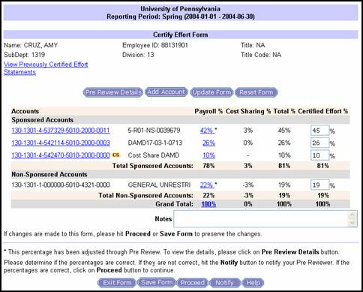
The certifier has the option of selecting “Pre Review Details” to see the effort report form that was reviewed by the assigned department pre-reviewer. (SEE EXAMPLE BELOW)
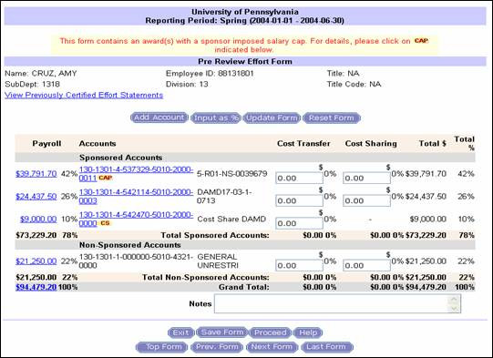

Additionally the certifier also can drill down to review their payment distribution details by selecting any individual payment, or choosing to select the total payment. (SEE DETAILS BELOW)
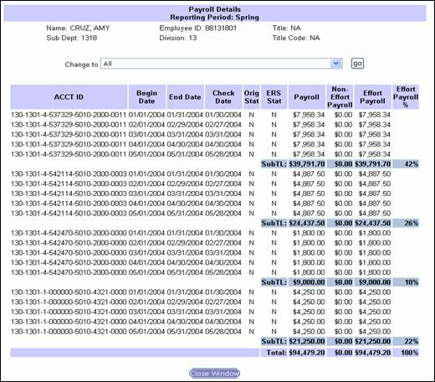
The certifier has the option of selecting “Pre Review Details” to see the effort report form that was reviewed by the assigned department pre-reviewer. (SEE EXAMPLE BELOW)

Additionally the certifier also can drill down to review their payment distribution details by selecting any individual payment, or choosing to select the total payment. (SEE DETAILS BELOW)
The certifier has the option of selecting “Pre Review Details” to see the effort report form that was reviewed by the assigned department pre-reviewer. (SEE EXAMPLE BELOW)

Additionally the certifier also can drill down to review their payment distribution details by selecting any individual payment, or choosing to select the total payment. (SEE DETAILS BELOW)
The certifier has the option of selecting “Pre Review Details” to see the effort report form that was reviewed by the assigned department pre-reviewer. (SEE EXAMPLE BELOW)
Additionally the certifier also can drill down to review their payment distribution details by selecting any individual payment, or choosing to select the total payment. (SEE DETAILS BELOW)

Reviewing and Changing Preprinted Effort Percentages
ERS displays the percentage of an individual's salary expense distributed to each sponsored project during the reporting period. This includes research projects, training grants, fellowships, career awards and all other sponsored projects are grouped together on the upper portion of the effort statement. Displaying the actual distributions is intended as a guide for completing the report.
The principal purpose of the effort reporting process is to determine whether the percentages as distributed are correct and to capture any necessary changes to the percentages to provide a reasonable estimate of actual effort. Changing the percentages as they appear when they do not substantially reflect actual effort expended is not only permitted but is required.
Changes to the effort percentages displayed can be made in the Pre-Review mode by the Pre-Reviewer or by the Certifier on the effort form. Changes to the effort percentages by the Certifier will send the effort form to the Post Reviewer where the differences will be resolved either through a cost transfer or by capturing cost sharing on a project.
Changes to effort forms may be made any time during the 45 business days of an effort reporting period, unless salary cost transfers have been made to adjust an individual’s effort. Once a cost transfer has been made, no further adjustments to that individual's distribution of effort are allowed, unless by exception. After the 45 business days have elapsed, the certified forms are archived by Research Services, removing the forms from current activity. The certified forms may be accessed through the reporting feature in ERS.

Effort Reporting of Individuals Subject to Salary Caps
By law, NIH may not reimburse salaries under NIH awards at an annual rate that currently exceeds federal Executive Level I. Section 16; Detailed Effort Reporting contains instructions and examples on the proper reporting of effort for those individuals affected by the NIH cap. Other sponsors, such as the Commonwealth of Pennsylvania, for certain awards, impose a salary cap consistent with that of the NIH.

Reporting Mandated and Voluntary Committed Cost Sharing
Mandatory and voluntary committed cost sharing (see Sponsored Project Policy No. 2119) must be reported on the effort form. This is effort which is either required by the terms of the award (mandatory) or voluntarily committed in the proposal by the principal investigator and is not reimbursed by the sponsor. This unfunded effort is considered cost sharing. In accordance with ORS Procedures for Cost Sharing and In-Kind Matching Requirements for Sponsored Projects, a separate fund will be established to account for Mandatory and Voluntary Committed Cost Sharing. The effort report form will display the percentage of salary charged to these cost share funds during the effort reporting period. Assuming that the principal investigator was working on the project during the entire reporting period, the percentages on the form should correspond to the amount of effort committed to the project.
For example, a faculty member formally commits 50% of his or her total effort in a sponsored project proposal, but the award is to be charged for only 25% of his or her salary. The effort report would list the 25% charged to the sponsored project fund, and in addition, the 25% charged to the cost share fund, if the project dates coincided with the effort reporting period. The actual printed percentages would vary depending on the performance period of the project.

Effort Percentages Must Total 100%
All University-compensated effort must be accounted for and the sum of the individual effort categories must equal 100%. The fact that a salaried individual may work more than a normal 35- or 40-hour week does not alter this rule. For example, an individual who spends 40 hours a week on sponsored research and 40 hours a week on clinical activity would report an effort percentage of 50% for each category, totaling 100% effort for the report period.

Penn’s Effort Reporting System
ERS is a role based system. A Central Administrator (CA) initiates each effort reporting cycle and provides the Help Desk Support. A Departmental Coordinator (DC) is assigned to each Org where effort reports are generated and is responsible for assigning pre-reviewers and certifiers for each form, and for ensuring that the effort reports are completed on time. The Pre-Reviewer is responsible for reviewing the effort report for accuracy before forwarding a form to a certifier. The Certifier applies their electronic signature to the form when they believe it to be accurate, and the form only goes to a Post Reviewer for resolution if the certifier adjusts the pre-reviewed effort. Detailed descriptions of these roles are available on the ORS web site under “Effort Reporting”.
At the end of each reporting period, the payroll distributions are initiated into ERS. A notification is sent to all the Departmental Coordinators in advance of initiation listing the dates that the effort reports will be available in ERS, and also the last date that a cost transfer can be processed prior to initiation of the effort reports. This information is also listed on the Comptroller’s Office web site under Payroll and on the ORS web site under Effort Reporting.
http://www.upenn.edu/researchservices/effortreporting.html

ERS Reports
There are various reports available in ERS. There are completion reports, exception reports and administrative reports. To print a copy of a certified form, select Administrative Reports, Print Certified Statements, select the period and choose either an individual or the entire department to print.

Roles and Responsibilities
The Departmental Coordinator is responsible for reviewing the assignments of the pre-reviewers, post reviewers and certifiers to make sure they are appropriate, and to change assignments if necessary, and to ensure that the effort reports are completed within the 45 business day policy.
The Pre Reviewer is responsible for assisting the certifier in understanding their effort report and to perform adjustments to payroll when necessary. They are required to review effort reports for individuals assigned to them for accuracy and forward the effort report to the certifier by selecting “Proceed” after the review process is complete.
The Certifier is responsible for reviewing the effort report form to make sure the percentages correctly represent the employee’s effort based on the salary charged to the award, and to change the percentages if they are incorrect.
The Post Reviewer is responsible for reviewing and resolving changes made to a pre-reviewed effort report by the certifier.
Detailed descriptions of these roles in ERS are available on this web site under Effort Reporting.

Guidelines for Cost Transfers

Overview
A cost transfer is a direct charge expense transferred from one university account to another after the charge has been posted to the General Ledger (BEN Financials). Transfers of expenses from a sponsored project fund to an unrestricted University account may occur when such expenses are determined to be unallowable. Since costs must be charged to sponsored projects funds accurately and according to applicable rules and regulations, transfers of original transactions should not be necessary.
In rare circumstances, charges must be moved from one sponsored project account to another. In such instances, cost transfers are allowable with proper justification and approval by the Principal Investigator (PI).

Allowable Cost Transfers
To be acceptable, cost transfers into a sponsored project fund must meet the following criteria:
- Occur in a timely manner (i.e., in the case of an erroneous charge costs should be transferred as soon as the error is discovered but not later than 90 days after month end in which the expense was incurred. See Sponsored Projects Policy No. 2113).
- Are allowable under sponsor and University policies
- Adequately describe the purpose of the entry, including an explanation of the reason for the entry and documentation of PI approval

- Are necessary to appropriately allocate expenses to a correct fund

Types of Allowable Cost Transfers

Errors/Corrections
Costs can be transferred for the following reasons:
  - To correct clerical or accounting errors, such as transposition of numbers; however a specific reason must be given: “correction of clerical error” is insufficient
  - Amend charges posted to wrong fund by service center providers
  - Resolve any misunderstanding of instructions from the PI
Such transfers must be documented with a full explanation of how the error occurred and a correlation of the charge to the fund to which the cost is transferred. Documentation must be retained according to Sponsored Projects Policy 2132 and should include the following information and any other pertinent details:

  - Provide a description of why the error occurred. Do not use the terms "to correct an error" or "to charge the correct project." Fully explain the circumstances of the error.
  - Correlate the expense item to the project to which the cost is being transferred, and if transferred to a sponsored projects account, explain how the cost benefits the project.
For further information on processing Journal Entries in BEN Financials, see http://www.finance.upenn.edu/benknows/browse_topics/journals.shtml.

Transfer of Unliquidated Items

If unliquidated obligations were reported on a FSR and remain outstanding as an encumbrance, the obligations should be paid within 90 days and charged to the old fund number. An item-by-item journal entry must be made to the new fund. This is necessary to create an appropriate audit trail.

Journal entries are necessary to transfer the expense of items encumbered in a prior year fund number and which appear as an unliquidated obligation (not posted to the fund) in the financial report. When these items are expensed they must be transferred into the subsequent year fund number. A description of the purpose of the entry and an explanation of the reason for the entry must be provided in the journal entry.
For other federal grants that are incrementally funded, the reporting of unliquidated obligations can vary from sponsor to sponsor. This does not change the liquidation requirement. Under these circumstances, ORS will report the items as required by the terms of the award.

Transfer of Costs to a Continuation Year of a Project
To avoid unnecessary cost transfers between continuation years of a project, an Advance Account should be requested from Research Services. Establishing an Advance Account eliminates the need for cost transfers when the award is finally received.

Unallowable Cost Transfers

Funds in Overdraft Status

The transfer of charges from a fund in overdraft status to a federal award (including federal awards passed through another sponsor) is expressly unallowable in accordance with
OMB Uniform Administrative Requirements, Cost Principles and Audit Requirements for federal Awards, Part 200.405(c). This section specifically states that “…any cost allocable to a particular Federal award under the principles provided for in this Part may not be charged to other Federal awards to overcome fund deficiencies, to avoid restrictions imposed by Federal statutes, regulations, or terms and conditions of the federal awards, or for other reasons.”
This includes any amount charged in excess of the federal share of costs for the project period (competitive segment).

Transfers of cost from one project to another or from one competitive segment to the next solely to cover cost overdrafts are not allowable. Costs allocable to a new competing segment should be charged to an Advance Account in anticipation of the award.

Regardless of sponsor, costs may only be charged to projects benefiting from that expense.

Funds Terminating with Unexpended Balances

In accordance with the requirements of OMB Uniform Guidance, costs must be allowable, allocable and reasonable/necessary. Therefore, costs should not be transferred to an account with an unexpended balance during the last months of a project simply to deplete the balance of funds.

Timeliness of Cost Transfers
It is important that cost transfers occur as soon as an error is discovered, but not later than 90 days after month end (see Sponsored Projects Policy No. 2113). If the transfer must be made after 90 days, the reason for the delay must be documented. In no instance may costs be transferred after the Grant and Contract Fund Closeout Adjustment Period, without the prior approval of Research Services.

Restricted Transactions:

F&A and Employee Benefits Adjustments
These entries are to be made by Research Services ONLY.

Transfer of Fund Balances
These entries are to be made by Research Services ONLY.

Object Code #4820 or #4920.
NEVER use these object codes for transferring costs to or from a sponsored project.

Project Reporting

Overview
Certain prescribed actions are required to ensure the orderly administration and timely reporting/closeout of a grant or contract. While these requirements vary by sponsor, the following are necessary for most projects:
- Technical/Programmatic Report (Interim and Final)
- Report of Inventions (Interim and Final)
- Final Inventory of Equipment
- Financial Report (Interim and Final)
  - For further information, see the section on The Close-out and Final Reporting Process
- Audit
- Record Retention

Relevant Sponsored Projects Policies
The following Sponsored Projects Policies are of direct relevance to the reporting of sponsored projects:

2126 Interim & Final Financial Reports
2130 External Audits, Reviews, Inquiries and Investigations
2132 Record Retention

The responsibility for preparing and submitting all interim and final financial reports rest with the ORS, however, timely reporting requires the assistance of the principal investigator and business administrator through their input prior to the point that the report is prepared. It is important to note that the principal investigator is ultimately responsible for management of the fund and, as such, must ensure that all expenses charged are accurate and allowable under the terms of the award.

Technical Reports
Most grants and contracts require the submission of a final report of the research accomplished during the period of performance. Some sponsors also require the submission of interim reports. Such reports may vary from a brief summary and list of publications to a complete compilation of the project and its results. The specific requirements are stated in either the award document, or, in the case of many grants, in a policy manual referenced in the award. It is the PI's responsibility to prepare and submit the technical/programmatic reports to the sponsor. ORS does not require a copy of the final report, but does require a signed and dated copy of the transmittal letter to document submission of the report for audit purposes. The NSF mandates the submission of technical reports via FastLane. In this case, the submission date is directly available to ORS through FastLane.

Report of Inventions

Most sponsors require that discoveries and inventions be disclosed to the sponsor upon conception or reduction to practice. Many sponsors require reports of inventions at regular intervals, generally annually. The PI is responsible for adhering to a sponsor's invention reporting requirements and the University’s policies regarding the disclosure of inventions (Intellectual Property Policies).

At the completion of a project it is often necessary to certify whether or not an invention has been made during the course of the project. ORS or the sponsor will notify the PI when invention reports are required. However, it is the responsibility of the PI to report an invention to the Penn Center for Innovation at the earliest possible time to avoid premature public disclosure.

Final Inventory of Equipment
All federal contracts and many grants require a final inventory of equipment purchased, fabricated or furnished by the sponsor during the period of the project. Non-federal sponsors may have other requirements, and the PI is responsible for adhering to individual sponsors' reporting requirements.

Interim Financial Reports
Interim financial reports may be required by the sponsor. The award notice will provide such instructions. The General Ledger Attribute Record will also designate that an interim report is due.
For grants specifically included under provisions of the Streamline Non-Competing Award Procedures (SNAP), NIH does not require interim Financial Status Reports (a final financial report is required). NSF does not require interim financial reports nor does it require final financial reports. (The NSF may require interim reports for cost sharing.) Monitoring of expenditures requires active grant management throughout the life of the award. For further information, see the section on Financial Reporting.

Final Financial Report
ORS is responsible for preparing and submitting all final financial reports and final invoices where required. However, the PI and his or her department and school play a vital role in assuring that the report (and final invoice, if necessary) is accurate and submitted on time. In addition, for awards with required cost sharing an accounting of the cost shared amounts will need to be provided. For further information, see the section on The Close-out and Final Reporting Process.

Audit
If a sponsor requests an audit of an award, the sponsor or its designee must perform or provide the audit at its expense. Research Services must be immediately notified when a sponsor plans an audit and will provide reasonable assistance during the audit. Costs disallowed as the result of an audit are the responsibility of the department and/or school. ORS will coordinate with the department the submission of a revised final invoice and/or FSR, if required as the result of an audit outcome.
A certified public accountant performs a financial audit of the University’s accounting records annually. The audit includes a review of federal sponsored project accounts, as well as University compliance with federal regulations. This audit is conducted in accordance with OMB Audit Requirements for Federal Awards (2 CFR Part 200, Subpart F) and should satisfy most federal audit requirements. ORS responds to all inquiries during this audit, however, a department may be called upon to participate in the audit as necessary and appropriate.

Departments may also be involved in internal audits conducted by University of Pennsylvania staff auditors. These audits serve a multitude of purposes. Further information regarding these types of audits can be obtained at http://www.upenn.edu/oacp/audit/audit101/audit-process.html . If any costs are deemed unallowable as a result of one of these audits, they must be removed within 90 days of notification.

Record Retention

In general, the record retention requirements of sponsors (usually 3 yrs for federal sponsors) do not begin until the last financial report is submitted. However, for certain sponsors, i.e., NSF the record retention requirement does not end until 3 yrs from the date the technical report is submitted. Notwithstanding sponsor record retention requirements, the University record retention policy may require longer retention times. See Sponsored Projects Policy No. 2132 for further information.

Audits

Overview
When the University accepts funds from outside organizations for research and other activities, those organizations presume the University will expend the funds for the purposes for which they were given and in accordance with any terms and conditions set forth in the award document. Similarly, the federal government has an obligation to the taxpayers to assure that recipients of federal funds are providing proper stewardship of those funds.
The University's sponsors generally reserve the right to audit the University financial records for sponsor awards and, in some cases, may audit the project's scientific records and data. This section on "Audits” addresses only financial audits by the federal government, since they are the most common audits to which the University is subjected. Other sponsors, however, can and occasionally do perform various audits. Typically, these audits will be of the awards themselves.
If the PI or the department is contacted directly regarding any type of audit, ORS should be informed immediately. For additional information, please see Sponsored Projects Policy No. 2130.

Pre-Award Audits
Occasionally, the federal government will require an audit before the issuance of an award. Such pre-award audits generally involve responses to federal Requests for Proposals that will result in the issuance of a contract that is more than $500,000 per year. These audits may be performed as desk audits at the sponsoring agency, or in rare circumstances, the federal auditors will visit the University to review documentation supporting the proposed project costs.

Post-Award and System Audits
Federal audits are generally one of two types:
- Audits conducted by federal auditors, typically the cognizant audit agency assigned to the auditee -- the Department of Health and Human Services, in the case of Penn. Any federal agency can, however, audit its awards. These audits tend to be aggressive efforts to determine whether the University is managing grants and contracts in accordance with federal laws and regulations.
- Audits conducted annually by the University's certified public accountants, as required by the "Single Audit Act of 1984" and the Office of Management and Budget (OMB) Audit Requirements for Federal Awards (2 CFR Part 200, Subpart F)

Audit Request

Research Services is the focal point for the coordination and conduct of financial audits of sponsored programs (see Sponsored Projects Policy No. 2130). Upon notification of an audit, ORS will inform the Controller, the Office of Audit and Compliance, the department BA and the PI of the anticipated audit.

The BA must be available or will arrange to have someone available who has knowledge of program expenditures for the purpose of answering questions that may arise during the audit. The BA must also notify and/or arrange for the principal investigator or other individuals at the department or school level to be available for an interview, if so requested by the auditors.

Conduct of Audit - Entrance Conference

With notification to all parties completed, Research Services will confirm the start date for the audit with the sponsor.

The sponsor’s auditor will be instructed to meet with the Director, Post Award Financial Administration for an entrance conference. The PI and BA will be notified of the date, time and the place of the entrance conference.

An ORS representative will be assigned to act as the liaison between the auditors and all other University areas for the purpose of retrieving documentation and/or contact with department personnel. The liaison will be responsible for arranging contact with the PI, BA, or other University personnel. The auditor will be instructed to submit all information requests or other type of requests through the designated ORS representative and is not permitted to schedule meetings or to meet with University personnel without first consulting with ORS. During the review, the liaison will escort the auditor(s) to other administrative areas to be visited.

Documentation Requests

The auditor must provide a list of required documentation identifying each transaction to be reviewed. During the audit, the designated ORS representative will provide explanations and documentation in support of claimed costs. If additional information or further explanation is necessary, the BA may be called upon to provide sufficient documentation or adequate explanation to preclude adverse findings or cost disallowances.

Exit Conference and Audit Reports

The PI and BA will be notified of the date, time and the place of the exit conference and will be requested to be present. During the exit conference, the ORS representative will review the findings and recommendations with the sponsor’s auditor and will seek a full description of the exceptions, disallowances or adverse findings. The ORS representative will attempt to correct or eliminate misconceptions or misinterpretations.

Audit reports that contain findings are usually forwarded by the sponsor to ORS. A copy of the audit report should be made available to the PI and the BA. When necessary, the PI and BA will be called upon to address findings of the audit. Cost disallowances cited in the audit report and which cannot be refuted must be funded from a source other than a sponsored projects account. The direct cost portion of the total disallowance will be funded by a charge to the applicable object code of the ledger account (funding source) with a corresponding credit to applicable object code in the sponsored projects fund account.

Challenges to a disallowance or finding must be addressed by the PI within fifteen (15) days of receipt of the audit report. Documentation and/or a certified explanation to discredit or mitigate the finding will be forwarded to the ORS representative who will ensure that all relevant information is transmitted in a timely manner to the appropriate agency or responsible person.

In the event that the department concedes the disallowances or the challenge is otherwise unsuccessful, ORS will work with the department to arrange for a suitable method of reimbursement of the disallowed costs.

Audit Findings and Resolution
When the audit is completed, the auditors issue a report identifying their findings. Such findings may range from comments on the adequacy of the University's systems for ensuring good grants management to specific disallowances of costs deemed improper. In many cases, the federal agency will extrapolate findings from a small audit sample to the entire expenditure universe, resulting in large dollar findings. While the University vigorously negotiates with auditors over the appropriateness of their findings, sometimes it is necessary to repay previously expended funds.
For further reference, see OMB Audit Requirements for Federal Awards (2 CFR Part 200, Subpart F) , Sponsored Projects Policy No. 2130: External Audits, Policy No. 2131: Compliance with Subrecipient Standards of OMB Uniform Guidance and Policy No. 2135: Monitoring of Subrecipients not Subject to OMB Uniform Guidance, all of which are in the University's Financial Policy Manual.

Accounting Procedures for Non-Federal Sponsors and the F&A Costs of Sponsored Projects

According to Sponsored Projects Policy No. 2116, commercial entities are expected to reimburse the University at the full federal negotiated research rate.

There are many foundations and associations that are willing to pay the direct costs of a project and also a reasonable share of the administrative costs associated with their funded project. In order to enable schools and centers to more fully recover the costs associated with the conduct of research, the University has instituted a series of procedures to enable recovery of some of these costs. The procedures below are designed to provide consistent charging and accounting practices for certain direct and F&A costs or supporting expenditures to non-federal grants.

Dependent Tuition Charges for Projects with Non-Federal Sponsors

The University will charge the dependent tuition benefit cost (currently 2.3% of full time EB-bearing salaries) to all awards from non-federal sponsors. These costs must be built into the budgets. Applications to non-federal sponsors must budget the dependent tuition benefit.

Full Federal F&A Rate for Projects Sponsored by Commercial Entities

The full federal research rate is expected on all proposals to commercial sponsors. This is consistent with the University’s policy on F&A cost recovery (Sponsored Projects Policy No. 2116), which specifies that all projects should pay the University’s appropriate negotiated F&A rate, while making exceptions for non-profits.

New Options for Projects Sponsored by Foundations and Associations
Recognizing Foundation and Association’s traditional reluctance to pay “full overhead”, reimbursement for the following items of cost that are normally precluded from Federal reimbursement must be requested. These items of cost are identified in Sponsored Projects Policy No. 2138.

Direct Costs for Projects Sponsored by Foundations and Associations

Where the following items of cost can be specifically identified to a project, they should be budgeted as direct costs:

School and Departmental Administrative Costs
- Administrative costs and clerical salaries
- IT support costs
- Telephone line charges
- Ethernet Connections
- Office Supplies

Subaward Costs
- Use Object Code 5332 for total subaward costs (the “greater than $25,000” exclusion will not apply to non-federal sponsors)

Space Used by the Project
- Lease Costs

Protocol Specific and Research Infrastructure Charges
- Protocol preparation fees for clinical trials
- Pharmacy fees for clinical trials
- IRB and IACUC fees
- Environmental Health and Radiation Safety fees for waste disposal and radiation safety tests

F&A Costs for Projects Sponsored by Foundations and Associations

Charges for School and Departmental Administrative Costs

If specific school and/or department costs for a project cannot be precisely quantified (and thus charged directly), then one may be able to negotiate a reasonable reimbursement of the project’s fair share of these school and departmental administrative costs. Object Code, 5298 has been established for this purpose.

How to Calculate:
Add together the project’s appropriate fair share of salaries, EB, telephone and Ethernet charges, office supplies, IT support and related costs. Note: When an employee’s effort is more than 5% on a project, it should be direct charged. Salaries and benefits should be included as an F&A charge only when the effort is 5% or less. Document the calculation for the above items of costs and the method used.

How to Post:
Debit the project in Object Code 5298 for School and Departmental Administrative Costs and credit the school’s general unrestricted fund (the 000000 fund) in Object Code 5511. These charges should be posted monthly.

Cost of Space Used by the Project
If the project is the sole occupant of leased space, then the lease should be built into the project budget as a direct cost using the standard Object Code, which is 5250 for leased non-University space.

If the project shares leased space with other projects, one may be able to negotiate a reasonable reimbursement of the project’s fair share of the lease cost as an F&A cost. A new Object Code 5297 has been established for this purpose.

If the project occupies University space, for which the Operations and Maintenance and Facilities Renewal costs are allocated to the schools as part of “allocated costs” then the sponsor may be willing to include a reasonable reimbursement of the project’s fair share of the space costs as an F&A cost. Object Code 5295 has been established for this purpose.

How to Calculate:
Determine where the project will be conducted and make a reasonable estimate of the net square footage needed. The Budget Office will supply to Senior Business Officers on an annual basis a schedule showing the space the school occupies and the cost per square foot for each building. Document the calculation for the above items of costs and the method used.

How to Post:
Debit the project in Object Code 5295 for the project’s share of University space or in Object Code 5297 for the project’s share of leased space and credit the school’s general unrestricted fund (the 000000 fund) in Object Code 5511. These charges should be posted monthly.

Charges for the Project’s Fair Share of the University Services
In a very few cases, where a single large project is a significant portion (greater than 5%) of the entire school’s total activity, it may be appropriate to negotiate with the sponsor a reasonable reimbursement of the project’s fair share of the school’s portion of University Services allocated costs. Object Code 5296 has been established for this purpose.

How to Calculate:
The Budget Office will assist schools in making the following calculations. At the time of proposal, estimate the project’s and the total school’s expected Total Direct Costs (TDC) used in the University Services allocation, and the school’s expected University Services Allocated Cost Charge (or that proportion of University Services that the sponsor will agree to pay) to estimate the project’s fair share of the school’s University Services charges for each year of the project period. Use the amount in the proposal, and for the first year of the project.

Annually during the life of the project, calculate the project’s actual cumulative project share of school TDC, and the actual cumulative University Services costs (or that proportion the Sponsor is paying) and project these amounts for the rest of the project. Recalibrate the charge to adjust for changes in the project’s share of the School TDC, changes in the School’s University Services costs, and any amount previously over or under recovered.

How to Post:
Debit the project in Object Code 5296 for the project’s share of University Services costs and credit the school’s general unrestricted fund (the 000000 fund) in Object Code 5511. These charges should be posted monthly.

Questions on charging costs not described above or for clarification of the instructions should be directed to Susie Won in the Office of Research Services or Fran Seidita in the Office of Budget.

Establishing a University Purchase Order for Subrecipients

General Guidelines

This Section provides detailed instructions for completing a BEN Financials requisition and resulting purchase order for sponsored project subrecipient services. These instructions are current as of the revision date. Users of BEN Financials should always rely on formal guidance documents and help provided for this system. BEN Financials requisitions and the resultant purchase order will facilitate payments. Any questions pertaining to the establishment of a BEN Financials requisition should be directed to the appropriate end user support. Questions pertaining to the subrecipient agreement should be directed to the Office of Research Services (ORS). ORS wishes to acknowledge the work of Merceda Lafferty, Peggy Ann Molli, Helen Sivieri, and Lucy Tate in the School of Medicine’s Department of Medicine, and Paul Weidner of the Financial Training Department for the procedures described in the following sections.

- When completing the requisition follow standard University BEN Financials procedures and, where indicated below, use the specific instructions provided.
- Time periods on the subaward requisition must correspond to the dates specified in the subaward agreement terms, usually the budget period, and are not constrained by the fiscal year of the University.
- Period of performance included on an invoice dictates the appropriate budget period, and therefore the appropriate PO and COA, of the subaward from which the invoice is to be paid.
- Review Sponsored Projects Policy Nos. 2116 and 2138 regarding the appropriate negotiated F&A rate, and direct cost expenditures for non-federal organizations, respectively. For the proper charging of F&A costs on the full amount of a subaward from a non-federal prime sponsor see Section on Accounting Procedures for Non-Federal Sponsors and the F&A Costs of Sponsored Projects.
- The terms and conditions of the University’s award will determine the invoice and reporting requirements pertinent to the subrecipient. For example, sponsors may require that invoices from subrecipients be itemized and presented in a particular format. In addition, the University and its sponsors require verification of work performance. All invoices for subaward activities will require a BEN Financials receipt. Please contact ORS if you have questions about the sponsor’s invoice requirements. The individual who processes the BEN Financials receipt is responsible for ensuring that any such invoicing requirement is met.
- The PI must verify that the subrecipient’s performance is satisfactory and the funds are being used for their authorized purposes. In doing so, the PI is required to review and approve all technical and financial invoices provided by the subrecipients. See Sponsored Projects Policy Nos. 2131 and 2135.
- Changes in the prime award to the University may necessitate modifications to a subaward. In those cases, ORS will issue a modification to a subaward if any of the original terms and conditions change. Contact ORS with any questions or concerns.
- Business administrators must not execute purchase orders for subawards without authorization from ORS.
- Once a subcontract purchase order has been fully invoiced and the check has been mailed to the subcontractor, the purchase order should be finally closed, whether or not it is fully expended.

New Subawards
ORS will send a subaward to the participating organization. Upon receipt of a fully executed subaward, ORS will forward a copy to the business administrator with instructions to execute a purchase order (initiated via a requisition). The signed subaward will indicate the supplier (subrecipient), supplier site, sponsored program award reference number, time period covered, dollar amount, and Principal Investigator (for both the University and the subrecipient organization).

Identifying Supplier Information in BEN Financials
The business administrator should verify that the necessary Supplier (Subawardee) information is in the BEN Financials supplier database. From the BEN Financials home page, choose Requisitioner. See screen shot below:
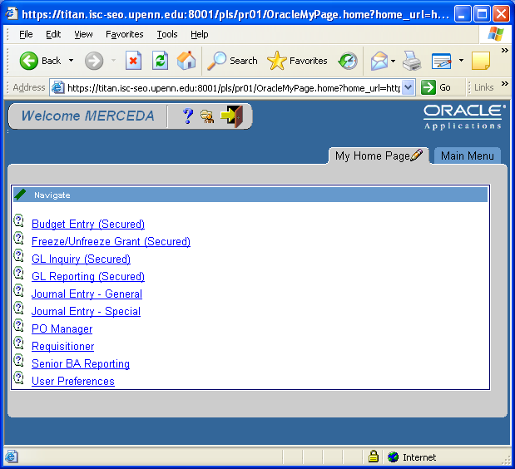
Then choose ‘Supplier List’ in the next screen:
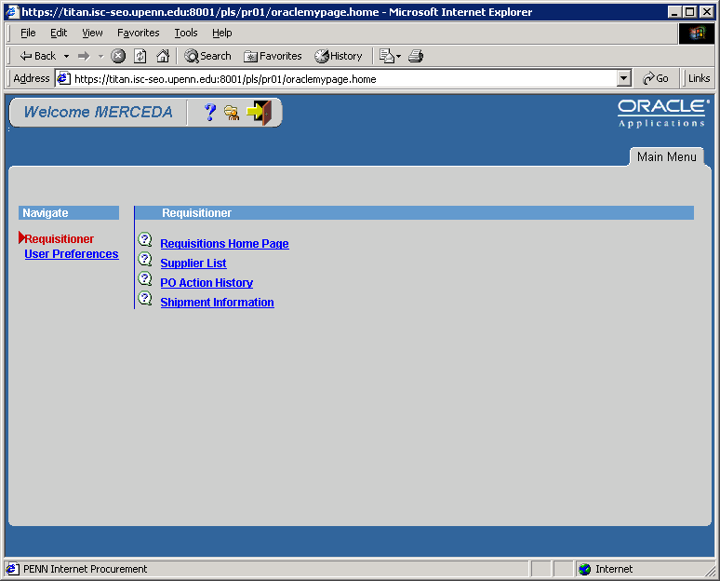

In the next screen, using the drop-down menus available after each parameter, search for the Supplier. Usually, ‘supplier name’, ‘starts with’ or ‘contains’, and part of the subrecipient’s name will provide adequate information to complete the search. Use all upper case letters and wildcards (%) before and after to bring back the most results.

After clicking [Search] and locating the supplier, click on the Y of the appropriate line in the PO Sites column. The following screen will display the address(es) and fax number(s) to which POs are faxed. If the supplier and/or the correct site are not included in the database, submit an on-line ‘Request for a new BEN Buys Supplier’ to the Purchasing System Administrator to add the supplier or site information into the system. This form is available on Purchasing Services’ website at http://www.purchasing.upenn.edu/buyinfo. Without the correct supplier and site information, the requisition for subrecipient services cannot be processed.

Entering the Subaward requisition

Tip: Limit one subaward per requisition

Tip: Only end users with PO Manager end user responsibility should create and submit requisitions for subawards.

Tip: If the initial year of a subaward on a federal project exceeds $25,000, then a two-line requisition must be created. The first $25,000 will be on line 1 of the requisition; and the balance, exceeding $25,000, will be on line 2 (much like ordering red pens on one line, and green pens on the second line).

Tip: Use object code 5332 for total subcontract costs for non-federal projects (commercial entities, foundations and associations) AND for federal projects up to $25,000. For subawards on non-federal projects (using the above analogy), you will only order red pens on one line and no green pens.

Tip: Because lines may be re-sorted when the requisition becomes a purchase order, adding an a., b., etc., at the beginning of the line description on a multiple-line, non-catalog requisition will keep the lines in the same order. This is important so that, when invoices are ‘matched’ by Accounts Payable, F&A costs are charged in the appropriate manner.

Tip: Use object code 5333 only for federal projects AND only after a cumulative $25,000 threshold per subrecipient on federal projects is reached. This threshold pertains to each project period (typically multiple years) and not to each budget period (which is typically no more than one year).

Non-catalog request
Item Type: Services/Maintenance
Category: SERVICES.SUBCONTRACTS
Item Description: The MM-DD-YY for final itemized invoice should be 45 days before the final report due date, or as indicated on the signed agreement. Use the exact language as written below:
“a.) Allocation set forth in award document issued by SPONSOR NAME for research services related to SPONSOR AWARD NUMBER [not Penn fund number]. Final itemized invoice must be received by the University of Pennsylvania no later than MM-DD-YY.”
Unit of Measure: Type US Dollar
Quantity: Dollar amount, or part thereof, of the subaward on a federal project to be charged F&A costs (via object code 5332). (F&A cost reimbursements on federal projects are limited to the first $25,000 of the subaward; contact ORS if questions arise.)
Rate per Unit: Enter the number 1.
Supplier Part Number: Leave blank.
Supplier Name: As indicated on the signed agreement.
Supplier Site: As indicated on the signed agreement.
(When multiple addresses are available for the same supplier, be sure to choose the correct supplier site when creating the requisition.)

Add to Cart [click]

A second non-catalog request will be required if the amount of the subaward will or has already exceeded the amount to be charged for F&A costs.

Return to Shopping [click]

Create Non-catalog Request [click]

Repeat the steps above from ‘Item Type’ with the following exceptions:

Item Description: The MM-DD-YY for a final itemized invoice should be 45 days before the final report due date, or as indicated on the signed agreement. Use the exact language as written below:
“b.) Allocation set forth in award document issued by SPONSOR NAME for research services related to SPONSOR AWARD NUMBER [not Penn fund number]. Final itemized invoice must be received by the University of Pennsylvania no later than MM-DD-YY.

Unit of Measure: Type US Dollar

Quantity: Dollar amount, or part thereof, of the subaward not to be charged overhead (via object code 5333). (F&A cost reimbursements on federal projects are limited to the first $25,000 of the subaward; contact ORS if questions arise.)

Rate per Unit: Enter the number 1.
Supplier Part Number: Leave blank,
Supplier Name: As indicated in the signed agreement.
Supplier Site: As indicated in the signed agreement.
(When multiple addresses are available for the same supplier, be sure to choose the correct supplier site when creating the requisition.)

Add to Cart [click]
Check out: Click [Proceed to checkout]

There are multiple screens in the checkout process. These include: Delivery, Billing, Notes, Approvers and Review & Submit, and are depicted in the screen shot below:

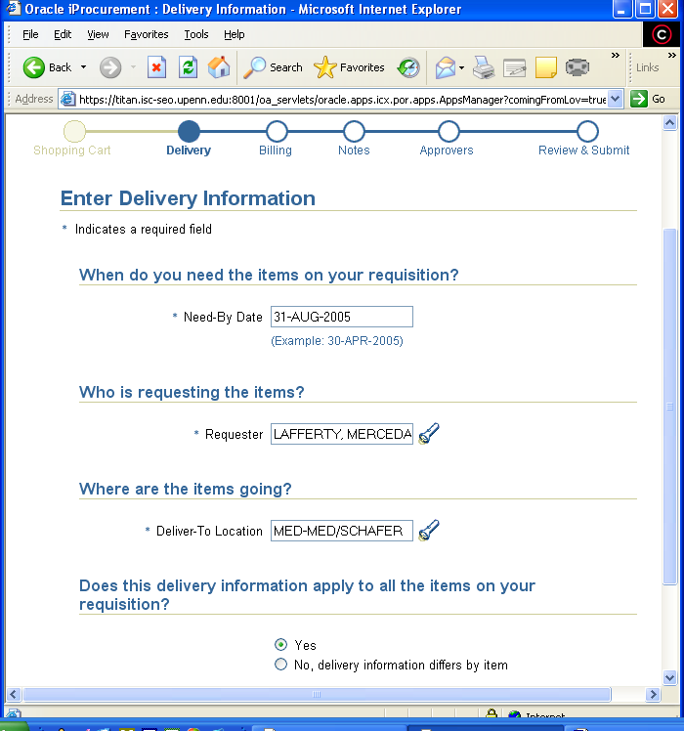

To determine the stage of checkout, simply refer to the Progress Indicator at the top of the screen. In the above case, the checkout is in the Delivery stage.

Delivery page of checkout:
Need by Date: Change to last day of period covered by subaward as indicated in the signed agreement.

Deliver-To Location Change to principal investigator’s location.

Receipt required: POs $5,000 or more will automatically require a receipt. If the total amount of the subaward is less than $5,000, the Purchase Order must be marked “Receipt Required.” Click the ‘No, delivery information differs by item radio button’; click the box in the “Receipt Required” column as shown below. Check the Receipt Required box if total amount of subaward PO is less than $5,000.

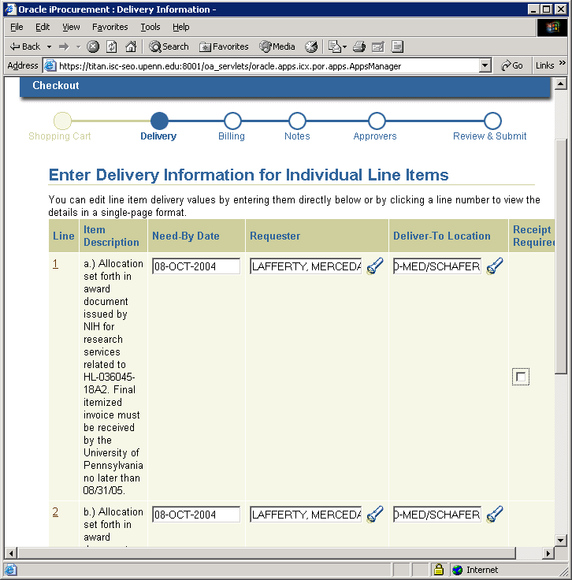

Tip: In the event you need to enter this screen and manually
select ‘Receipt Required’, you will also need to re-enter the Deliver-To Location (remember, you previously clicked ‘No, delivery information differs by item’, so the system pre-populates the screen with your default deliver-to).

Billing page of checkout:
University Contact: Change to the departmental business administrator indicated in the subaward agreement.
Click [Continue]

Click in one of the charge account fields to open and edit.
Enter COA combination.

DO NOT click the ‘select multiple charge accounts’ hyperlink.
DO select ‘Apply this account to all requisition lines’ (This applies everything except the object code to all lines of the requisition). Use object code 5332 when F&A costs are allowable.

Click [OK]

Review charge accounts: Click in the charge account field representing the line of the order not to be charged F&A. Use object code 5333 when no F&A costs are to be charged (federal projects only). Review terms and conditions of non-federal subawards.

Click [Check Funds].

- If funds checking fails, click [Cancel], and check the following information
- COA combination for errors such as transposition of numbers or incorrect CREF
- If COA combination is correct, ensure the current year budget has been entered in the correct CNAC/ORG/Fund/CREF combination
- Ensure a budget has been entered up to PBUD
- When funds checking passes, click [Continue]

Notes page of checkout: You may find it helpful to add a requisition description in this screen. DO NOT “add notes/attachments”.
Click [Continue]

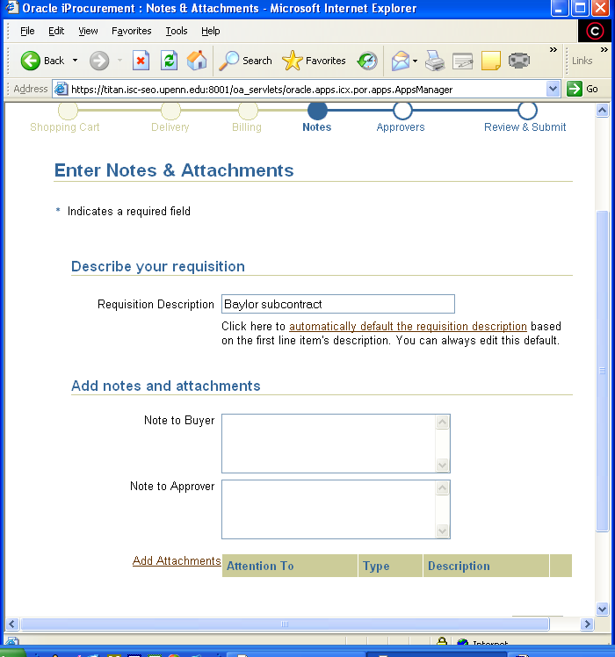

Approvers page of checkout:
Click [Continue] without adding approvers. All requisitions should be approved by PO Manager regardless of dollar amount. When the requisition is approved, resulting PO will route to appropriate party.
Review & Submit page of checkout:
In the ‘Items’ section of this page, there is a hyperlink to ‘View’ additional details of each line of the requisition.
Click [View] on the first line that appears;

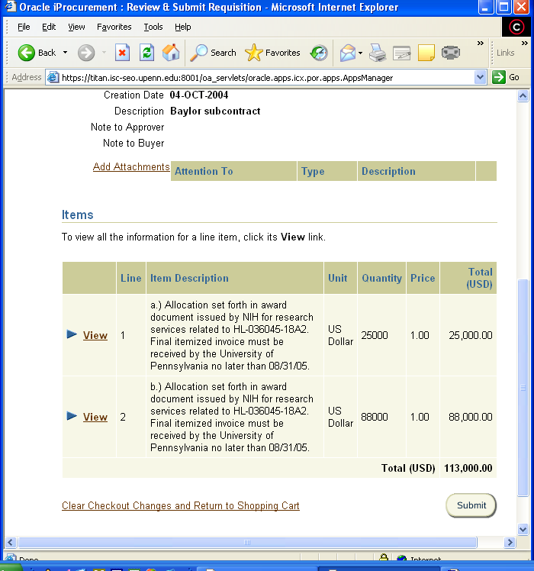

Scroll to the bottom of the next screen (screen shot shown below in two parts) containing the details of the selected line; (There are two ‘Add Attachments’ links on this page; you will pass an Add Attachments link below a blank Note to Buyer);

Immediately below the account number at the bottom of the page, click ‘Add Attachments’ link;

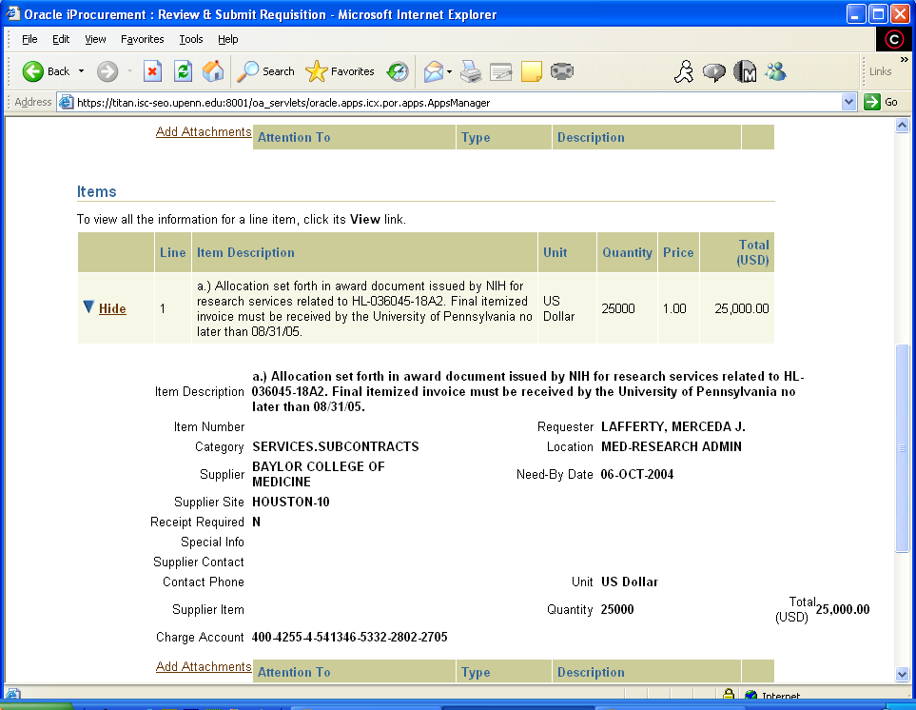
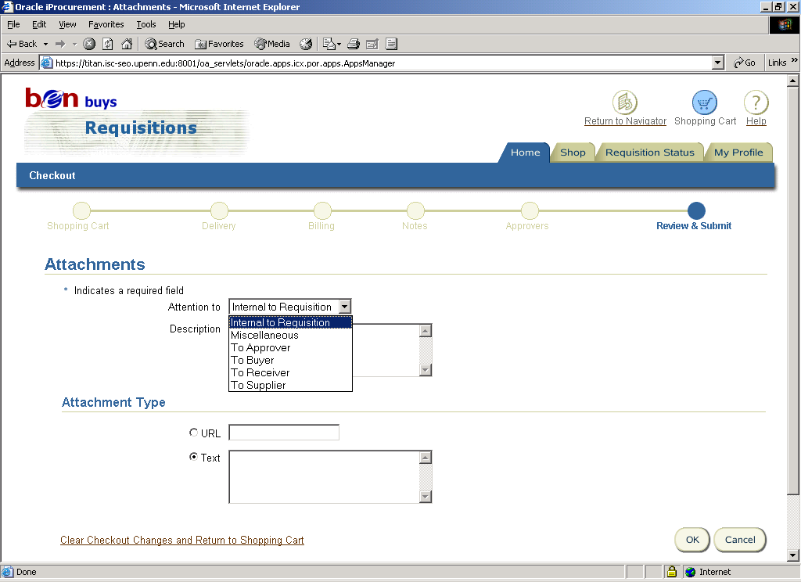
Description field is behind the drop down menu in this screenshot

Attach 4 NOTES for subaward requisitions:

NOTE 1:

Attention to: Miscellaneous (select from drop down menu)
Description: Type Bid waiver

In the attachment type, accept ‘Text’ and enter in the box to the right of text ‘Subaward, Competitive bids are not required’
Click [OK]

Again click ‘Add Attachments’ link immediately below the account number toward the bottom of the page;

NOTE 2:

Attention to: To Supplier (select from drop down menu)
Description: Type Terms & Conditions

In the attachment type, accept ‘Text’ and enter in the box to the right of text “Subaward in accordance with the terms & conditions of Agreement 5xxxxx (this is the Penn fund number), dated MM-DD-YY, covering the period MM-DD-YY to MM-DD-YY. Subaward of _________________ (PRIME SPONSOR NAME), __________________ (PRIME SPONSOR AWARD NUMBER) for __________________ (SUBRECIPIENT PI NAME).”

Refer to the signed agreement for the appropriate dates, sponsor name and sponsor award number.

Click [OK]

Again click ‘Add Attachments’ link immediately below the account number at the bottom of the page;

NOTE 3:

Attention to: To Supplier (select from drop down menu)
Description: Type PO/subaward conflict

In the attachment type, accept ‘Text’ and enter in the box to the right of text “Subaward service, in accordance with the terms and conditions of Subaward # __________________, dated ______________ (date the last person signed agreement) with an effective date of _______________ (first day of current budget period). In case of any conflict between the conditions of the purchase order and the subaward, the terms of the subaward shall take precedence.”

Click [OK]

Again click ‘Add Attachments’ link immediately below the account number near the bottom of the page;

NOTE 4:

Attention to: To Supplier (select from drop down menu)
Description: Type Invoice number
In the attachment type, accept ‘Text’ and enter in the box to the right of text “All invoices must reference PO number and display a unique invoice number.”

See Section 15.4.3 for two additional notes required in subaward requisitions when there is an increase in award amount in an existing subaward period.

Perform a final review of the requisition for accuracy and completeness

Click [Submit]

Requisition creation process will complete and will automatically begin requisition to purchase order creation process via the PO workflow administrator.

Approval Hierarchy
No special approvals are needed. Follow the purchase order approval process based on approval limit and approval hierarchy.

Subaward Changes

When changes in the University’s award impact a subrecipient or when the needs of the project require changes in a subaward, it is ORS’ responsibility to issue, when necessary, modifications to the subaward. Possible modifications include but are not limited to:

No Cost Extensions
Upon written request from the subrecipient, ORS will issue a modification to the subaward and inform the responsible University business administrator. If the University effects a No Cost Extension of its prime award, it may or may not extend the period of performance of the subaward (without additional funds). The decision to extend the subaward depends on the needs of the project and the terms and conditions of the University’s award. If a request to extend the subaward from the subrecipient’s PI and authorized official is approved by Penn’s PI and the University, the original purchase order remains unchanged and the subrecipient continues to invoice during the extension period under the original purchase order.

Reduction in Period of Performance and/or Subaward Amount
Upon written notification from the PI, ORS will issue a modification to the subrecipient and inform the Penn business administrator. It is important that the subaward agreement is revised to reflect the reduction because the terms and conditions of the subaward agreement will take precedence over the purchase order. Some business administrators choose to notify their counterpart in writing of a change in the expiration date and/or total dollar amount, indicating a modified/amended subaward agreement is being processed, and that a new purchase order number will be issued when the modification to the subaward agreement is fully executed (current BEN Buys functionality requires this step).

- The business administrator must review all payments against the original purchase order to ensure that all invoices and payments to the supplier have been processed by Accounts Payable. After payment has been made for all outstanding invoices, the business administrator should ‘finally close’ the purchase order.
- The modified subaward agreement should contain language regarding the reduced total amount of the modified agreement; the total amount of invoices that have been paid to date, if any; and a note that a new purchase order will be issued and may not match the revised total amount of the subaward agreement due to previously paid invoices, if any.
- A new purchase order is created in the reduced amount of the modified subaward agreement, less previously invoiced expenses.

Increase in Award Amount for Existing Subaward Period

Upon written notification from the PI, ORS will issue a modification to the existing subaward and notify the business administrator. The business administrator must create a new BEN Financials requisition for the increased award amount only. See detailed instructions for entering a subaward requisition included in this document in Section 15.3; incorporate the following two notes in addition to those detailed in section 15.3 during checkout:

NOTE 5:

Attention to: To Approver (select from drop down menu)
Description: Type Amendment to approver

In the attachment type, accept ‘Text’ and enter in the box to the right of text “This purchase order is a modification of University of Pennsylvania Purchase Order #XXXXXXX (PO numbers may be 6 or seven digits) Dated MM-DD-YY. Modification to Subaward Agreement to be sent under separate cover.”

Again click ‘Add Attachments’ link immediately below the account number towards the bottom of the page;

NOTE 6:

Attention to: To Supplier (select from drop down menu)
Description: Type Amendment to supplier

In the attachment type, accept ‘Text’ and enter in the box to the right of text “This purchase order is a modification of University of Pennsylvania Purchase Order #XXXXXXX (PO numbers may be 6 or seven digits) Dated MM-DD-YY. Modification to Subaward Agreement to be sent under separate cover.”

New Subaward for a New Budget Period
Business administrators need to create a new requisition and resulting purchase order for all new budget periods.

Continuation Funding Available:
When appropriate, ORS will issue a modification to the existing subaward agreement, extending the period and increasing the subaward. Upon notification by ORS, the business administrator will execute a requisition/purchase order for the new budget period’s award amount only.
If the award’s COA combination changes, the previous year’s purchase order should be ‘finally closed’ when the purchase order has been fully invoiced and paid. See section 15.6 for more information. A new purchase order should be established for services performed in the new budget period and for any remaining funds with approved carryover from the previous subaward agreement. Billing under a previous year’s purchase order means expenses will post to the previous year’s COA combination and will result in cost overruns.
ORS will issue a new subaward agreement with a new fund number assigned by the University and will forward a copy of the fully executed subaward to Penn’s business administrator with instructions to execute a new purchase order. The business administrator will execute a new requisition and purchase order for the new period.

Receipting of Invoices for Subaward Purchase Orders

DO NOT ENTER A BEN FINANCIALS RECEIPT BEFORE AN INVOICE HAS BEEN PROCESSED THROUGH ACCOUNTS PAYABLE.

The signed subaward agreement states that the original invoice will be sent to Accounts Payable. Once the invoice is received by Accounts Payable, an automatic notification is sent to the PO Manager/Buyer requesting receipt entry. The following procedure should be followed once the PO Manager/buyer receives the Alert:

- PO Manager/Buyer who received the Oracle Alert should verify the invoice was posted by Accounts Payable to the correct line of the PO.
  - Click on the hyperlink in the Oracle Alert applicable to the workstation to go to the working folder;

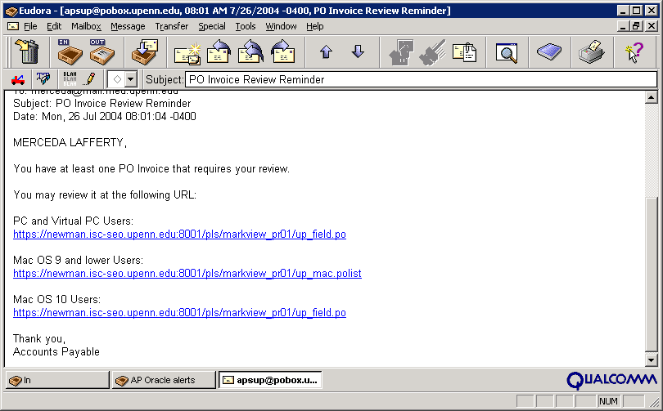

  - Click on the “Details?” icon to see information including the hold code and reason, PO number as well as the line(s) to which the hold pertains:

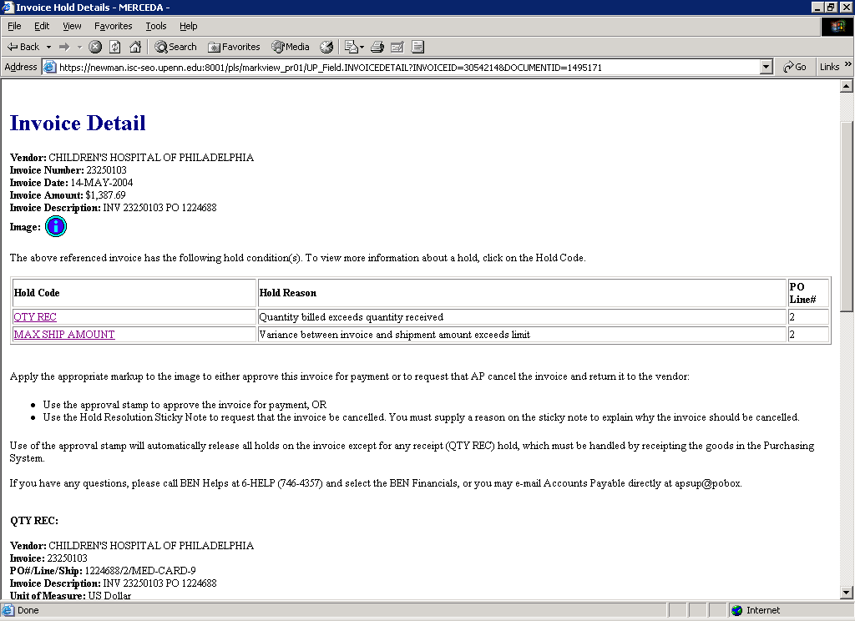

  - Make a note of the PO line # that appears to the right of the Hold Reason.
  - While in this screen, click on the “Image i” icon; when it appears, print a copy of the invoice (single right mouse click and select File > Direct print)
- Log into BEN Financials in the PO Manager “User” responsibility and navigate to the View/Control PO screen.
  - Enter the applicable PO number and click [Find]
  - Once in the PO Header form, from the Inquire dropdown menu, select “View Shipments”
  - In the PO Shipments screen, there are multiple views. Change the view to Quantity Detail by clicking on the Open Folder icon just above and to the left of the first line. Select Quantity Detail. On this screen, you will be able to view quantity ordered, quantity cancelled (do not ever cancel!), quantity billed, and quantity received.

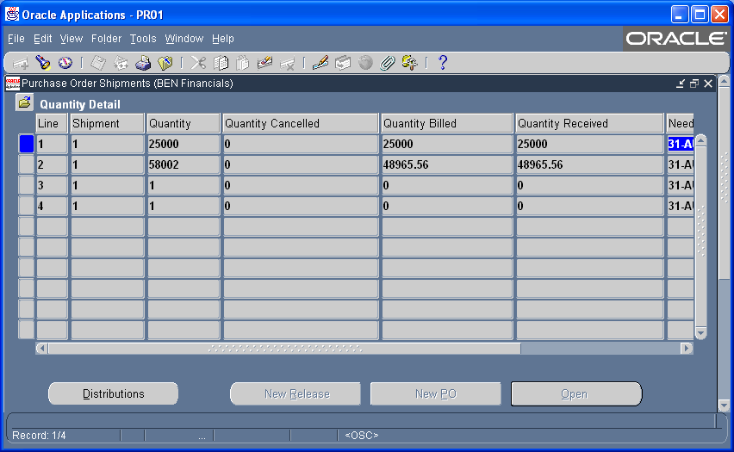
  - A line that has been invoiced for greater than the quantity ordered will be apparent.
  - Close the Shipments form and navigate to the Lines form to see which line of the PO pertained to that part of the subcontract up to $25,000 and which pertained to the subcontract above $25,000.

Was the invoice posted to the correct line(s) in the correct amount(s)? If not, go back to the MarkView working folder and apply a Hold Resolution Sticky (icon with black H on green background) with a note indicating how much of the invoice should be applied and to which line of the PO.

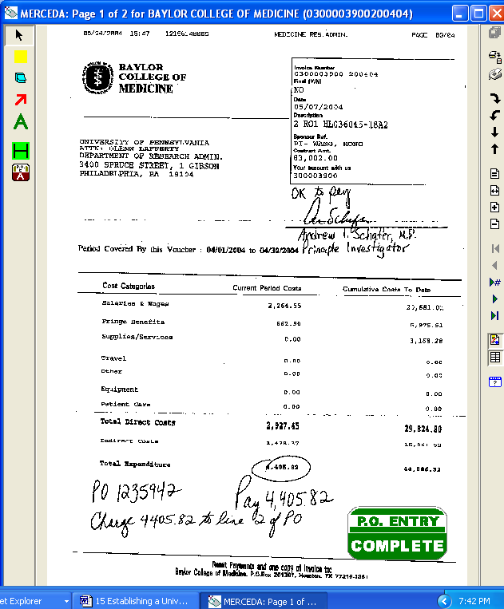

Saving the Hold Resolution Sticky will automatically transition the invoice back to Accounts Payable and they will adjust the amounts accordingly.

In the meantime, if the invoice itself appears to be accurate, the hardcopy should be submitted to the PI for his/her review and approval.

- Print a copy of the invoice through MarkView (retrieve invoice; right click and select File > Direct print)
- The PO Manager/Buyer or BA and PI should compare the invoice with the subaward scope of work and budget to ensure that the work has been performed as contracted and that all charges are allocable and allowable and within the period of performance, and within the dollar amount of the subaward. The PI must indicate approval of the invoice by:
  - Signing the printed invoice and returning it to the PO Manager/buyer; or
  - Sending email to the PO Manager/buyer and/or BA indicating approval; or
  - Providing some other written approval that can be included with the invoice documentation.
- If the invoice is acceptable, the PO Manager/buyer should enter a BEN Financials receipt. This can be done from the Requisitioner user responsibility by the requisition “Creator”. From the Requisitions home page, click on the Receiving tab (seen in the following screen):

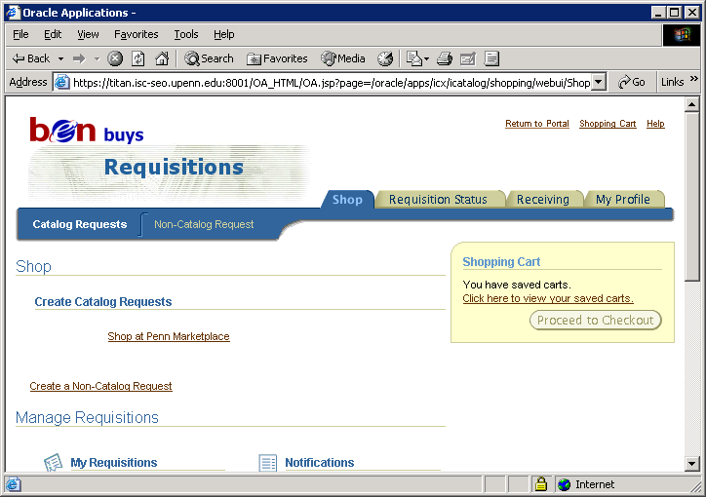
Then click on the Receive Items hyperlink

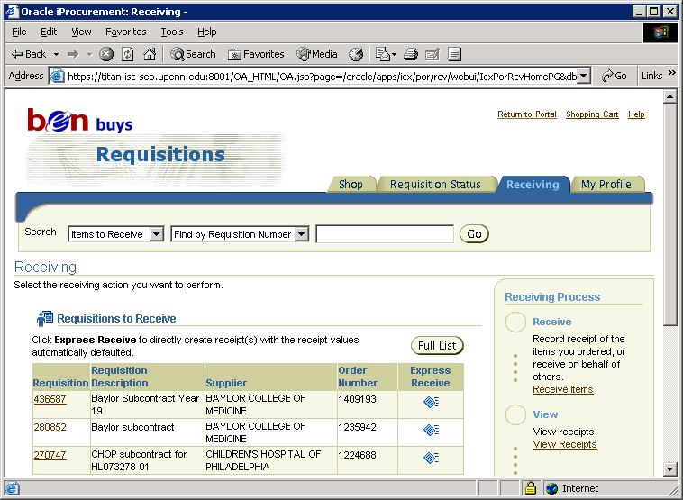

Then enter the Requisition number (not PO number) in the Requisition Number field and click [Go].

BE SURE TO ENTER THE CORRECT REQUISITION NUMBER. OUTSIDE INTERVENTION IS REQUIRED TO UNDO A RECEIPT. GET IT RIGHT THE FIRST TIME;

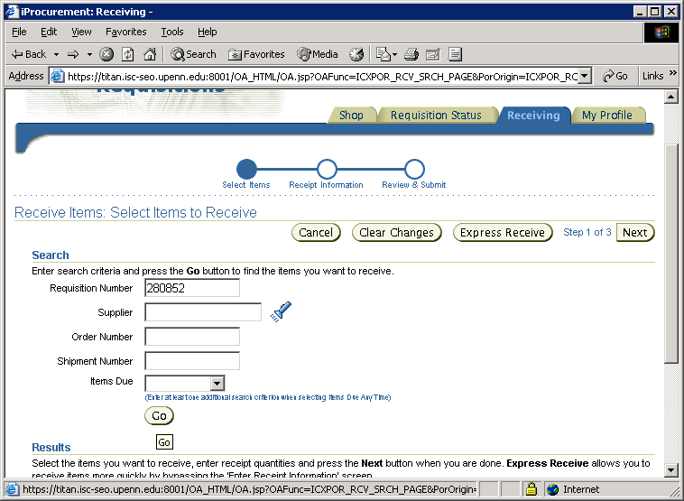

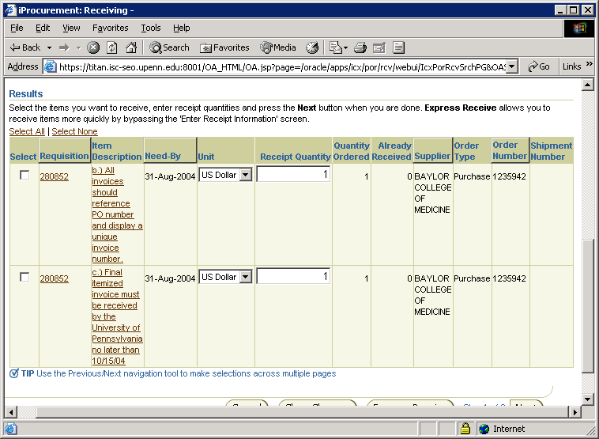

- Be sure to receipt the correct line(s) in the correct amount(s) so that F&A is charged appropriately. In the Receipt Quantity field, enter the amount received, i.e. the dollar amount of the current invoice approved for payment by the PI.

- Alternatively, a PO Manager/buyer may enter a BEN Financials receipt from the PO Manager user responsibility.

- Log into PO Manager user responsibility from the main menu;
- Select Enter Receipts form;
- BE SURE TO ENTER THE CORRECT PO NUMBER. OUTSIDE INTERVENTION IS REQUIRED TO UNDO A RECEIPT. GET IT RIGHT THE FIRST TIME;

Tip: Receipts are entered at the line level of the order. In other
words, you may have one $25,000 line in the PO, and one $79,568 line in the PO. These flow through to the receipt.
- Enter the receipt(s) against the applicable line(s).
Tip: The system will allow receipting greater than the quantity
ordered. Be sure to enter the correct ‘quantity’. In the case of subawards, the “quantity” receipted is the dollar amount of the invoice to be paid.
Below is a screen shot of a fully receipted two-line subcontract purchase order from the Enter Receipts form:

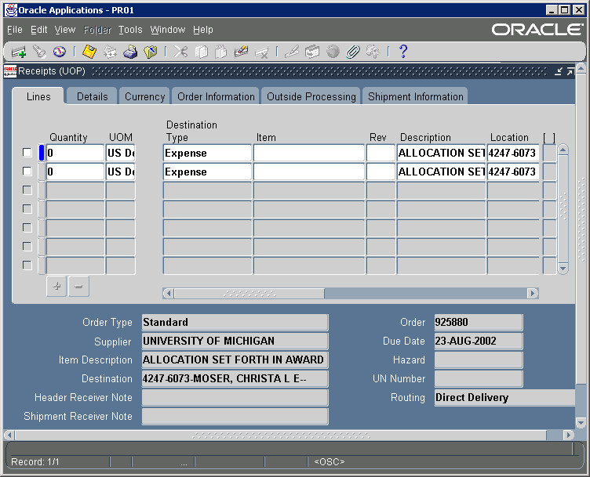
Note that the Quantity fields are 0. That means receipts totaling the entire amount ordered has been entered.

- A MarkView approval stamp is only required in the event the invoice is to be paid AND has holds other than ‘Quantity Received Hold’. Types of holds include:

- Finally Closed PO Hold (FINAL MATCHING): Invoice is imaged, but cannot be matched to referenced PO that is “Finally Closed”. The Hold is not viewable in MarkView. AP clerk e-mails PO creator personally for appropriate account combination to charge. PO creator replies via e-mail. AP processes invoice as a C-368 form.
- Items Not Ordered Hold (ITEMS NOT ORDERED HOLD): Items billed on invoice, but not ordered on PO
- Maximum Total Amount Hold (MAX SHIPMENT): Total invoice line > total PO line by $25
- Quantity Ordered Hold (QTY ORD): Quantity billed on invoice > 10% of quantity ordered on PO
- Quantity Received Hold (QTY REC): Created when any invoice is received for a PO that exceeds $5000 and no receipt has been entered in BEN Financials for items invoiced.
Applying an approval stamp in MarkView to an invoice on Quantity Received Hold will result in the invoice remaining on hold.

- Keep a hardcopy of the invoice with the PI’s original signature in the grant expenditures file and the date the invoice was receipted including the receipt number.
- Invoices should be receipted within 30 days in order to meet payment requirements.
- If the invoice is unacceptable, a green Hold Resolution Sticky (icon with black H on green background) should be applied to the invoice in MarkView detailing why department is disputing the invoice (i.e. duplicate invoice, invalid time period, unallowable expense, etc.) (See below for screen displaying stamps).

Hold resolution sticky text example:

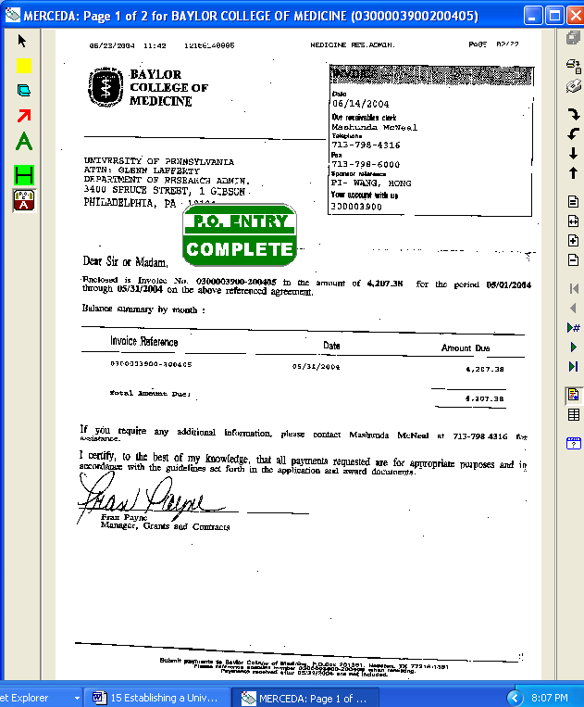

Tip: Applying a “BLUE” note to the invoice will not transition invoice from your queue, nor will it cancel the invoice, nor will it relieve any invoice encumbrance.

A good use of a “BLUE” note would be to electronically record when the invoice was printed and submitted to the PI for review; or when the PI and BA are scheduled to meet to discuss the invoice. Text of the “BLUE” note remains within Penn; it does not get communicated to the supplier.

- After the Hold Resolution Sticky has been applied, print the invoice and maintain in the grant file. The Sticky text will automatically print following the invoice.

- When the Hold Resolution Sticky is applied to the invoice and the view is saved, the invoice electronically transitions back to Accounts Payable;
- Accounts Payable is notified electronically that an invoice is to be cancelled;
- Accounts Payable incorporates the text of the Hold Resolution Sticky into a cover letter sent, with the invoice, back to the Supplier;
- The invoice encumbrance is relieved;
- Accounts Payable will release the hold and cancel the invoice.

- ORS should be informed of all disputed subaward invoices by email.

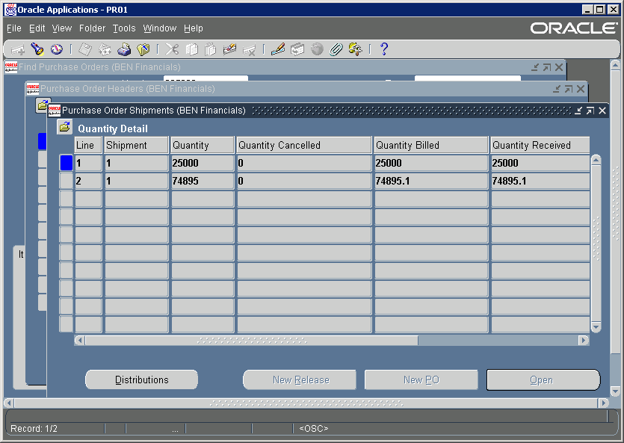
Here is a screen shot of the results of a properly executed PO that was receipted correctly and the invoice ‘matched’* correctly (from the View/control PO screen in the Shipments form in PO Manager):
* Matching of an invoice is a function performed by Accounts Payable and involves linking a line of an invoice to a line in a purchase order, resulting ultimately in the purchasing encumbrance being relieved. Invoices do not have to be ‘matched’ to be paid. However, unmatched invoices result in encumbrances remaining on POs.

Finally Closing Fully Invoiced Subaward Purchase Orders
“Finally closing” a purchase order is a system action that will relieve any remaining encumbrance that may result when purchase orders are invoiced for less than the amount of the purchase order. All subaward purchase orders should be “finally closed” when the subrecipient has submitted a final invoice for the period of performance represented in the subaward document. Also the ‘Payment Date’ in BEN Financials must reflect that the payment has been mailed by Accounts Payable.

Funds with Automatic Carryover (Change of Fund #):
The purchase order should only be kept open until the subrecipient final bills for services performed in the budget period covered by the purchase order AND all invoices are paid as indicated by a ‘Payment Date’ in the BEN Financials Invoice Inquiry form. Once all invoices are paid, the purchase order should be finally closed.

Funds without Automatic Carryover (Change of Fund #):
The purchase order needs to be closed immediately after the adjustment period ends (i.e., the P.O. cannot remain open whether paid or not). A final invoice for the budget period also needs to be received from the subrecipient so ORS can accurately report unliquidated obligations to the sponsor. Copies of any unpaid invoices for the covered budget period should be forwarded to Research Services. As long as ORS receives a copy of the final invoice prior to filing the FSR, the amount will be reported as an unliquidated obligation.

If the final invoice is not received prior to filing of the FSR, the amount may be reported as an unobligated balance and carryover must be approved. Once approved, ORS will increase the PBIL/PBUD on the new fund number by the amount of the unliquidated obligations reported to the sponsor. Any payments on invoices after the adjustment period on the old fund number will need to be moved to the new fund number. The unpaid invoices have to be paid from the new fund number. The new purchase order for the next budget period should include the authorized funding for the next budget period, including the prior year carryover of unliquidated funds only.

Purchase orders for a subsequent budget period should include the authorized funding for services performed in the next budget period. A subsequent period’s purchase order may include the prior year carryover of unobligated funds only if approved.

To “finally close” a purchase order, ensure all invoices have been paid and confirm the payment date has passed. This information is available in the Inquiry Invoices screen. Search for all invoices by purchase order number.

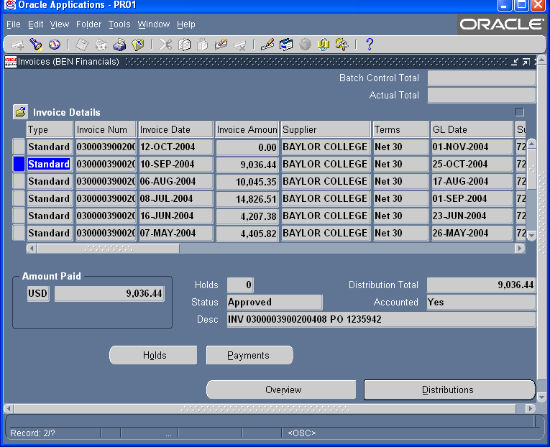

Once in the Invoice Details window, click the [Payments] button for each invoice.

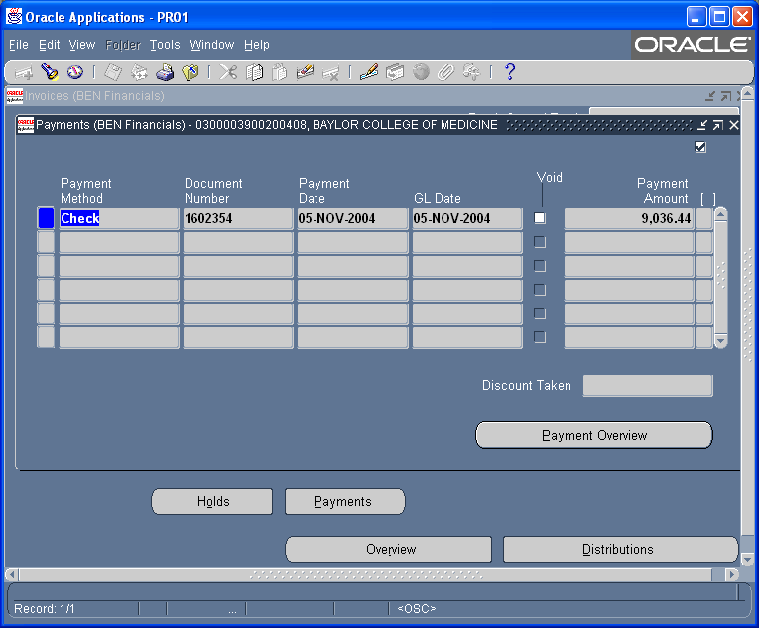

Once you have confirmed all invoices have been paid, navigate to the View/Control PO screen within the PO Manager user responsibility.

On the View/Control Purchase Orders screen, enter the PO number and click the [Find] button.

Confirm you have the correct purchase order. Once a PO has been finally closed, it cannot be re-opened and no further invoices can be paid against it.

From the Purchase Order Header window, select ‘Control’ from the Tools dropdown menu. Select “Finally Close” and enter a reason for the action.

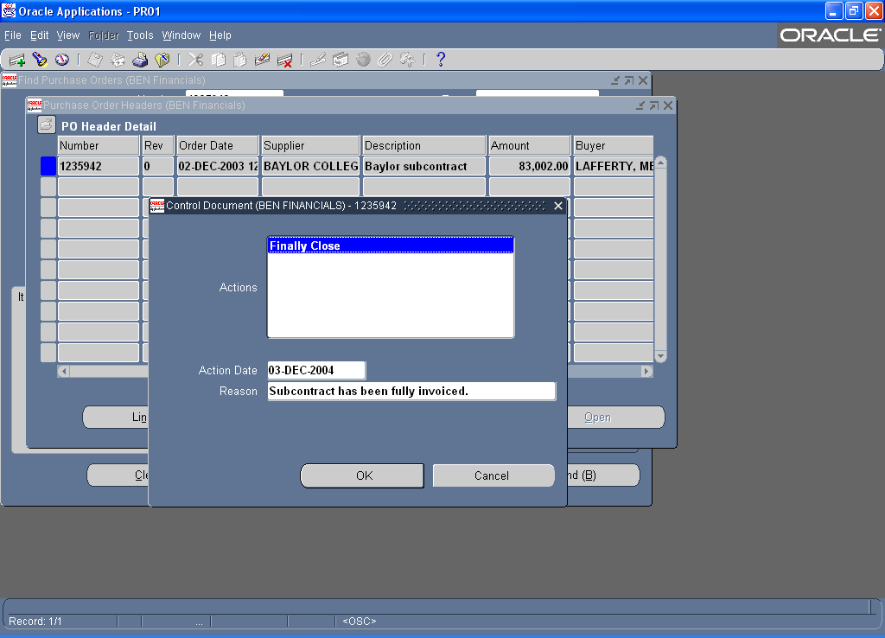

Click [OK] and answer affirmatively to the next three prompts.

Payment of Foreign Subrecipients and Wire Transfers

{Reserved}

Detailed Effort Reporting Procedures in ERS

ERS is Penn’s web-based effort reporting system. Payroll data for employees for whom an effort report is necessary for a specific reporting period is electronically added to ERS in the month following the end of a reporting period. There are 7 effort reporting periods; Fall and Spring Semester for faculty on a 12 month appointment and professional staff employees; a Summer semester period for faculty on a nine month appointment conducting research in the summer; and quarterly reporting for non-exempt employees.

An Effort Report will be generated in ERS for the following Individuals:
- Faculty and professional staff employees. An effort report is required to be certified for each semester (Fall and Spring) in which part or all of their salary is charged to a sponsored project.
- Faculty with a nine month appointment. A summer semester effort report is required to be certified for faculty with part or all of their salary charged to a sponsored project in June, July or August on a summer semester salary object code, #5052 or #5053.
- UPHS Physicians. An effort report is required to be certified for both the Fall and Spring semesters for Medicare reporting purposes.
- Support Staff Personnel. Certified effort reports are required for support staff personnel with salary charged to a sponsored project on a quarterly basis, July – September; October – December; January – March; and April – June.

ERS System Roles:
The ERS system is designed to function based on specific individual roles in order to facilitate the effort reporting process. The specific roles are:
Central Administrator: The central administrator is responsible for the initiation of each effort reporting cycle, monitoring the timeliness of the completion of effort reports, and to provide help desk support to the participants in the system.
Department Coordinator (DC): The DC plays a critical role in ERS since they are responsible to facilitate the effort reporting process in their department. The process should be efficient, credible, timely and accurate. They are responsible for ensuring that the appropriate individuals are assigned as certifiers of effort report forms, and to ensure compliance with federal and other sponsor effort reporting requirements.
Pre and Post Reviewers: Individuals assigned this role are expected to review effort reports and make appropriate adjustments to payroll when necessary. They need to assist the certifiers to understand their effort report, and keep them informed of federal and institutional policies regarding effort reporting.
Certifier: The individual who is responsible for affixing their electronic certification to the effort report form. ERS defaults the individual compensated on sponsored projects as the certifier. It is the DC’s responsibility to change certifier assignments when appropriate.
Division Head (DH): An individual assigned to this role has the ability to monitor the effort reporting progress in their school or center. This role allows the individual to send email messages to certifiers and departmental coordinators, and also to run various administrative reports to determine the effort reporting progress in their school or center, as well as ability to view and/or print certified individual effort reports and exception reports.

Initiation of an Effort Report Period
The ERS system Central Administrator will notify the Departmental Coordinators when effort reports are available for review for each reporting period and also the date that the reports are due to be completed. Effort Reports are due within 45 business days after available for review (Sponsored Projects Policy No. 2114 Effort Reporting).
The Department Coordinator should review the employee assignments in ERS to determine if the appropriate certifier is assigned to each effort report (e.g. faculty are assigned to certify reports of employees paid on their projects), and change assignments where necessary prior to notifying the pre-reviewer that the reports are ready to be pre-reviewed. For more information, refer to the “roles” document available on ORS web site http://www.upenn.edu/researchservices/effortreportingA.html.
Pre-Reviewer responsibilities: In reviewing the effort report forms in ERS, the pre-reviewer should do the following:
- Anticipated Resources/Suspense Account. Effort reports display the distribution of an individual’s salary after a reporting period. Since anticipated resources is not an activity, and salary that falls into a suspense account is an error, salary distributions to these accounts must be cleared out by processing cost transfers to appropriate accounts before proceeding through the effort report. Advance accounts should be used in lieu of anticipated resources when an award is fully anticipated.
- If adjustments to the salary distributions for the effort report period are necessary, enter the cost transfers on the pre-review form, and proceed to the define cost transfer screen to enter the cost transfer for the appropriate month(s) and select the appropriate reason before proceeding through the form. If adjustments are not necessary use the proceed option to complete the form which will send a notification to the certifier that their form is ready to be certified.
- For more information refer also to the “roles” of the Pre-Post Reviewer available on the ORS web site:
http://www.upenn.edu/researchservices/effortreportingA.html.
Certifier responsibility: Each individual with a role of certifier has the responsibility of ensuring the accuracy of the effort report before they apply their electronic certification to the form. If a certifier is unsure about the percentages of effort on the form, they have the option of sending an email message directly from the effort form to the pre-reviewer noting any concerns, or they may change the percentages of effort to reflect how effort was actually expended during the reporting period. If changes are made to the form, the certifier can include a message in the Notes box on the form, proceed through the form and apply their electronic signature to the form. If no changes are made to the form it is complete. If a change is made, a message will automatically be sent to the post reviewer to resolve the discrepancy between the payroll distributions and the certified effort.
Certifiers are notified that an effort report is ready for certification via an email message from the pre-reviewer. Regardless of the number of forms assigned to a certifier that have been pre-reviewed, ERS contains a bulk email feature that automatically sends one email message to the certifier at 8AM the morning after an effort report(s) has been pre-reviewed. The email includes the URL to log on to ERS.
Post Review responsibilities: An individual assigned as a post reviewer in ERS will receive a system generated email message when a certifier has changed the percentage distributions from the pre-review process. This results in a discrepancy between an individual’s actual salary distributions in payroll and the percentages certified on the effort form. It is the post reviewer’s responsibility to resolve the differences, either by processing a cost transfer or adding cost sharing to the effort report form. The post reviewer should discuss the differences with the certifier before completing the effort form.

ERS System Access
In order to have access to ERS, Departmental Coordinators and Pre and Post Reviewers must submit an ERS access form to the ERS system administrator in ORS, review the effort reporting tutorial accessible from the ORS web page, pass the quiz at the end of the tutorial and attend the ERS desk top training on the use of the system. The tutorial can be accessed via the ORS web page.
http://www.upenn.edu/researchservices/effortreportingA.html

ERS System Features include the following:
Profile: Each individual assigned a role in ERS has a personal profile in the system. Selecting this option will bring up name, Penn ID, Department, your role in ERS and email address.
Assignment: This option is available to the Department Coordinator (DC) and allows the DC to manage the effort reporting process in their department by establishing appropriate staff to pre-review effort forms, post review effort forms, and assign appropriate certifiers to each effort form. ERS defaults the individual compensated as the certifier. In most instances, the Principal Investigator should be assigned as the certifier of effort forms of individuals compensated from their projects.
Notification: This feature allows DC’s and Pre/Post Reviewers of effort report forms to send reminder email messages to review or certify effort report forms.
Pre-Review: Individuals assigned as a pre-reviewer of effort reports need to choose this option to begin the process of pre-reviewing effort reports in each Org assigned to them. After selecting this option, select a reporting period and the desired Org to begin the process of reviewing individual effort reports.
Certify: Only individuals assigned as a certifier will see this option in ERS. A certifier only needs to choose this option, select certify again, and the reporting period they want, and then choose the individual effort report they want to certify.
Post Review: This is only required when a certifier changes the effort report after it has been pre-reviewed. The post reviewer will receive an automatic notification when an effort report requires post review. Select Post-Review and the period and Org desired, and select the form requiring post review.
Reporting: Selecting this option will bring up a suite of reports available in ERS. There are completion reports, effort results reports, administrative reports, and a Penn custom report.
Help Topics: Choosing this option will allow the user to submit ERS related questions and problems via email and the Remedy software to the ERS Help desk without leaving the application, and to also access the ORS web site to view the effort reporting section for information and forms.

The ERS Effort Report Form
Sponsored Accounts
- Sponsored accounts are displayed at the top of the form, below the employee name and department. The salary distributions and percentage of activity on all grant or contract projects sponsored by parties other than the University (e.g., federal, state, city, foundations, and corporations) are listed. The detailed salary distributions are easily available by placing the cursor over any of the salary totals, and clicking on the mouse. The detailed sponsor information about each award where salary was charged is also available by placing the cursor over the fund number and clicking on the mouse.
Non-Sponsored Accounts
- Non-Sponsored accounts are listed below the sponsored accounts with the payroll distributions and percentage of total activity listed. Details of the salary distributions are available in the same manner as for sponsored accounts noted above.
Reporting Cost Sharing
- Effort expended (but not charged) on sponsored projects and which is required by the terms of the agreement (mandatory or voluntarily committed to the project), must be reported on a project-by-project basis as cost sharing. The Office of Research Services establishes companion cost share funds to account for the required cost sharing. If the companion cost share account does not appear on the effort form, the account needs to be added to the form in order to account for the required cost sharing. Refer to the ERS User Guide available on the ORS web site. http://www.upenn.edu/researchservices/effortreporting
- Note: Research activities that are NOT expended on externally sponsored projects and are NOT separately budgeted and accounted for (e.g., scholarly activity or departmental research) will be included in the non-sponsored section of the form and no additional reporting is necessary.

Definitions and Reporting of Clinical Activity
Clinical Activity relates to Health Science only (Medicine, Nursing, and Dentistry) and includes patient care-related activities whose purpose may combine instruction and/or therapy and/or administration. Clinical activity may fall under one or all of the following:
- Direct Patient Care – Includes effort applicable to professional services rendered to patients and for which a professional bill would ordinarily be rendered.
- Education of Housestaff – Includes supervision and instruction of individuals enrolled in accredited Intern and Residency Programs, including preparation of lectures.
- Administration – Includes the administration of ancillary or inpatient areas, including such activities as budget management and supervision of technical and clerical personnel, related committees, in-service education programs, and activity of general benefit to patients (e.g., quality control).
- Other Activity – This section is for reporting any other activities that do not fit into any of the categories of effort listed above.
In addition to reporting clinical activity, UPHS Physicians must also report their average weekly hours in the box provided on the effort form.

Detailed Instructions for Reporting Effort of Individuals Subject to Salary Caps

NIH Salary Cap
The Department of Health and Human Services (DHHS) appropriation contains a provision that none of the funds appropriated for National Institute of Health (NIH) or Substance Abuse and Mental Health Administration awards shall be used to pay the salary of an individual at a rate that exceeds a level prescribed by NIH, referred to as the “salary cap” (see: http://grants.nih.gov/grants/policy/salcap_summary.htm for the current year cap). Since the restriction is based on a rate of pay, not a fixed amount, and since the University is required to report effort on a semester basis (Fall, Spring, and Summer), the following guidelines must be used by the following individuals who have part of their salaries distributed to an NIH funded project:
* Faculty with 12-month appointments and staff employees who earn more than half the annual salary cap in either the Fall or Spring semester.
* Faculty with 9-month appointments who earn more than the pro-rated share in either the Fall or Spring semester (9/12 x $183,300/2) or more than $15,275 ($183,300/12) in any month of the Summer semester.
These individuals must show a percentage of effort that is more than the amount funded by NIH and greater than the percentage on the effort report form which is calculated on total salary, not on the NIH limit. To report this effort correctly, calculate and report the amount of this effort as cost share activity in the cost sharing column provided in ERS.
To facilitate the calculation of either the amount of cost sharing or the maximum amount of salary that can be paid from an NIH grant, Research Services has prepared a salary cap calculator (Capped Salary Calculator).

Reporting Procedures

Faculty and staff with a 12-month appointment
If the salary distribution to the project is correct, calculate the percentage of that amount to $91,650. The difference between the percentage of effort displayed in ERS and the calculated ratio to $91,650 must be reported as cost share activity in the column provided in ERS for cost sharing. The actual distributions need not be changed unless they are incorrect.
Example A: Salary Funded from Grants and Other Sources Fall or Spring Semester Total Compensation for Semester $120,000
Fund | Salary Distribution | Percentage
NIH Grant A | $20,000 | 17%
NIH Grant B | $25,000 | 21%
Department | $35,000 | 29%
CPUP | $40,000 | 33%
Total | $120,000 | 100%
Calculation of Unfunded Activity
NIH Grant A: $20,000/$91,650 = 22%.
The difference between 22% and the 17% on the effort form (5%) must be reported as cost sharing activity. Enter the 5% difference in the cost share column on the effort form on the line for NIH Grant A. Since the effort report must add up to 100%, you also need to enter a minus 5% in the cost share column of an unrestricted fund.
NIH Grant B: $25,000/$91,650 = 27%.
The difference between 27% and the 21% on the effort form (6%) must be reported as cost sharing activity. Enter the 6% difference in the cost share column on the effort form on the line for NIH Grant B, and also enter a minus 6% in the cost share column of an unrestricted fund.
Final Distribution
Fund | Salary | Percentage | Cost Share | Revised Percent
NIH Grant A | $20,000 | 17% | 5% | 22%
NIH Grant B | $25,000 | 21% | 6% | 27%
Department | $35,000 | 29% | -11% | 18%
CPUP Fund | $40,000 | 33% |  | 33%
Total | $120,000 | 100% | 0% | 100%
Example B: Total Salary Funded from Grant Only (or All Restricted Funds) Fall or Spring Semester -- Total Compensation - $100,000
Fund | Salary Distribution | Percentage
NIH Grant | $50,000 | 50%
NSF Grant | $35,000 | 35%
Private Grant (or Service Center) | $15,000 | 15%
Total | $100,000 | 100%
Calculation of Cost Transfer and Reporting of Unfunded Activity
Since salaries cannot be charged to an NIH funded project at a rate of pay that exceeds $91,650 per semester, the following steps must be taken:
- Do a cost transfer to reduce the amount initially charged to the maximum amount allowable.
- Move the difference to an unrestricted fund.
- Report the calculated percentage of this adjustment as cost share activity in the column provided in ERS.
NIH Grant: Maximum amount allowable is $45,825 (50% x $91,650)
The difference between the amount charged and the maximum amount allowable must be transferred to an unrestricted fund and the corresponding percentage of this adjustment must be reported as cost sharing by entering the calculated percentage in the cost share column in ERS.
$50,000 - $45,825 = $4,175 to be transferred to an unrestricted fund. Use the add account feature in ERS to add the unrestricted fund to the effort report and enter $4,175 in the Cost Transfer column of the unrestricted fund added to the effort form, and a minus $4,175 in the cost transfer column of NIH Grant A.
Since the cost transfer will reduce the percentage of effort on NIH Grant A to 46% ($45,825 / $100,000) the 4% difference needs to be entered in the cost sharing column on the form on line for NIH Grant A, and a minus 4% in the cost share column for the unrestricted fund.
NSF Grant: There is no salary limitation on NSF sponsored projects. No adjustment is necessary.
Final Distribution
Fund | Salary | Percentage | Cost Share | Revised Percent
NIH Grant | $45,825 | 46% | 4% | 50%
NSF Grant | $35,000 | 35% |  | 35%
Non-Federal Project | $15,000 | 15% |  | 15%
Unrestricted Fund | $4,175 | 4% | -4% | 0%
Total | $100,000 | 100% | 0% | 100%

16.3.2.2 Faculty with a 9-month appointment
If the distribution to the project is correct, calculate the percentage of that amount to $68,738. The difference between the percentage of effort displayed in ERS and the calculated ratio to $68,738 must be reported as cost share activity in the column provided on the effort report form.
Example C: Salary Funded from Grants and Unrestricted Resources Fall or Spring Semester -- Total Compensation for Semester - $80,000 (Annualized Salary of $160,000)
Fund | Salary Distribution | Percentage
NIH Grant | $30,000 | 38%
Department Funds | $50,000 | 62%
Total | $80,000 | 100%
Calculation of Unfunded Activity
NIH Grant: $30,000/68,738 = 44%
The difference between 44% and the 38% preprinted (6%) must be reported as cost share activity. Enter the 6% difference in the cost share column on the effort form for the NIH grant. You must also enter a minus 6% in the cost share column of the department funds.
Fund | Salary Distribution | Percentage | Cost Share | Revised Percent
NIH Grant | $30,000 | 38% | 6% | 44%
Department Funds | $50,000 | 62% | -6% | 56%
Total | $80,000 | 100% | 0% | 100%
Note: No change to the actual distribution is required in this example.
Example D: Summer semester
The summer semester consists only of salary expense in June, July, and August charged to Object Codes #5052 (Instruction) and 5053 (Research).
Academic Base $144,000 (9-Month Appointment)
Monthly Salary = $16,000 (144,000 / 9)
Total Compensation for Summer Semester $32,000 (Two months effort)
Salary Distribution
Fund | June |  | July |  | August |  | Total
NIH Grant | $ 8,000 | 50% | $16,000 | 100% | $0 | 0% | $24,000 | 75%
NSF Grant | $ 8,000 | 50% | 0 | 0 | $0 | 0% | $8,000 | 25%
Total | $16,000 | 100% | $16,000 | 100% | $0 | 0% | $32,000 | 100%
For the Summer Semester, if there is a monthly salary distribution more than $15,275 ($183,300/12) and all or part of the distribution is made to an NIH sponsored project, the following must be done:
- Do a cost transfer to remove any salary charge in excess of $15,275 in any month, or do a cost transfer to remove the pro-rata share of any salary charged to an NIH sponsored project for any month in which the salary distribution exceeds $15,275; and
- Report the amount of this adjustment as cost share activity by entering the percentage calculated on the Effort Report form.

Calculation of Cost Transfer and Reporting of Cost Share Activity
June: NIH Grant was 50% of Effort; 50% x $15,275 = $7,638 allowable on NIH Grant:
Enter a cost transfer to move $362 ($8,000 - $7,638) to an unrestricted fund.
July: Since the entire salary was distributed to the NIH grant:
Enter a cost transfer to move the difference ($725) between the total paid ($16,000) and the amount allowable for NIH ($15,275) to an unrestricted fund.
Final Summer Semester Distribution: * $362 + $725 = $1,087
Fund | Payroll | Adjustment | Adjusted Payroll | Revised Percentage
NIH | $24,000 | -$1,087 | $22,913 | 72%
NSF | $ 8,000 |  | $ 8,000 | 25%
Unrestricted |  | +$1,087 | $ 1,087* | 3%
Total | $32,000 |  | $32,000 | 100%

Service Centers & Recharge Centers

Overview
Service centers are University operating units created for the primary purpose of providing services, or a group of services to users, principally within the Penn community, although services may be provided on an incidental basis to external users as well. The services may range from highly specialized facilities to basic recharge centers providing departmental support functions. As such, service centers should be treated as unique businesses.
Examples of service centers at Penn include the following:
- Stockrooms
- Printing and copy centers
- Machine and instrumentation shops
- DNA Sequencing Facilities
- Telecommunications facilities and services
- Computing facilities and services
- Animal care facilities
- Fee-based cell analysis center

University and Federal Requirements
All Service Centers that bill federal grants or contracts are subject to the cost principles set forth in the Office of Management and Budget’s Uniform Administrative Requirements, Cost Principles, and Audit Requirements for Federal Awards (OMB Uniform Guidance). In addition, the Service Centers must adhere to the following requirements identified in OMB’s Uniform Guidance, (CFR2, subtitle A, Chapter II, Part 200, Subpart E - §200.468), “Specialized Service Facilities” and Sponsored Projects Policy No. 2115:
- Charges must be designed to recover no more than the total cost of the service over a long-term period.
- Rates must be reviewed periodically for consistency with a long-term cost recovery plan and must be adjusted if necessary.
- Alternative costing arrangements may be negotiated with a federal agency where it is in the best interest of both the government and the institution.
- Billing rates charged directly to users must be based on the actual use of the services.
- A schedule of rates must be established that does not discriminate between federally and non-federally supported users including internal users.

Cost Accounting Standards (CAS) & Service Centers
The following are CAS implications for service center charging practices:
- CAS 501 - Service center costs budgeted in proposals must be reconcilable to actual charges in the BEN Financials accounting system.
- CAS 502 - Costs must be charged consistently, and the rate development process must be consistently applied.
- CAS 505 - Service centers must exclude unallowable costs from billing rates and must identify the actual cost of providing services to all users, regardless of their funding sources.
- CAS 506 - Rates should be established based on the University's fiscal year, unless there are legitimate reasons for using an alternative period.

Principles for Achieving Compliance with CAS
The following principles should be applied to comply with CAS:
- Recharge centers should operate as nonprofit businesses that recover their aggregate costs over a reasonable period.
- Rates charged to users should be based on actual costs and established billing rates.
- Costs of recharge center operations must be accumulated separately and excluded from the University's Facilities and Administrative (F&A) cost rate.
- In most cases, costs and revenues should be identified by service.

Service Center Costs
Examples of Service Center Costs:
  - Supplies used solely by the service center (e.g., paper for a copy center)
  - Salaries for personnel associated solely with the provision of the service (e.g., equipment operator)
  - Labor costs of administrative personnel that are directly associated with the specific service
  - Depreciation expense for equipment used to support services
  - Equipment repairs and service contracts

Recovery of Fixed Assets
In recovery of fixed assets, the following principles apply:
- Depreciation expense of equipment purchased for service center operations is an allowable cost of the service center and should be included in billing rates.
- Allowable costs should include only the depreciation for the current accounting period.
A schedule including each item of equipment with the item description, Penn barcode number, PO number, the annual depreciation expense and depreciable life must be sent to Research Services annually in June for approval.
Depreciation included in billing rates must be excluded from the University's F&A cost rate.

Pricing
The following should be implemented in the conduct of pricing:
- Federal users must be charged no more than the cost-based rate.
Non-federal users can be charged more than the cost-based rate.
- If market prices are used, they should be compared to actual costs to ensure rates do not result in overcharges to federal users.

Calculating Variances
The following should be taken into account when calculating variances:
- Revenues should be compared to the full cost of providing each service at least annually.
Note: No cross-subsidization is permitted, whereby federal grants use services that, in effect, subsidize other services.
- Revenues that exceed the full cost of service should not be used to subsidize other services of the same service center, unless the user mix is similar.
- Imputed revenues should be calculated for users that are not charged cost-based rates.

Documentation
Service center personnel should maintain the following supporting documentation:
- Descriptions of the procedures used to charge the costs of each service to users and how billing rates were determined
- Schedule of current rates
- Billing records
- Listing of transfers into and out of center-related accounts
- Central Administration rate approval documents
- Detailed records indicating service center usage statistics

Guidelines for Establishing Billing Rates
The following guidelines should be implemented to establish billing rates:
- Identify all services provided.
- Determine costs associated with each service, regardless of how it is funded. Include all costs incurred directly in support of the service center activities.
- Identify and segregate unallowable costs – to ensure unallowable costs are not included in the service rates.
- Add prior period variance in accordance with University Sponsored Projects Policy No. 2115: University Service Centers.
- Accumulate/estimate usage for each service (i.e., number of units) to establish the distribution base. All usage must be included, regardless of whether discounts or free service is provided.
- Calculate cost-based rate for each service.
- Submit annual budget and rate schedule to Research Services for approval.
- In accordance with University policy, Research Services allocates University-wide F&A costs to specialized service centers through the F&A rate process. These allocated costs are not charged to the specialized service center.

Sample Calculation
Service Center Costs=
Total Costs | - Unallowables | + Variance
(Salaries, supplies, etc.) | Costs (e.g., alcohol) | (Over/under recovery from prior year
$10,000 | -$500 | <$1,000>=$8,500
Divide to Calculate Rate:
Service Center Costs | $8,500
Distribution Base | 2,000 hours | $4.25/hour

Service Center Management Responsibilities
The following are typical service center management responsibilities:
- Performing billing rate calculations
- Ensuring compliance with federal regulations and University policy
- Complying with record retention requirements
- Reviewing/approving billing rate calculations and providing regulatory guidance
Note: Performed by Research Services
- Monitoring compliance with federal regulations

Financial Reporting

Agencies of the federal government, as well as non-federal organizations, require adherence to the reporting requirements set forth in the award document or notice. Sponsors often require periodic interim financial reports in addition to final financial reports. Failure to submit a financial report within the specified time frame may place the University in jeopardy of having remedial actions imposed. A sponsor may withhold an award(s) to a particular investigator, to the entire University; or withhold payment on invoices, reduce a continuation award, terminate the project, or revoke an award, if financial reports are not provided on time.

Financial Reports, General Information

Responsibility

Throughout the project, the principal investigator and the business administrator are required to review expenses posted to the account to ensure that they are necessary and appropriate for the award and are properly recorded. A monthly review of the costs incurred during the budget period must be undertaken by the PI and BA and adjusting entries processed as needed and before the end of the budget period. Direct cost expenditures that are considered erroneous or unallowable must be moved to the appropriate source of funding according to Sponsored Projects Policy No. 2113. Should adjustments be necessary, the BA must take corrective action within 90 days of the month end in which the expense was incurred.

Submission of all financial reports to sponsors is the responsibility of Research Services. If the PI or other responsible department administrators are contacted regarding a financial report, they should contact their responsible ORS financial grant and contract administrator.

Requirements

Most grants and contracts require a final accounting of project costs; however, there is often a need to submit interim reports, as well. For grants or contracts sponsored by non-federal agencies, financial reports will be submitted by ORS not later than the due date specified in the award document (see Sponsored Projects Policy No. 2126).

For federal sponsors subject to OMB Uniform Guidance, the University is required to submit quarterly financial reports within 15 calendar days of the close of the reporting period and within 90 calendar days for annual reports or finals. Some sponsors, including NIH and NSF are moving to 10 days for the final closeout of awards including the final financial report.

Initiation of the Reporting Process

Determination of whether or not a financial report is due can be found in the view fund segment attribute field of BEN Financials (refer to Financial Reporting Attributes). The Account End Date designates the entire funding period of the fund. When the Budget End Date and the Account End Date are the same, the general ledger fund will terminate at the end of the adjustment period (generally 90 days from the end date). Final reporting and account close-out procedures will be initiated at the Account End Date. For more complete information on final reporting see The Close-out and Final Reporting Process.

If the Account End Date indicates a future date beyond the current Budget End Date, an additional period of funding is anticipated. The closeout and final reporting process is not necessary at this point. However, an interim financial report may be required by the sponsor.

Financial Reporting Attributes

Information critical to the reporting process can be found in the Fund Segment Attribute record of BEN Financials. Information found there will include:

Current Budget End Date - This value is the end date of the Current Budget Period.

Account Start Date – Indicates the beginning of the award

Account End Date - Date that fund is expected to terminate.

If the Current Budget End Date and Account End Date agree, the fund will terminate upon that date. The Final Report will be issued, if required (see Reporting Frequency Code).

If the Account End Date exceeds the Current Budget End Date, there remain anticipated future budget period(s). Interim financial reporting will be undertaken at the end of the current budget period (following the Current Budget End Date), if required (see reporting Frequency Code) or as otherwise designated by the sponsor.

Next Financial Report Date - Date that next financial report is due according to the terms and conditions of the award.

If interim reports are not required, this field will be populated with the final report due date.

Financial Reporting Frequency - Sponsor imposed financial reporting requirements.

Last Financial Report Filed Date - Date that the last (interim or final) report was submitted.

If this date field is equal to the Next Financial Report Date field, the final report has been submitted.

Days to Submit - Provides information regarding the time frame allowed by the sponsor for financial reporting.

Report Format Code - Provides information relative to the sponsor approved reporting format and/or method.

Report Format Code (FC) | Report Format Description (FC+)
00 | NO REPORT REQUIRED
01 | STANDARD
02 | SPONSOR
03 | E FSR-SF269
04 | FSR-SF269
05 | FSR-SF269, SF272
06 | INTERNAL
07 | SF1034 & COMPLETION VOUCHER
08 | ADVANCE ACCOUNT

Billing Format Code - Provides information relative to the sponsor approved billing format and/or method.

Billing Format Code | Billing Format Description
01 | STANDARD INVOICE
02 | STANDARD PER TERMS
03 | FEDERAL 270
04 | FEDERAL 1034
05 | FEDERAL OTHER
06 | SPONSOR FORMAT
07 | AUTOMATIC PAYMENT
08 | INVOICED BY DEPARTME
09 | NO INVOICE REQUIRED
10 | AUTOMATIC PAYMENT FO
11 | INVOICE BY SCHEDULE

Report Frequency Codes

This list contains a column entitled Financial Report Frequency. This column is numerically coded and identifies the reporting frequency that the sponsor requires.

NO - No Financial Report
A - Annual and Final Report
F - Final Report
S - Semi-Annual and Final Report
Q - Quarterly and Final Report
I - Coordinate Report with Invoice
PI - Coordinate Report with PI
SC - By Specific Schedule
Q1 - Fiscal Quarter (Jan, Apr, Jul, Oct)*
Q2 - Fiscal Quarter (Feb, May, Aug, Nov)*
Q3 - Calendar Quarter (Mar, Jun, Sep, Dec)*

*Indicates month in which report is due.

Adjustment Period | Days to Submit Final Report
First 15 Days after Account End Date | 30 - 30 Days after Termination
First 30 Days after Account End Date | 60 - 60 Days after Termination
First 60 Days after Account End Date | 90 - 90 Days after Termination

Reports to Assist in Reporting and Management of the Award
There are a number of reports available in BEN Financials to assist business administrators and PIs in managing their active funds. The reports most often used include:

- 115.ORG: Grant FUND Summary
- 10X.ORG: SUMMARY BY Parameter
- 15X.ORG: Transaction Detail
- 163.ORG: Open Encumbrance
- 130.ORG: PI Report by CNAC/ORG/FUND
- 137.ORG: Grant Budget Period Summary
- Salary Management Reports (Payroll)

These reports contain a summary of budget, expenditure, and revenue activity for the fund. The principal investigator and business administrator should review the reports for accuracy throughout the life of the award. These or similar reports are used by ORS to assist in the preparation and submission of interim financial reports and invoices.

For more detailed information on these and other reports, please go to http://www.finance.upenn.edu/ben/benfin/documentation/reportdoc/quickv/.

Interim Financial Reports

Interim financial reports may be required annually, quarterly or more frequently. The financial information contained in an interim financial report is derived from the financial accounting system general ledger detail of expense record for the reporting period.

In addition to costs posted to the general ledger fund, the interim report to the sponsor may include credit adjustment(s) not processed by the close of the reporting period. An adjustment would be required for expense items posted to the fund during the reporting period but which should have been charged to another account. These adjustments must be made by the responsible Business Administrator.

F&A Costs and Employee Benefit amounts are reconciled as part of the reporting process and adjustments are made by ORS. If at any point during the administration of the award, the department becomes aware of F&A or Employee Benefit Costs being charged at incorrect rates, they must contact ORS to make the necessary adjustments. It is the department’s responsibility to monitor their awards on a regular basis (monthly) and to ensure that charges are correctly occurring. Any over expenditures at the end of the award are the responsibility of the department.

If required, an interim financial report will be issued regardless of the amount of expenditure activity during the reporting period. Thus, if no expense has been posted during the reporting period, Research Services will report a total expense of $0.00 for the period.

Unliquidated obligations will be reported and unobligated balances will be carried forward in accordance with the terms and conditions of an award.

Upon submission, revisions to this report will be made only for credit adjustments or as required by the sponsor. Furthermore, for NIH awards where the reported carryover of unobligated balances is in excess of 25% of the award, the carryover amount may be subject to sponsor review and approval and may require justification.

For most federal awards covered under Expanded Authorities, the fund number will remain active and will be retained for future budget periods. (This does not include training grants and program projects.)

Interim/Annual Reporting on DHHS Grants with Non-Competing Continuation of Funding

Grants awarded by agencies within DHHS (please refer to provisions of the Expanded Authorities detailed in the NIH Grants Policy Statement) and not subject to the Expanded Authorities or excluded under the provisions of Streamline Non-competing Award Procedures (SNAP) are subject to annual financial reporting.

Interim financial reporting will be provided by submission of the quarterly Federal Cash Transaction Report (FCTR).

Final Period of Project Segment

If the current budget period is the final budget period of a project or a project segment, then the guidelines for final reporting apply. Please see The Close-out and Final Reporting Process.

The Close-out and Final Reporting Process

Pre-Closeout Review

Preparing for closeout begins upon receipt of an award. The notice of award, the accompanying terms and conditions, and the AIS must be reviewed to ensure accuracy and future compliance. The fund must be reviewed monthly by the responsible Business Administrator and the Principal Investigator. Charges should be reviewed to ensure that all expenses are appropriate and allowable. F&A costs and Employee Benefits charges must be reviewed to ensure they are being charged at the appropriate level. Any necessary adjustments discovered must be made within 90 days of month end in which the expense was incurred. ORS should be contacted immediately with any issues regarding F&A costs or Employee Benefits charges.

At least 3 months prior to termination of the award, attention must be devoted to a full review of the fund and preparation for closeout. The review should be undertaken with the collaborative effort of the principal investigator and designated business administrator.

Three months before the termination date of a grant or contract fund, notice of termination appears in the General Ledger report 133.ORG entitled "List of G & C Funds Due to Close." At this juncture, the initial phase of the final financial reporting and account close-out process begins.

All categories of direct cost (salaries, equipment, supplies, tuition, etc.) must be reviewed for completeness, accuracy and allowability before the close of the award. All necessary adjusting journal entries and/or payroll reallocations should be made during the course of the project period and before the close of the project period according to Sponsored Programs Policy Nos. 2113 and 2128.

During the pre-closeout phase a plan must be established to update the payroll and procurement systems for an orderly transition to a new funding source, if applicable.

General Ledger report 132.ORG entitled “List of Terminated Grants and Contracts (G&C) Funds” can be accessed after the fund(s) have expired.

Summary Final Expenditure Report for Closeouts
The Summary Final Expenditure Report (SFER) (General Ledger Report 134.ORG) is available to assist in the final reconciliation of grant or contract funds. The report contains a summary of budget, expenditure and revenue activity compiled over the life of the account at the fund level. The principal investigator and business administrator should verify the accuracy and allowability of the expenses posted to the account. The SFER has been designed to provide a one page summary of activity and assist in the closeout process. Features include:

- Accounting of expenses for the current budget period for the total project actuals
- The expense on the SFER is sorted by object code classification with a description of the cost item
- Cost categories such as salary, current expense and expense credit are subtotaled
- Other Data such as Operating Budget, Total Expense, Encumbrance, Budget Balance, Post Project Costs, PBIL, PBUD, Total Revenue, Total Cash Received, Receivable Balance, Total Expense, Unallowables, and Overdrafts.

Areas of the SFER designed to assist in the close-out of funds include:

- Close-out Period Adjustments:

Expense activity information during the period immediately following the termination date of the fund will appear in this column. Project related cost such as service center costs, telephone toll charges and liquidation of obligations that are posted during the months following termination will appear here. The information includes posted adjustments and is generally intended to assist in the close-out process. Departments must confirm that these charges are appropriate and properly allocated to the fund.

- Total Project Actuals

For final reporting, the amount appearing in this column, up to 30 days prior to the Report Due Date, will be considered to be the total expenditure outlay for the project. All related charges must be reviewed, authorized and/or adjusted and must be allowable per terms of the agreement at this point in the close-out process. Any unallowable expenses must be removed from the fund.

- Encumbrances

A purchase order obligates the University to reimburse the vendor for purchases of supplies, equipment and other materials or services. No purchase order should be executed after the close of business on the final day of the award's performance period. All outstanding obligations related to a project must be reviewed and action taken to expedite the payment of invoices 30 days prior to the financial report due date.

Items ordered prior to the termination of the budget period for use in that budget period, but not actually paid until sometime after the termination date, are properly classified as unliquidated obligations.

ORS Review of the SFER
The fund and all related documents will be subject to a summary desk audit by ORS to determine the propriety and allowability of the expense charged. Should questions regarding a particular cost item arise, ORS will review all available documentation to ensure that an approval or exception has been granted. If the authorizing documentation is not readily available, the business administrator will be called upon to provide explanation and documentation. In the absence of proper documentation, the charge will be deemed unallowable and must be moved to an unrestricted account by the designated Business Administrator. If this is not completed in the closeout period, the ORS Accountant will transfer revenue to pay for the expense from a departmental unrestricted fund. When the review is completed, the financial report will be submitted in accordance with the sponsor's formal requirements.

Final Financial Reporting
When the final budget period ends, (when "Current Budget End Date" and "Account End Date" are equal in the General Ledger Attribute record of the fund), the financial reporting process begins. The process is comprised of an adjustment period, a review of the account, and preparation of the final financial report.
Federal sponsors subject to Circular A-110: Uniform Administrative Requirements for Grants and Agreements with Institutions of Higher Education, Hospitals, and Other Nonprofit Organizations require submission of Financial Status Report (FSR) SF-269 within 90 calendar days from the expiration date (which allows for a 60 day adjustment period). Upon issuance of the FSR, the General Ledger Attribute Record fields (Next Fin Report Due and Last Fin Report Filed) are updated to reflect the date the FSR was issued.
Should a sponsor not indicate a due date for the final financial report, then the Financial Report Due Date will be established as 60 days beyond the Account End Date. The Adjustment Period in this instance is equal to 30 days in duration. Adjustments for the final month preceding the termination date must be posted by the end of this 15 day period. ORS will report expenses in the month immediately following the termination so as to capture adjustments to expense incurred during the final month. All costs which have been charged to allowable object codes (per terms and conditions of awards) to this point will be considered allowable project related expense.

Adjustment Period

The Adjustment Period is equal in length to the interval of time required by the sponsor for the submission of the financial report, less 30 days (Submit Final Report value minus 30 days). The 30 days is required by Research Services to review direct costs, reconcile F&A costs, and prepare and submit the report to the sponsor. The exception to this general rule is when the final financial report is due 30 days after the Account End Date. In this case, the Adjustment Period is equal to 15 days.

The purpose of the Adjustment Period is to capture final Accounts Payable transactions, service center, and telecommunication charges, and other final adjusting entries. All final adjusting entries must be processed during this period to allow sufficient time for all charges to be viewed through G/L Inquiry at the close of this period.

When the Adjustment Period concludes, the fund fully freezes and the financial system will no longer allow charges to be incurred on the fund by the department. Research Services Post-Award will issue the final financial report based on accounting information contained in the general ledger fund as of the end of the adjustment period unless otherwise instructed. The General Ledger report that assists in the close-out process is 134.ORG "Summary of Final Expenditure Report," which provides the summary of expense and encumbrances on a project-to-date basis. The department has the option to freeze their fund prior to the end of the Adjustment Period. This action notifies ORS that the fund is ready for reporting and will ensure that no additional charges are incurred. Use of the “freeze” function in this way is strongly encouraged. Fund can be frozen any time prior to the end of the adjustment period.

ORS will report financial expenditures in accordance with the procedures outlined in this manual. Therefore, compliance with all reporting and close-out procedures by the Departmental BA is extremely important. ORS will always operate on the assumption that, at the close of an Adjustment Period, the fund and any related fund has been reviewed, adjustments posted, if necessary, that all costs including salary are properly posted, are allowable and appropriate under the terms of the grant or contract award. During this process, ORS reviews the charges which have occurred and may request a written verification of the allowability of charges on certain object codes. See Sponsored Projects Policies Nos. 2126 and 2128. ORS will submit a financial report based solely upon the information available in the financial accounting system general ledger record.

Account Review

During the life of the award, it is important to review the award and ensure that the charges are appropriate and allowable. During the pre-closeout and adjustment period, it is imperative that the following areas are reviewed and addressed as appropriate:

Salary Management System Review

Salary distribution must be validated and/or updated for new funding source(s). This activity should be performed at least quarterly and before the close of the Effort Reporting period (Semester or Quarterly period).

Review G/L and Salary Management Systems, to ensure that executed salary transactions have been properly posted.

All required adjusting Payroll Reallocations must be posted either during the budget period but not later than the close of the Adjustment Period allowing sufficient processing time so that the results can be viewed through G/L inquiry of the fund by Research Services - Post Award.

Salary Distribution upon Termination

It is absolutely essential and critical to ensure accuracy of the reporting process, to ensure that the payroll system is updated, to change salary distribution to a new funding source and that this update be undertaken prior to the termination date of the award.

Salary Reallocation/Prior Period Adjustment

An adjustment to salary in a prior budget period or previous semester will change the percentage of effort previously certified and reported. This may also result in a revision to a previously filed FSR. Revision of previously certified effort is unacceptable unless it favors the Sponsor. However, should such a revision be necessary, a letter signed by the principal investigator explaining the reason for a change in the originally certified percent of effort must accompany the Salary Reallocation. The Salary Reallocation report and the letter should be forwarded to Research Services - Post Award and to the ORS Federal Compliance Group.

Subcontracts/Subawards

A subcontract or subaward may be active concurrent with the performance period of the prime award. For final reporting purposes, the responsible principal investigator/business administrator must ensure that the final invoice is received by the date specified in the subrecipient agreement.

If the final invoice is outstanding, the department should notify Research Services - Post Award of the amount to report. The departmental business administrator should contact the subrecipient for the invoice and request that it be immediately faxed. A copy should be faxed to Research Services - Post Award upon receipt.

Subrecipients’ final invoices not received, approved and paid in accordance with the terms and condition of the subaward and within the Adjustment Period will be subject to deobligation.

Training Grant Balances

Upon termination of the grant award period, for each trainee assigned by way of the Statement of Appointment, the amount of the unpaid balance of stipends and tuition will be reported as an unliquidated obligation. A reserve for the amount of the unliquidated obligations, to include related Facilities and Administrative Costs, will be established under the new fund.

Identify appointees and amount of stipends and tuition and medical coverage costs as unliquidated to be carried forward, where applicable as follows.
    - Name of Trainee
    - Description
    - Object Code
    - Amount
    - Number of months
    - Include stipends and all other related trainee cost categorically listed.
    - Provide copies of trainee appointment forms.

Information must be made available to Research Services – Post Award no later than the close of the Adjustment Period.

If there is no future funding support authorized, the unspent balance will be reported as an unobligated balance.

Facilities and Administration Costs and Employee Benefits Amounts

The SFER provides summary balances of EB and F&A charges. Financial data is presented for the current budget period up to two fiscal years. Categories of expense generally excluded from the total direct cost base for F&A calculation are subtotaled. Facilities and Administration Costs are charged via mass allocation entry on a daily basis. The charge appears under Object code 5282 and any manual adjustment is recorded against Object Code 5292 by ORS.

Employee Benefits are likewise charged as a mass allocation entry at the point of salary posting. EB charges are posted to Object Code 5190 for full-time employees and to Object Code 5191 for part-time employees. Charges for dependent care tuition are posted to 5196 for non-federal sponsors according to Sponsored Projects Policy No. 2138. Manual adjustments are charged to Object Code 5193.

Special salaries for non-Penn employees such as HUP and CHOP are recorded via journal entries by Business Administrators using object codes 5140 (HUP) and 5141 (CHOP). EB Costs for these are recorded in object codes 5192 (HUP) and 5194(CHOP).

If any discrepancies regarding F&A or E/B rates are discovered contact ORS immediately.

Facilities and Administration Costs Calculation
F&A expense is calculated by multiplying the appropriate F&A rate by the Modified Total Direct Cost (MTDC) Base or other base as outlined in the specific terms and conditions of the award.

F&A costs are charged via a mass allocation entry on a daily basis. The charge appears under Object Code 5282 and any manual adjustment is recorded against Object Code 5292 by ORS.

F&A Costs = Rate x MTDC Base

Generally, an MTDC Base is calculated as follows:
Total Direct Costs Object Code –5010-5360
Less:
Tuition¹ Object Code 4180 - 4190
Object Code 5288, 5287
Object Code 5350 - 5359
Subcontracts² Object Code 5333
Equipment³ Object Code 1820 - 1834
Patient Care Object Code 5334
Alterations/Renovations³ Object Code 4821
Expense Credits⁴ Object Code 5500

1) Tuition is a contra revenue item and is not included in the Direct Cost Base. Tuition and fees paid to Other Institutions are excluded.

2) For federal awards only, the first $25,000 of each subcontract for each segment is subject to the F&A cost calculation and must be charged to Object Code 5332. The balance in excess of $25,000 must be charged to Object Code 5333. Non-federal awards are not subject to limitations of F&A reimbursement unless the terms of the award dictate otherwise.

3) For federal awards, equipment with a useful life of greater than one year and an acquisition cost of $5000 or greater, and Alteration and Renovation charges are not included in MTDC.

Maximum Facilities and Administration

A maximum F&A amount may be incorporated as part of the conditions of an award. Should this be applicable, Research Services - Post Award will establish a limit (PIND) within the fund to restrict the amount charged to the fund. If this amount changes during the life of the award, ORS will make an adjustment to meet new conditions.

Employee Benefits

Employee benefit charges are derived by multiplying the applicable EB rate(s), full or part-time, approved for the particular period, by the salary total for each class of employee.

Employee Benefits are charged via a mass allocation entry at the time of salary posting. The charge is to Object Code 5190 for full-time employees and 5191 for part-time employees. Charges for dependent care tuition benefits are charged to non-federal awards via Object Code 5196 per Sponsored Projects Policy No. 2138. Manual adjustments are recorded against Object Code 5193.

Discovery of Possible Error in F&A or Employee Benefits Charges

If at any time during the life of the award, the amount charged differs from the expected amount, Research Services –Post Award should be contacted immediately. They will review and make the proper adjustment and/or change in the F&A expense or rate and/or the Employee Benefits charge.

Accounts Payable

Unliquidated obligations cannot be reported on the final FSR. Upon posting of the final payment of all unliquidated obligations and journal entries within the Adjustment Period, the fund can be reported on and disabled. Unliquidated obligations may be carried forward on interim annual financial reports in accordance with sponsor policies and procedures.

Purchasing
Activity must be concluded prior to award closing and never beyond the last day of the performance period.

Review G/L to ensure that all posted transactions are project related and that encumbrances accurately reflect open commitment status and amount. All outstanding encumbrances must be removed before final financial reporting.

Service Center Charges
Ensure that the transaction is authorized and acceptable and that the feeder systems contain the correct account information. Service centers must be notified of changes in account number before or immediately upon the termination date of the project or current year fund end date.

Review G/L and address any unauthorized or erroneous postings prior to the close of the Adjustment Period, except under exceptional circumstances.

Purchasing Card

Make sure the charges are appropriate and reallocate, where necessary. Notify Accounts Payable of a change in fund number before the termination date of the award.

Review G/L to reallocate, where necessary, and/or post correcting journal for erroneous posting of purchasing card charges. All entries must be processed prior to the close of the Adjustment Period.

Cost Sharing/Matching

Cost sharing/Matching is the utilization of University resources or other grants and contract funds that may be required by federal and private sponsors. Proper recording and accounting for these costs is required as outlined in Sponsored Projects Policy No. 2119. Departments must certify to required cost sharing according to the procedures outlined in Procedures for Cost Sharing and In-Kind or Matching Requirements for Sponsored Projects.

Cost Sharing Employee Benefits

If a sponsor does not provide for the reimbursement of Employee Benefits, the unreimbursed amount is deemed to be Cost Sharing. The department or organization is responsible for full funding of the unreimbursed Employee Benefits amount. A transfer of revenue from a source other than a sponsored program equal to the full amount of Employee Benefits must be made to the Object Code 4822. The Object Code must be budgeted and revenue posted for the full amount of the EB as often as is necessary.

Accounting for Cost Sharing/In-Kind Contribution

It is the responsibility of the principal investigator, through the record keeping of their business office, to maintain a record of all project related costs, including Cost Sharing and the value of in-kind contributions, (see Sponsored Projects Policy Nos. 2119 and 2120) and to retain such records for the period of time prescribed under the record retention requirements (see Sponsored Projects Policy No. 2132).

For in-kind contributions or other cost sharing not requiring a discrete 5-fund, a statement of cost sharing is required to be submitted to Research Services. Upon conclusion of the program or at the end of an interim reporting period, the departmental business office must provide Research Services - Post Award with a certified Sponsored Projects Cost Share Form. A properly completed form (see instructions) will contain an itemization of expense and an identification of the University ledger account charged or an identification of the in-kind contribution with a value of the amount contributed. This form must be returned to Research Services - Post Award at least 30 days prior the report due date, along with a certifying signature. This form will be part of the official accounting records file and will be subject to audit and verification. An email facsimile of the form is acceptable for submission to Research Services and must be transmitted prior to the 30 day period cited above. The original certified form must be retained for audit purposes.

Revised Final Financial Reports
Submission of revised final financial reports is discouraged but may be necessary in cases that benefit the sponsor or report unavoidable additional expenditures. In such cases Research Services must be contacted immediately to determine the appropriate action.

Requests to submit an upwardly revised final financial report must be approved by the principal investigator and senior business officer (or designee), and sent to the ORS Post Award Director for approval.

If approved, the ORS Post Award Director will request the necessary financial documentation supporting the revised expenditures and a corrective plan outlining future action to avoid unwarranted submissions of revised final financial reports.

Preparation of the revised final financial report will be completed and submitted to the sponsor by Research Services. Additional expenditures reported in the revised final financial report are subject to the terms and conditions of the award i.e., rebudgeting restrictions, allowability, allocability, reasonableness, etc., and University policies.

A revised final financial report wherein the University claims less in expenditures than were originally reported is required regardless of timeframe.

Please note that some sponsors to not allow or accept revisions to the final costs reported (they do require a refund of funds resulting from any reduction in expenses).

Final Account Close-out

All adjusting entries must be processed not later than the final day of the Adjustment Period. ORS will prepare and process closing entries based upon the final report of expenditures (see Sponsored Projects Policy No. 2126).

Immediately following submission of the Final Report of Expenditures, the account will be closed as expeditiously as possible (see Sponsored Projects Policy No. 2128). Should there exist an overdraft at the point of review, ORS will write-off the amount to a departmental fund. Object Code 4822 will be credited for the direct cost portion of the overdraft. An adjustment for the associated F&A will be completed to credit the responsible school center.

Disabling the Fund
When the final financial report is submitted, all funds due the University have been received, no encumbrances remain, and ORS has completed the close-out process, the fund can be disabled in the General Ledger. Following the submission of the final FSR, ORS will complete the following closeout adjustments:
- Special Budget categories PBIL and PBUD are adjusted to reflect the reported amounts
- FSRD (Financial Status Report-Direct) and FSRI (Financial Status Report-Indirect) categories are posted to reflect the reported amounts of direct cost and F&A cost; and
- Equipment assets are transferred to the school surrogate account.
ORS will transfer via journal entry assets of the fund to the school’s surrogate account. This will appear as a credit to the asset object code and a debit to Object Code 4826 of the fund.
If the fund is not ready for disabling once the final financial report is submitted, Research Services will conduct a follow-up review after the submission date to determine the fund's eligibility for disabling. Issues which may delay the disabling of the fund include outstanding receivables, pending adjustment for encumbrances and overdrafts. Once disabling criteria is satisfied, the fund Enable flag is set to "NO" and the date of disabling entered.

Overdrafts

The business administrator must address and/or remove direct cost over expenditures immediately and not beyond the close of the Adjustment Period (see Sponsored Projects Policy No. 2129).

Project related expense in excess of the awarded amount may be funded from another source of revenue other than another sponsored program fund. In such instances, credit the Cost Sharing object code 4822 in the general ledger account and debit the applicable object code of the funding account.

Expense not related to the project MUST be transferred item by item with the appropriate transaction identification, date and explanation, to an unrestricted account. Object Code 4822 of the fund will be credited for the full amount of the direct cost overdraft.

Accounts with Residual Cash Balance

When a non-federal program is fully funded by advance payments and the available funds are not fully expended, a cash balance will exist at the end of the project. If total payments exceed the amount of total reimbursement claimed, ORS will determine from the terms of the award the proper disposition of the remaining cash. If the award notice does not provide adequate instruction, a letter will be sent to the sponsor along with the final report requesting information regarding the disposition of the unexpended cash balance. If, after a reasonable period of time the sponsor does not reply, it will be assumed that the funds may be retained by the University. ORS will process a journal entry to transfer the balance to a designated unrestricted ledger account identified by the school or department. In the event that the sponsor subsequently requests the residual amount, the school is obligated to provide funding.

If the sponsor authorizes the University to retain the residual cash, a journal entry will be processed by ORS transferring the funds to a designated department ledger account. The general ledger sponsored project account will not remain open in order to exhaust the residual funds. ORS will transfer residual cash to new fund via journal to Object Code 1220.

If the unexpended cash balance is to be returned to the sponsor, ORS will initiate the return of the balance.

If the sponsor authorizes a carryover of the cash balance to the continuation of the program or other funded programs, the department will be notified of the carryover amount utilizing the “Accounting for Unliquidated Obligations and Carry-over” form. ORS will process the appropriate carryover journal entry, decreasing PBIL and PBUD of the expired fund, increasing PBIL and PBUD of the new fund.

Disallowances

Disallowances, as a result of an audit, must be resolved by the department's business office as quickly as possible.

Upon receipt of the audit report, cost disallowances which cannot be refuted must be expeditiously transferred to another ledger account other than a sponsored program. The direct cost portion of the total overdraft and/or disallowance will be funded by a charge to the applicable object code of the ledger account (funding source) with a corresponding credit to the applicable expense object code of the award fund.

The write-off can be made as a single line of entry utilizing a departmental funding source by crediting Object Code 4822. This Object Code is used if the cost item(s) are deemed to be an expense of the project but are not recognized for reimbursement by the sponsor. This could occur if the cost is allowable but exceeds the award amount thereby exceeding PBIL.

OMB Circular A-21: Cost Principles for Educational Institutions

Overview
Those sections of OMB Circular A-21: Cost Principles for Educational Institutions that have the greatest impact on the daily accounting and administration of federal grants are summarized in this section, including principles to determine the costs for research and development, training, and other sponsored work performed by colleges and universities under grants, contracts, and other agreements with the federal government. These agreements are referred to as sponsored agreements.
The cost principles in OMB Circular A-21 apply to all educational institutions.

Allowability of Costs
The cost of a sponsored project is comprised of the following:
- Allowable direct costs incident to project performance
- The allocable portion of the allowable Facilities and Administrative (F&A) costs (also known as indirect costs or overhead) of the institution
The following factors are considered in determining whether costs are allowed for a sponsored project or grant:

Reasonable Cost
A cost is considered reasonable if the goods or services acquired, and the amount involved, reflect actions that a prudent person would take under the circumstances. Factors to consider in determining reasonableness are as follows:
  - Is the cost necessary for the performance of the project?
  - What laws and regulations should be considered, and what are the terms and conditions of the award?
  - Did all individuals act with prudence and satisfy their responsibilities to both the institution and the federal government?
  - Are the actions consistent with University policies and practices?
Example:
Cost of a retirement party for a senior technician at a local restaurant does not constitute a reasonable cost.

Allocable Cost
An allocable cost is one that can be charged to a project in accordance with relative benefits received. An allocable cost can be a direct cost or an F&A cost.
Examples:
  - The salary expense of a lab technician whose work is confined to a single sponsored project is an allowable cost because the project benefits solely and directly from the work the technician performs.
  - Flowers sent to a hospitalized staff member are not an allocable cost because the project received no benefit -- directly or indirectly.
  - Bulk purchases of lab supplies for an investigator who holds more than one grant are allowable costs; however, such costs should be divided among each project in direct proportion with the costs and how such supplies are used in the project.
Note: Any cost that is allocable to a particular sponsored project cannot be shifted to other sponsored projects to meet deficiencies caused by overruns or other funding considerations or to avoid restrictions imposed by law or the terms of the agreement.
Example:
A particular project provides the stipend of a graduate student but will not pay the student's tuition expense. In reality, both the stipend and tuition expense are allocable to the project; the tuition cannot be charged to another project to cover the deficiency.

Consistent Accounting Treatment
All costs must be afforded consistent accounting treatment. This means that a particular type of cost should always be treated the same -- as either a direct or an indirect cost. If a particular cost is charged directly to one project, that type of cost must be charged directly to all projects. If you can't charge the cost directly to all projects, do not charge the cost to any project.

For non-federal awards the University has established a policy that permits charging of certain costs differently than it would otherwise require on a federal award (see Sponsored Projects Policy No. 2138). This deviation from the principle of consistent accounting treatment has been disclosed to the University’s cognizant audit agency.

Conformance to Limitations or Exclusions
To be allocable, costs must conform to any limitation or exclusion on the types or amounts of cost items, as specified in OMB Circular A-21.
Example:
Example:
In accordance with the limitation in OMB Circular A-21, administrative and clerical salaries are normally treated as F&A costs. When clearly proposed, awarded, and approved by the sponsor, however, these salaries can be charged as direct costs.

Cost Accounting Standards
OMB Circular A-21 was revised in 1996 to incorporate and apply four (4) cost accounting standards to educational institutions, as follows:

501: Consistency in Estimating, Accumulating, and Reporting Costs
The practices used in estimating costs in a proposal must be consistent with the institution's normal practices employed to accumulate and report costs.

502: Consistency in Allocating Costs Incurred for the Same Purpose
All costs incurred for the same purpose, and under similar circumstances, are either direct costs only or F&A costs only concerning final cost objectives. Final cost objectives include a grant, an endowment or gift fund, the instruction costs of the department, and the like. No final cost objective shall have allocated to it any F&A costs if other costs incurred for the same purpose, and under similar circumstances, have been included as a direct cost of that or any other final cost objective. In other words, according to A-21, you cannot charge a particular cost directly to a project and include similar costs in the F&A rate.

505: Accounting for Unallowable Costs
This standard is to facilitate the negotiation, audit, administration, and settlement of sponsored projects by establishing guidelines covering the identification and accounting of unallowable costs

506: Cost Accounting Periods
This standard provides criteria for the selection of time periods to be used as cost accounting periods for estimating, accumulating, and reporting costs.
For further reference, see the complete text of OMB Circular A-21: Cost Principles for Educational Institutions.

Additional Reference Materials
ORS will be pleased to amplify the information provided in this Handbook or to assist with matters not covered in the Handbook. See the ORS Home Page for additional information or contact the Associate Director, Contract Administrator or Research Accountant assigned to your department or school. (See the contacts page for individual assignments, telephone numbers and email addresses).
The Sponsored Projects Handbook refers to other University administrative source documents, which are listed below and are available at http://www.upenn.edu/services/policies.php.
- Computing and networking policies
- Environmental health/radiation safety policies and procedures
- Financial Policy Manuals
- Handbook for Faculty and Academic Administrators
- Human Resources Policy Manual
- Nondiscrimination Policy
- Penn Book (policies affecting Penn students)
- Policies for research investigators
- Policies relevant to graduate education
- Sponsored projects financial policies
- Travel and entertainment policies
- Work-Study Program Supervisor's Manual Policies and Procedures

