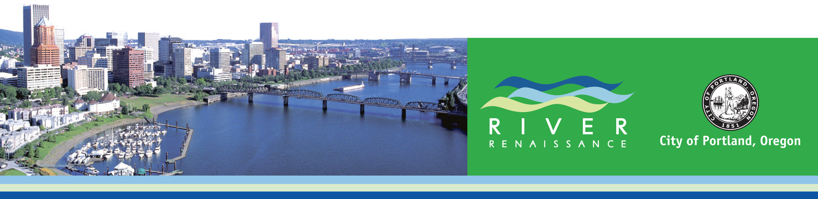

Portland’s River Renaissance

The Portland (Oregon) metropolitan area (2.3 million) lies at the confluence of the Columbia and Willamette Rivers, near the end of the trail blazed 200 years ago by Lewis and Clark. Over the past two centuries these rivers have been at the center of the agricultural, commercial, industrial and recreational development in the region and have played a vital role in the livelihood of the area’s residents. The Portland area has become one of the nation’s most attractive places to live and do business and has long been regarded as a bastion of thoughtful urban planning. However, as with many cities and developed regions around the country, its rivers have been developed incrementally with conflicting uses and without a coherent and comprehensive plan. The rivers are now at the center of debate about the region’s future.

Before entering Portland, the Willamette River drains the Willamette Valley, which is home to most of the state’s cities and population and much of its most productive farmland. It then flows through some of Portland’s most affluent neighborhoods, its downtown and the largely industrial harbor before merging with the Columbia. The Willamette has become a particular focus of planning and investment debates in recent years. The River’s natural attributes have been severely degraded despite past attempts at clean-up; the City’s development over the last century has largely turned its back to the riverfront and underutilized its potential for urban rejuvenation; new residents argue for increased river access where freeways have been placed; and seemingly intractable conflicts persist between industrial and environmental objectives for the river. In 2001, preparing to honor the bicentennial of President Thomas Jefferson’s commissioning of the Corps of Discovery, the City of Portland and several regional partners launched the River Renaissance Initiative aimed at reclaiming and restoring the Willamette River for a set of multiple objectives: a clean and healthy river, a continued prosperous working harbor, Portland’s “front yard” for gathering and recreation, a focal point of new urban neighborhoods to be developed, and a source of continuing education and leadership. This effort is complemented by the Governor’s effort to clean and restore the Willamette for the entirety of its length through the state. With the Initiative and partnerships now in place, the City of Portland is undertaking a comprehensive plan for the Willamette River within its boundaries. Known as the River Plan, the effort has commenced with an initial focus on the “North Reach” which comprises Portland’s Working Harbor.

The Challenges

- Environmental-industrial conflicts. Portland’s working harbor, the fourth largest port on the West Coast, serves as an industrial and trans-shipment hub for several western states and has seen relative growth and stability during the past two decades. Yet, most of the harbor has been designated as an EPA Superfund site. Historically, plentiful runs of salmon and steelhead passing through the City have been listed as threatened or endangered under the Endangered Species Act and the City is under orders to remedy Clean Water Act violations for storm-water/sewage contamination. Investments to remedy these will be massive. The myriad of Federal, State, regional and local mandates and regulations provide no clear path forward. A plan is needed that responds to environmental mandates, keeps the harbor industries active and healthy, allows for other public objectives and is fiscally achievable.

- The river that now divides the Central City must be used to heal it. Downtown Portland faces the River, but its banks are armored with concrete walls and riprap. Expansion of downtown to the east is blocked by the presence of an eight-lane Freeway (Interstate 5) immediately across the river on the east bank. In order to activate the eastside district and expand the Central City, the Freeway must be removed or relocated and the City must find ways to scale back the embankments and activate use of the water itself.

- Restoring natural functions in an urban area. Watershed protections and restoration of functional habitat within the City must be accommodated while still allowing use of the riverside and streams for trails, recreation and urban development. New tools for preserving and creating functional habitat and low footprint buildings are needed to accomplish both objectives.

Portland’s Response

Rather than dive into plan-making, Portland chose to “set the table” in a new way first. The River Renaissance Initiative was formed to accomplish three primary purposes at the outset: lay out high level aspirations that all partners and stakeholders could agree to; study in depth the various systems (systems approach) at work in the river’s ecology, economy and social functions; and posit outcomes that could be measured over time which would correlate directly to the agreed upon high level aspirations directly. The City and its partners have committed to these measures, which are reflected annually in a State of the River Report. These account for such things as water quality, tree canopy, size of fish runs, trail usage, number of new green buildings, job retention and creation in the harbor, community education, etc. These are meant to serve as long term public accountability and awareness indicators, but also as the underpinnings of the more specific planning activities now underway for different reaches of the River.

Planning Now Under Way

Planning has begun on the North Reach of the river, home to Portland’s working harbor. The plan components include a harbor reinvestment strategy, industrial land retention policy, revisions to the City’s “greenway code” (zoning ordinance), a new strategy for public trails, a harbor-wide habitat conservation and rehabilitation strategy, and urbanization plans for selected industrial lands. This effort will be followed by plans for the Central Reach (downtown), the South Reach and the Columbia shore. The downtown reach will address issues of freeway relocation, regional gathering places, river ferries, boat launches, and increased riverfront residential, office and retail development. The South Reach plan (upriver) will tackle issues of major wildlife restoration, trails through existing neighborhoods, regional recreational expansion and “floating homes”. The Columbia Corridor plan will take on issues of industrial and airport expansion, public access and natural resource protections.

By providing a cohesive and systems-based foundation for these efforts, the City of Portland believes it is in the best position in decades to bring the entire community together around these difficult challenges. Partners in the effort include the regional government (Metro), the Port of Portland, the US Army Corps of Engineers, the Office of the Governor, and local business, environmental and neighborhood leaders.

In a 2004 publication by the American Planning Association entitled Ecological Riverfront Design: Restoring Rivers, Connecting Communities (Otto et al), Portland’s River Renaissance Initiative was called “arguably the most ambitious river revitalization effort in recent US history…” In 2006 the Waterfront Center awarded the River Renaissance an award for Excellence on the Waterfront in the waterfront planning category, noting in particular its innovation in the use of progress measures.

Information about Portland’s River Renaissance and related planning efforts can be found on the web at www.portlandonline.com/river or by contacting the Portland Bureau of Planning at 503-823-1103.

